JOHANNES ZUKERTORT (Part II)

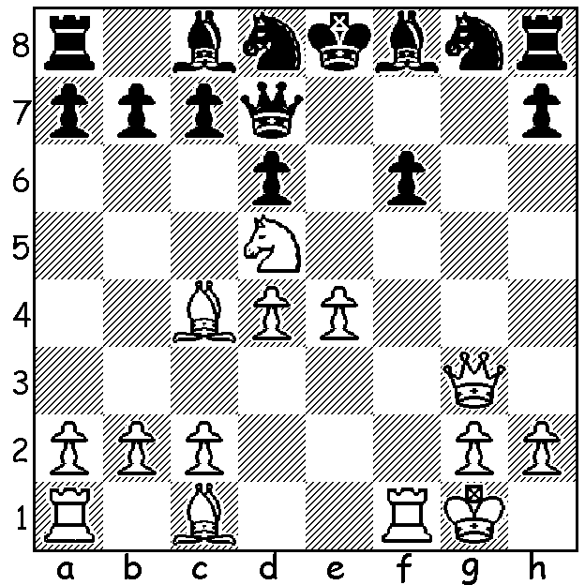
Johannes Zukertort played thousands
of games with his mentor Adolf Anderssen.
Here is a position from one of the games,
a Kings Gambit, Muzio, where Zukertort
(White) wins brilliantly (5 moves):

Diagram 410

After Zukertort’s outstanding win at the London Tournament of 1883 arrangements were made for the first official world championship match pitting Zukertort against Wilhelm Steinitz. The match was to be played in New York, St Louis and New Orleans where Steinitz was domiciled after emigrating from England, with each group
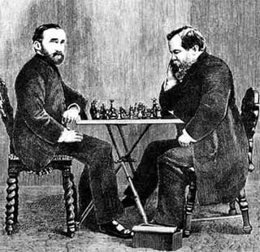
putting up a £2000 stake. Play would be at 30
moves in 2 hours and, after a 2 hour dinner, 15
moves per hour. The winner would be the first
to win 10 games. After losing the first game
Zukertort rapidly gained a three point lead before
Steinitz was able to level the scores in the ninth
game. Zukertort’s play then collapsed and Steinitz
finished an easy winner +10, -5, =5. While
Zukertortrelied on his consummate tactical skill,
Steinitz had the advantage of his own well thought
out positional theories which put him in a class
aheadof his challenger. Moreover Zukertort was
handicapped by poor health and had become
dependent ondrugs to control his nerves. He was
never to win another tournament and died aged 45
from a cerebral haemorrhage after a game in London.
Here is perhaps Zukertort’s best win from the
Steinitz match: Zukertort (left) v Steinitz

Wilhelm Steinitz - Johannes Zukertort
World Championship 1886, Game 2
Scotch Game
1.e4 e5 2.Nf3 Nc6
3.d4 exd 4.Nxd4 Nf6
5.Nc3 Bb4 6.Nxc6 bxd6
7.Bd3 d5 8.exd cxd
9.0-0 0-0 10.Bg5 c6
11.Ne2 Bd6 12.Ng3 h6
13.Bd2 Ng4 14.Be2(a) Qh4
15.Bxg4 Bxg4 16.Qc1 Be2!
17.Re1 Ba6 18.Bc3 f5
19.Re6 Rad8 20.Qd2 d4!
21.Ba5(b) Rd7 22.Rxd6! Rxd6
23.Bb4 Qf6 24.Rd1 Rd5
25.Bxf8 Qxf8 26.Nh5 Qe8
27.Nf4 Re5! 28.h4 c5
29.h5 Re4 30.c3(c) Qb8
31.g3 Qe5 32.Ng6 Qd6
33.Nf4 d3! 34.b3 c4
35.Rb1 Kh7 36.Kh2(d) Qb6
37.Kg1(e) Bb7 38.Rb2(f) Qc6
39.f3 Qc5+ 40.Qf2 Re1+
41.Kh2?(g) Qxf2+ 42.Rxf2 Bxf3!
43.g4 Be2 44.Ng2 d2
45.Ne3 cxb 46.axb Bxg4
White resigns

a) Not 14.h3? Nxf2! 15.Kxf2 Qh4 16.Qf3 f5 which regains the piece with a pawn advantage.
b) Capturing the pawn loses a piece – 21.Bxd4 Bxg3 22.hxg3 Qxd4 or 21.Qxd4 Qxd4 22.Bxd4 Bxg3 23.hxg3 Rxd4.
c) Attempting to undermine Black’s centre White commits an error allowing the d pawn to advance and become passed. Better was 30.f3 (30…Re3 31.Qa5 Be2 32.Nxe2 Rxe2 33.Qxc5 Qe3+ 34.Kh1 Re1+ 35.Rxe1 Qxe1+ 36.Kh2 Qh4+ would be drawn).
d) 36.Rd1 threatening 37.bxc Bxc4 38.Nxd3 would be met by 36…Re7.
e) Black threatened 37…Re2! 38.Nxe2 39.Qxf2+ winning.
f) Better 38.Rf1 (38…Qc6 39.f3).
g) A fatal error: White could defend with 41.Kg2 and if 41..Re3 42.Ne6! Qe5 43.Nd4 while 41.Qxf2+ Kxf2 activates the king.

SOLUTION: 1.Qxg8!! Rxg8 2.Nxf6+ Ke7 3.Nxg8+! Ke8 4.Nf6+ Ke7 5.Nxd7.

