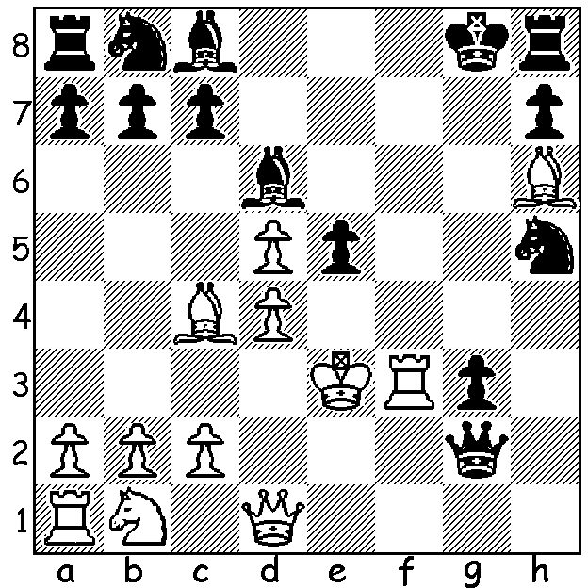

In Wilhelm Steinitz – Peter Wilson 1862
White wins quickly:

Diagram 411

In the article last week covering the first official world championship, the match between Wilhelm Steinitz and Johannes Zukertort, reference was made to Steinitz’s superior positional judgement gained through a thorough study and development of chess principles. In ‘My Great Predecessors: Part I’ Gary Kasparov writes that Steinitz propounded ‘that one should always play strictly according to a plan, taking into account the features of a particular position. And that one should attack only if a sufficient number of small advantages has been accumulated stemming from certain properties in the position …such as lead in development, mobility of the pieces, seizure of the centre, position of the enemy king, weak squares in the opponent’s position, superior pawn formation, pawn majority on the queenside, open lines, and the advantage of the two bishops.’ With regard to pawn structure Steinitz established that an isolated pawn in the centre is a weakness, a target for attack and that the square in front of it provides a springboard for a knight. Here in the ninth game Steinitz clearly puts his principles into practice perfectly and in so doing wins the game to equal the score 4-4 and break the resolve of Zukertort who was able to win only one more game in his 5-10 loss (5 draws):

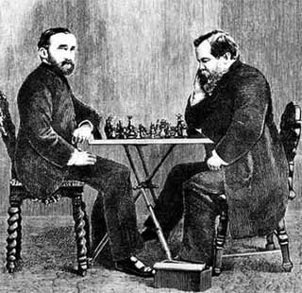

Johannes Zukertort (left) - Willhelm Steinitz

Johannes Zukertort - Wilhelm Steinitz
World Championship 1886, Game 9
Queens Gambit Accepted (by transposition)
1.d4 d5 2.c4 e6
3.Nc3 Nf6 4.Nf3 dxc
5.e3 c5 6.Bxc4 cxd
7.exd Be7 8.0-0 0-0
9.Qe2 Nbd7(a) 10.Bb3 Nb6
11.Bf4(b) Nbd5 12.Bg3 Qa5
13.Rac1 Bd7 14.Ne5 Rfd8
15.Qf3 Be8 16.Bh4(c) Nxc3
17.bxc3(d) Qc7 18.Rfe1 Rac8
19.Qd3 Nd5 20.Bxe7 Qxe7
21.Bxd5(e) Rxd5 22.c4 Rdd8
23.Re3(f) Qd6 24.Rd1 f6
25.Rh3!? h6! 26.Ng4 Qf4!(g)
27.Ne3 Ba4! 28.Rf3 Qd6
29.Rd2 Bc6 30.Rg3 f5 !
31.Rg6 Be4 32.Qb3 Kh7
33.c5 Rxc5! 34.Rxe6 Rc1+
35.Nd1(h) Qf4 36.Qb2 Rb1
37.Qc3 Rc8! 38.Rxe4 Qxe4
White resigns

a) 9…Nc6 is considered better as White could now play 10.d5 and eliminate his isolated pawn.
However Zukertort believed the isolated d pawn gave him attacking chances (an accepted view today which balances rather than refutes Steinitz’s dogma).
b) Better 11.Bg5 fighting for control of the key d5 square.
c) Finally hitting on the right diagonal for the bishop but at the cost of two tempi.
d) Now White has a weak c pawn on a half open file and if it advances to c4 (as it should) the notorious ‘hanging pawns’ which though subject to attack provide excellent attacking opportunities.
e) White should not part with such an important piece: 21.c4 should be played immediately.
f) Seeking a kingside attack with few prospects.
g) Prepared to meet 27.Rg3 with 27…b5! 28.cxb Rxd4! 29.Nxh6+ (29.Qxd4? Qxd4 30.Rxd4 Rc1+ mating) 29…Kf8 30.Qa3+ Qd6.
h) Better 35.Nf1 as now White cannot defend against Black’s back rank pressure.

The CHRISTMAS OPEN (final Grand Prix for 2011) will be played Sat 3 & Sun 4 December at the Moresby St. Centre. Details on cawa.org.au with entries to Haydn Barber 93984242.

SOLUTION: 1.Rf8+! (a fine deflection sacrifice) 1…Bxf8 2.d6+ Be6 3.Bxe6#.

