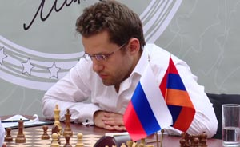
Almost certainly time trouble prevented Sune Berg Hansen (Denmark) downing world number 3 Levon Aronian (Armenia) in the 2011 European Team Championships. Can you find an immediate winning move for White?

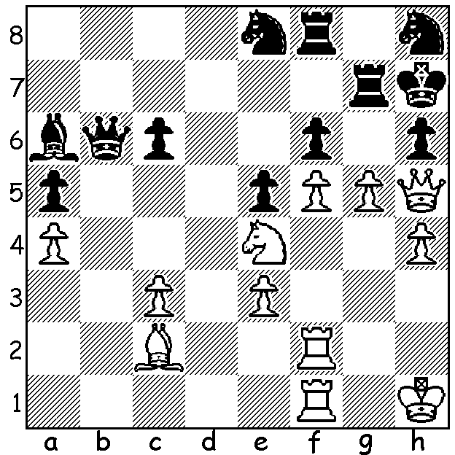 Levon Aronian at the Tal Memorial 2011

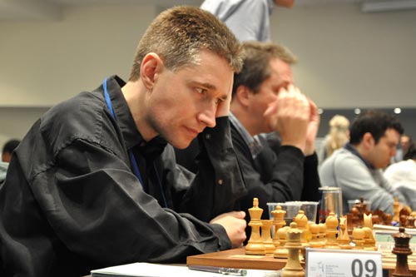
The 2011 European Team Championships,
played in Greece November 3rd to 11th, had 38
teams in the Open and 28 in the Women’s with
each team having four players plus a reserve.
With 2011 being a non Olypiad year these
championships would be the top team event
of the year with many of the world’s leading
GMs competing. Surprise winners in the Open
were Germany with 15/18 from their nine rounds
with Azerbaijan (14) second and Hungary (13)
third, followed by Olympiad champions Armenia
and the fancied Russian team both also on 13.
Russia did win the Women’s event. Michael
Adams (England) gained the prize for the best Michael Adams at the European Team Champs
score on Board 1.
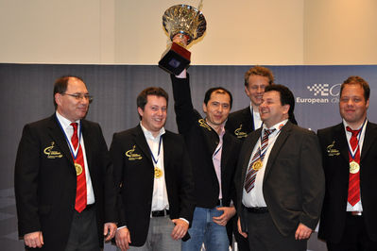

The victorious
German team

Here are two impressive attacking games from the event:

Christian Bauer (France) - Ilia Smirin (Israel)
European Team Championships 2011, Rd 3
Torre Attack
1.d4 Nf6 2.Nf3 g6 3.Bg5 Bg7
4.Nbd2 0-0 5.c3 d5 6.e3 Nbd7
7.Bd3 Re8 8.0-0 e5 9.e4! exd4
10.cxd4 dxe4 11.Nxe4 h6 12.Qb3!! Re6(a)
13.Bh4 g5 14.Bxg5! hxg5 15.Nexg5 Nb6(b)
16.Bg6!! fxg6 17.Nxe6 Bxe6 18.Qxe6+ Kf8
19.Ne5 Qe8 20.Qb3 Nfd5 21.f4 Bxe5
22.fxe5+ Kg7 23.Rf2 Qe7 24.Raf1 Rh8
25.Qg3 Rh5 26.Rf6 Qe8 27.R6f3 Qe7
28.Rf6 Qe8 29.R6f3 Qe7 30.Qf2 Qh4
31.g3 Qe4 32.g4! resigns(c)

a) If 12...hxg5 13.Nexg5 Rf8 14.Nxf7 Rxf7 15.Bxg6 Qf8 16.Ng5 with a winning attack.
b) Planning to blockade on d5 but 15...Nf8 guarding e6 & g6 was better.
c) If 32…Qxg4+ 33.Rg3 Qe4 34.Qf8+ Kh7 35.Rf7# or 32…Rh8 33.Rf7+ Kg8
34.Rf8+ Kg7 35.Qf7+ Kh6 36.Rxh8#.

Trajko Nedev (Macedonia) - Christian Jeitz (Luxembourg)
European Team Championships 2011, Rd 8
Kings Indian Attack v French Defence
1.e4 c5 2.Nf3 e6 3.d3 Nc6
4.g3 Nf6 5.Bg2 d5 6.Nbd2 Be7
7.0-0 0-0 8.Re1 b6 9.a3 Bb7
10.e5 Nd7 11.Nf1 a5 12.h4 Qc7
13.Bf4 b5 14.N1h2 d4 15.Ng4 Nb6
16.Nf6+! Kh8 17.Ng5 h6 18.Qh5 Bxf6
19.exf6 e5 20.Rxe5! Nxe5 21.fxg+ Kxg7
22.Ne6+! fxe6 23.Bxe5+ resigns

The CHRISTMAS OPEN (final Grand Prix event for 2011) will be played tomorrow (12.30 – 8pm) & Sunday (10.30 am – 6pm) at the Moresby St. Centre. Details on cawa.org.au with entries to Haydn Barber 93984242 (phone today for concession on entry fee).

SOLUTION: 1.Qxe8!! (1…Rxe8 2.Nxf6#). Instead play continued 1.Rg1? Nf7 (desperation) 2.g6+ Kh8 3.gxf7 Qxe3! 4.fxe8=Q?? (4.Rg6 or 4.Ng5 maintained a winning position) 4…Qh3+
5.Rh2 Rxg1+ White resigns (6.Kxg1 Qf8#).

