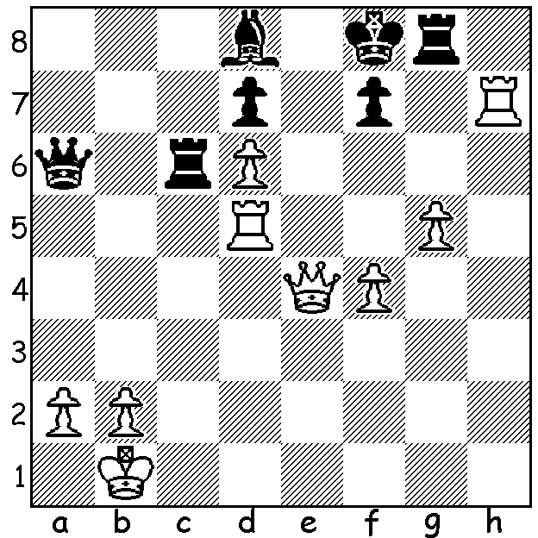

Nigel Short’s mild appearance
belies his aggression over the board.
Over the next few months I intend
presenting some of his brilliant
finishes. Firstly Short – Lutz 2003:
White to play and mate (9 moves):

Diagram 413

What it lacked in quantity the final WA Grand Prix event of the year, last weekend’s Christmas Open, made up for in quality with many of the state’s leading players taking part including the WA champion Yita Choong, the WA Allegro champion Stephanus Kurniawan and the joint WA Lightning champions Tom Donaldson and Aston Tamimsjah. Thirteen of the 22 entrants were rated above 1800 with 4 players over 2000 and another 5 players 1900-1999. Winner was Yita Choong (5.5/6), his third GP success for the year in as many attempts, with Stephanus Kurniawan runner-up with 5. Rating prizes were won by Dave Dempster (Under 2000), Dennis Holland (Under 1900), Joe Aquilina & George Carolin-Unkovich (Under 1700) while Aston Taminsjah gained the Junior prize. One of the most entertaining games was between two of WA’s best juniors, 14 year old Aston Taminsjah and 13 year old George-Carolin Unkovich who has been a regular player GP player over the past few years and has made enormous progress in that time. George was successful on this occasion although Aston finished with a half point more in the tournament.

Aston Taminsjah - George Carolin-Unkovich
2011 Christmas Open, Rd 3
Kings Indian Defence
1.d4 Nf6 2.c4 g6
3.Nc3 Bg7 4.e4 d6
5.Nf3 0-0 6.h3 e5
7.d5 Nbd7 8.Bg5 a5
9.Qc2 Qe8 10.Be2 Nc5
11.b3 h6 12.Be3 Nh5(a)
13.Qd2 Kh7 14.g4 Nf6(b)
15.Qc2 Ng8 16.g5 h5
17.Nh4 f5(c) 18.exf Bxf5
19.Nxf5 Rxf5 20.Bxh5! e4
21.Be2 Qe5 22.Kd2 Re8
23.Raf1 Na6 24.a3 Nc5
25.h4 Rf4(d) 26.h5 Ne7
27.hxg+ Kg8 28.Rhg1 Nf5
29.Nd1 Nd4 30.Qb2 Ncxb3+
31.Ke1 a4 32.Qa2 Nxe2(e)
33.Qxe2 Nd4 34.Bxd4 Qxd4
35.Qd2 e3 36.Nxe3(f) Qxc4
37.Kd1 Qb3+ White loses on time(g)

a) White’s 11.b3 has left the a1 rook in danger. Black could now play 12…Nfxe4! – 13.Nxe4 Nxe4 14.Qxe4 f5 15.Qc2 f4 16.0-0 Bf5 17.Qc3 fxe3.
b) 14…Nf4 is better.
c) Black boldly opens the kingside to obtain an attack through the middle. That he loses a pawn is of little consequence.
d) An attractive exchange sacrifice offer to enhance the power of his minor pieces. However White could accept – 26.Bxf4 Qxf4+ 27.Kd1 Qe5 28.h5! Ne7.
e) 32…Nf3+ is even stronger.
f) 36.fxe3 keeps White in the game.
g) White is lost – 38.Ke2 Bc3 39.Qd1 Qb2+ or 38.Qc2 Rd4+ 39.Kc1 Rxe3! or 39…Qxa3+ 40.Qb2 Rc4+! 41.Nxc4 Bxb2+ 42.Nxb2 Re2.

The final event of the year, the TEAMS LIGHTNING, will be held on Sunday at Moresby St. Centre starting at 10.30. Open to players of all standards. Contact Gordon Dunlop ASAP 9368 6412. After the finals there will be a presentation of prizes covering ALL CAWA events. Please attend if you won a prize during the year (for Grand Prix prize winners check on cawa.org.au ).

SOLUTION: 1.Rxf7+! Kxf7 2.Qf5+ Kg7 3.Qxd7+ Kg6 4.Qe6+ Kh5 5.Qh3+ Kg6 6.Qh6+ Kf7 7.Rf5+ Ke8 8.Qe6+ Be7 9.Qxe7#.

