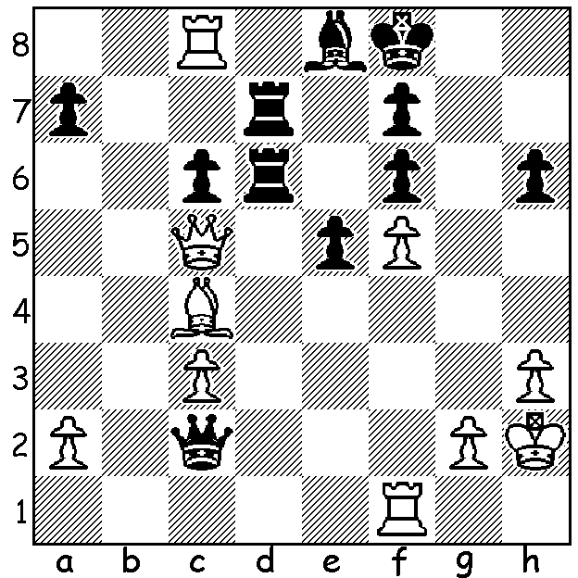
Magnus Carlsen – David Howell
(2011 London Classic, Rd 1): Black
is almost completely tied up with pins
on his bishop & rook (d6). White’s
next move, exploiting one of the pins,
wins material. Can you find the move?

Diagram 414

2011 LONDON CLASSIC
As well as obtaining the entry of five of the very best of the world’s GMs to face the England’s top four, the London organisers put on a series of most attractive side events including 10 FIDE rated and many Rapid and Blitz competitions. Gary Kasparov was present to sign copies of his latest book, ‘Gary Kasparov on Gary Kasparov – 1973-1983’, 80 year old Viktor Korchnoi gave two simuls, world champion Vishy Anand and world problem solving champion John Nunn gave a lecture on astronomy, there were a showing of the film ‘Bobby Fischer Against the World’, a workshop on getting the most out of Fritz on Chess Base software and two courses on training teachers to teach chess in schools. Juniors were well catered for with an oversubscribed simul for 500 and five days of schools’ chess activities. Visitors were also entitled to a reduced charge to attend the neighbouring exhibition, ‘The Doctor Who Experience.’ The first move of the tournament was made by tennis legend Boris Becker (on crutches after breaking a leg) who also played an exhibition game against Nigel Short. (Becker often played chess before important matches as a means of relaxation).
Final Scores (3 pts a win, 1 pt a draw): ex-world champion Vladimir Kramnik (Russia) 16/24 (+4, =4), Hikaru Nakamura (USA) 15 (+4, =4, -1), Magnus Carlsen (Norway) 14 (+3, =5), Luke McShane (UK) 13 (+3, =4, -1), world champion Vishy Anand (India) & Levon Aronian (Armenia) 9, Nigel Short (UK) 6, David Howell (UK) 4, Michael Adams (UK) 3.
Magnus Carlsen, winner in 2009 & 2010, went through undefeated. Here is his win against runner-up Hikaru Nakamura (page 3):

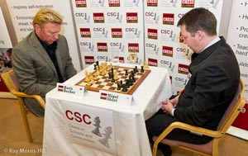
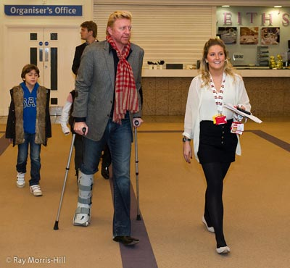

Boris Becker arriving on crutches and playing an exhibition game against Nigel Short.

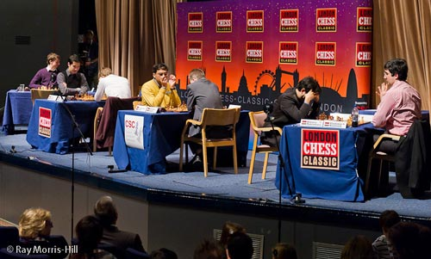

Round 1:(right to left) Kramnik v Nakamura, Adams v Anand,
Carlsen v Howell, Aronian (not in picture) v McShane .

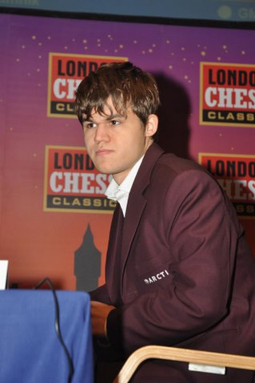
Magnus Carlsen - Hikaru Nakamura
2011 London Classic, Rd 3
Giuoco Piano
1.e4 e5 2.Nf3 Nc6
3.Bc4 Nf6 4.d3 Bc5
5.c3 d6 6.Bb3 a6
7.Nbd2 Ba7 8.Nf1 h6
9.Ng3 0-0 10.0-0 Be6
11.h3 Qd7 12.Be3 Ne7
13.Nh4 Ng6(a) 14.Nhf5 Ne7
15.Nxe7+ Qxe7 16.Bxa7 Rxa7
17.f4 c5 18.Bc2 b5
19.Qd2 Rb7 20.a3 a5
21.Rf2 b4 22.axb4 axb4
23.Raf1 bxc3 24.bxc3 exf4 Carlsen (top) & Nakamura
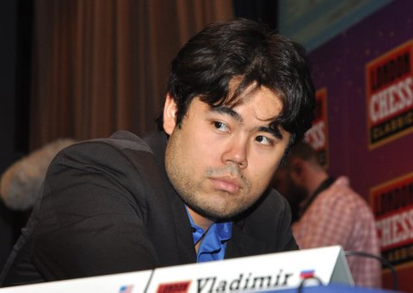
25.Rxf4 Nh7 26.d4 cxd4
27.cxd4 Qg5 28.Kh2 Nf6
29.Bd1 Rfb8?(b) 30.h4 Qg6
31.Rxf6! gxf6 32.Qf4 Rb2
33.Bh5 Qg7 34.Bf3 Ra8
35.d5 Bc8 36.Nh5(c) Qf8
37.Nxf6+ Kh8 38.Rc1 Kg7
39.e5 dxe5 40.Nh5+ Kh7
41.Be4+ resigns(d)

a) If 13...Bxh3 14.gxh3 Qxh3 White can defend with 15.Bxa7 Rxa7 16.Ng2 Ng4 17.Re1.
b) Better 29...Rb1 and if 30.h4 Rxd1! 31.Qxd1 Ng4+.
c) White’s attack is overwhelming.
d) 41…Kg8 42.Qg3+ Kh8 43.Qxe5+ wins a rook.

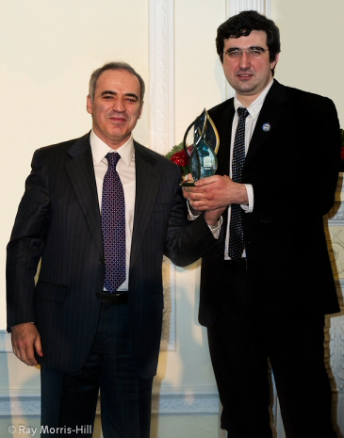
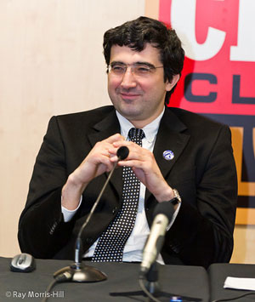

Vladimir Kramnik a happy winner
and (right) receiving the trophy
from Gary Kasparov.

SOLUTION: 1.Be6!! (motif - Attacking the Guard) and if 1…fxe6 2.fxe6. Black played 1…Ke7 but soon lost.

