To finish the year another set of miniatures under 16 moves in which the underdog comes out on top, this time from 1921 onwards. Simultaneous displays create opportunities for the club player to gain his moment of glory and here is a defeat of the child prodigy Samuel Reshevsky aged nine at the hands of Ed Duncan in San Francisco in 1921. Black plays 1…Rac8 and after 2.Bxd7 wins quickly (2 moves):

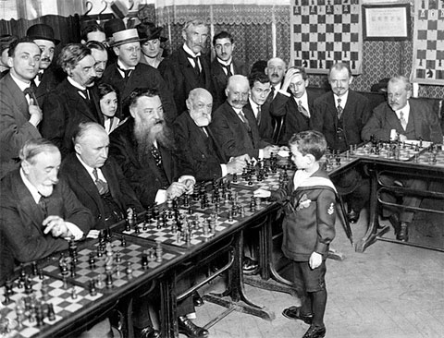
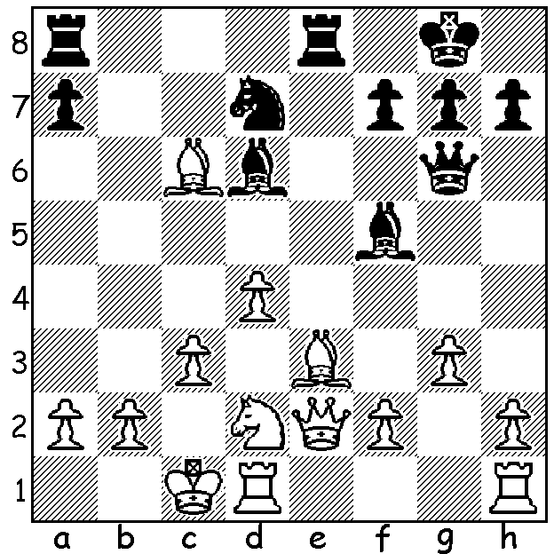

Diagram 415

Reshevsky giving simul aged 8.

Paul Keres - Menke
Correspondence 1933: Steinitz Gambit
1.e4 e5 2.f4 exf 3.Nc3 Qh4+ 4.Ke2 d5 5.Nxd5 Bg4+ 6.Nf3 Nc6 7.Nxc7+ Kd8
8.Nxa8 Ne5 9.h3 Bh5 10.Rg1 Qg3 11.Qe1 Bxf6+ 12.gxf3 Qxf3# Reuben Fine - Mikhail Yudovich
Moscow 1937: Queens Gambit Declined
1.d4 d5 2.c4 e6 3.Nc3 Nf6 4.Nf3 c5 5.Bg5 cxd 6.Nxd4 e5 7.Ndb5 a6 8.Nxd5? axb5
9.Nxf6 Qxf6!! 10.Bxf6 Bb4+ 11.Qd2 Bxd2+ 12.Kxd2 gxf6 White resigns

Another Reshevsky loss, this time playing just one opponent:
Samuel Reshevsky - Israel Margolit
Israel 1958: Nimzo Indian
1.d4 Nf6 2.c4 e6 3.Nc3 Bb4 4.e3 c5 5.Ne2 Nc6 6.a3 Qa5 7.Bd2 e5 8.axb4? Nxb4!!
9.Rxa5? Nd3# (if 9.Ng3 Qxa1! 10.Qxa1 Nc2+)

The great Bobby Fischer bites the dust in a Simul in 1963:
Bobby Fischer - Robert Burger: Two Knights Defence
1.e4 e5 2.Nf3 Nc6 3.Bc4 Nf6 4.Ng5 d5 5.exd5 Nd4 6.c3 b5 7.Bf1 Nxd5 8.cxd4 Qxg5
9.Bxb5+ Kd8 10.Qf3 Bb7 11.0-0 e4! 12.Qxe4? Bd6 13.d3? Bxh2+! 14.Kxh2 Nf4
White resigns (15.Qxb7 Qh4+ 16.Kg1 Ne2#)

Bagley - Pal Benko
New Jersey 1975: Benko Gambit
1.d4 Nf6 2.c4 c5 3.d5 b5 4.axb a6 5.Nc3 axb 6.e4 b4 7.Nb5 Nxe4? 8.Qe2 f5
9.f3 Ba6 (9…Nf6 10.Nd6#) 10.fxe4 Qa5 11.exf resigns

An embarrassing loss by a future world champion:
Alonso Zapata - Viswanathan Anand
Biel 1988: Petroff Defence
1.e4 e5 2.Nf3 Nf6 3.Nxe5 d6 4.Nf3 Nxe4 5.Nc3 Bf5?? 6.Qe2 resigns
(if 6…Qe7 7.Nd5 / 8.d3)

An ex-world champion blunders badly:
Larry Christiansen - Anatoly Karpov
Wijk aan Zee 1993: Queens Indian
1.d4 Nf6 2.c4 e6 3.Nf3 b6 4.a3 Ba6 5.Qc2 Bb7 6.Nc3 c5 7.e4 cxd 8.Nxd4 Nc6
9.Nxc6 Bxc6 10.Bf4 Nh5 11.Be3 Bd6?? 12.Qd1 resigns

Did you get many of the quiz questions right last week? I recently came across an interesting piece of information regarding the first chess world championship match between Willhelm Steinitz and Johannes Zukertort in 1886. An article stated that Chess was the second sport after Billiards (1873) to have an official world champion.

SOLUTION: after 1…Rac8 2.Bxd7? Black plays 2…Rxc3+! and White resigns (3.bxc3 Ba3#).

