Tarrasch – Allies 1914: White finds a brilliant way to win with a move one would expect to see only in a composed problem (4 moves):
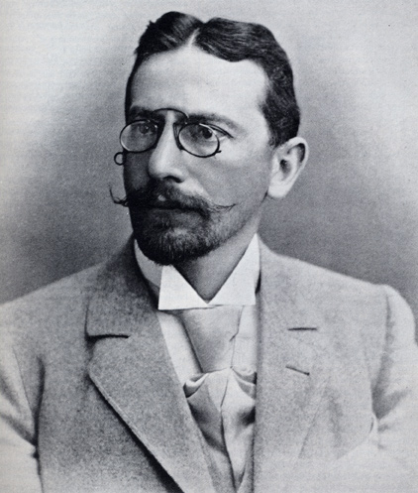
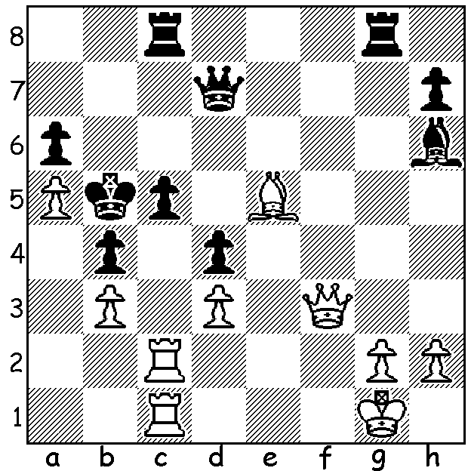

“EVERYTHING OLD IS NEW AGAIN” (Part I)
So often what is seen as new is in reality something old that has been neglected or forgotten. We see that in the fashion industry and it is certainly true in chess with openings that have almost disappeared from tournament play being resurrected by prominent players and then taken up with enthusiasm by others. One example is the popularity of the Berlin Defence to the Ruy Lopez where a main line is 1.e4 e5 2.Nf3 Nc6 3.Bb5 Nf6 4.0-0 Nae4 5.d4 Nd6 6.Bxc6 dxb6 7.dxe Nf5 8.Qxd8+ Kxd8. This seemingly obsolete defence was played four times in the Gary Kasparov - Vladimir Kramnik World Championship match with all four games drawn, a highly satisfactory result for Kramnik, which was significant in his defeat of Kasparov. The first recorded game with the Berlin Defence was played in 1840 in Berlin (naturally) and it was a popular defence through to the early part of the twentieth century. Lasker won with the Berlin in his World Championship defence against the American Frank Marshall in 1907 and it was also used by one of his challengers Siegbert Tarrasch:

Max Harmonist --Siegbert Tarrasch
Breslau 1889: Ruy Lopez, Berlin Defence
(L’Hermit Variation –‘The Berlin Wall’)
1.e4 e5 2.Nf3 Nc6
3.Bb5 Nf6 4.0-0 Nxe4
5.d4 Nd6 6.Bxc6 dxc6
7.dxe Nf5 8.Qxd8+ Kxd8(a)
9.Bg5+ Ke8 10.Nc3 h6
11. Bf5 Be6 12.Rad1 Rd8
13.Ne4 c5 14.Rxd8+ Kxd8
15.Rd1+ Kc8 16.h3 b6
17.Kf1 Be7 18.a3 Rd8
19.Rxd8+ Kxd8 20.c3(b) Bd5
21.Nfd2 Kd7 22.Ke2 g5
23.Bh2 Nh4 24.g3 Ng6
25.f4 Ke6 26.Ke3 c4
27.Nf3 gxf+ 28.gxf c5(c)
29.Ng3 Nh4(d) 30.Nxh4 Bxh4
31.Ne4 Be7 32.Bg1 Bc6
33.Bf2 Bd7 34.Bg3(e) Kd5
35.Nf2 h5 36.Kf3 Bf5
37.Ke3 b5 38.Kf3 a5
39.Ke3 b4 40.Kf3 Kc6
41.axb cxb 42.cxb axb
43.Ne4 Kd5 44.Nd6 Bxd6
45.exd6 c3 46.bxc b3
White resigns

a) Black has gained the advantage of the two bishops and his queenside majority is threatening despite the doubled pawns.
b) Necessary due to the threat of 20…Nd4 but weakening the queenside.
c) Black was alert to the threat 29.f5+! Nxf5 30.Nd4#.
d) Black negates the threat of White’s kingside majority by blockading the e & f pawns.
e) 34.Nd6! would have given some hope with bishops of opposite colours after 34…Bxd6.

Tarrasch, physician and theorist, lost a World Championship match to Emmanuel Lasker in 1908 (+3 =5 -8).
Max Harmonist was better known as a professional ballet dancer. He won a brilliancy prize for his win against Gunsberg at Frankfurt 1887.

SOLUTION: 1.Bc7!! a stunning interference sacrifice: if 1…Rxc7 2.Qb7+!! (now a deflection sacrifice) 2…Rxb7 (2…Kxa5 3.Ra1#) 3.Rxc5# or 1…Qxc7 2.Rxc5+ Qxc5 3.Qb7+ Kxa5 4.Ra1#. This type of interference in which piece a (here the queen) obstructs piece b (here a rook) and vice versa, b obstructing a, is called a ‘Grimshaw’ after English problemist Walter Grimshaw (1832-90).

