Sydney Schoolboys Expelled for Playing Chess
Two of Australia’s best young chess players have been told by prestigious Sydney Grammar to find another school after taking unauthorised leave to participate in the World Youth Championships in Brazil. Kevin Willathgamuwa came 10th out of 90 competitors in the Under 8s and his brother Rowan scored 50% in the Under 9s. Readers may well think their achievements deserve commendation not condemnation and that the action taken was very high-handed for an absence of only 10 days.
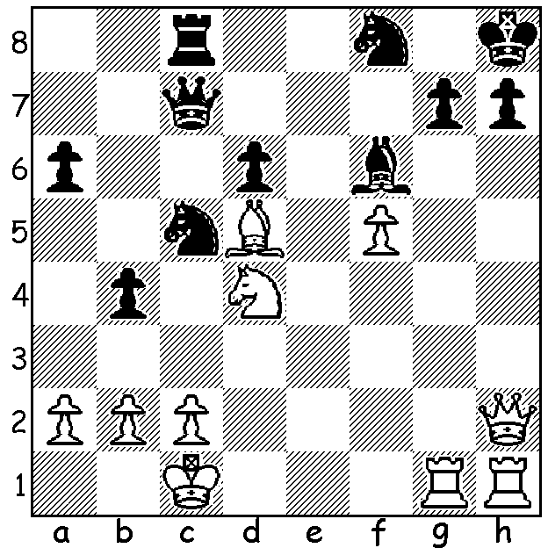
‘Short and Sweet’
Another sparkling finish by Nigel Short
(White v Muir 2004):
White mates in 4 moves:

Diagram 416

Everything Old is New Again (Part II)
Last week we looked at the Berlin Defence to the Ruy Lopez and a game won by one of the leading players of the early twentieth century Siegbert Tarrasch employing this defence. After almost a century of neglect it was resurrected by Vladimir Kramnik who drew all four games using this defence in his successful challenge to Gary Kasparov in 2000 for the world title. Below we see Kasparov eventually breaking down the ‘Berlin Wall’ at the sixth attempt:

Gary Kasparov - Vladimir Kramnik
Astana, Kasakstan, 2001
Ruy Lopez, Berlin Defence (L’Hermit Variation)
1.e4 e5 2.Nf3 Nc6
3.Bb5 Nf6 4.0-0 Nxe4
5.d4 Nd6 6.Bxc6 dxc6
7.dxe Nf5 8.Qxd8+ Kxd8(a)
9.Nc3 h6 10.h3 Bd7
11.b3 Ke8(b) 12.Bb2 Rd8
13.Rad1 Ne7 14.Rfe1 Ng6
15.Ne4 Nf4 16.e6! Nxe6(c)
17.Nd4 c5(d) 18.Nf5 Rh7
19.Bf6! Rc8 20.Bxg7! Bxg7
21.Nxg7 Rxg7 22.Nf6+ Ke7
23.Nxd7 Rd8 24.Ne5 Rxd1
25.Rxd1 Nf4 26.Kh1 Rg5(e)
27.Ng4 Rd5(f) 28.Re1+(g) Kf8
29.Nxh6 Rd2 30.Re5 Rxf2?(h)
31.Rf5 Kg7 32.Ng4 Rxg2
33.Rxf4(i)

a) Black loses the right to castle and falls behind in development but the exchange of queens means he is not subject to the ‘Spanish Torture’, a slow and enduring White kingside attack.
b) Kramnik has played the king to both e8 & c8.
c) Not 16…Bxe6 17.Nf6+! gxf6 18.Rxd8+ Kxd8 19.Bxf6+ wins.
d) Better is 17.Rh7 when White’s coming combination would fail – certainly not 17…Nxd4?? 18.Nd6#.
e) The g pawn is poisoned – 26…Rxg2? 27.Nd3 or 26…Nxg2? 27.Rg1 Kf6 28.f4 Nxf4 29.Nd7+ Ke7 30.Rxg7.
f) 27…h5 seems to maintain equality.
g) There is no advantage after 28.Rxd5 Nxd5 29.Nxh6 Nb4.
h) A blunder: 30…Rxc2 should be played although White would expect to win after 31.Rf5 Kg7
32.Rxf4 Kxh6 33.Rxf7 Rxa2 34.Rxc7 b6.
i) Conclusion 33… Rxc2 34.Rf2 Rc3 35.Kg2 b5 36.h4 c4 37.h5 cxb 38.axb Rc5 39.h6+ Kf8 40.Nf6 Rg5+ 41.Kh1 resigns (if 41…Rg6 42.Rh2 & wins or 41…Rg3 42.Rh2 Rxb3 44.Rh5! wins – not 44.h7? Rb1+ 45.Kg2 Rb7+).

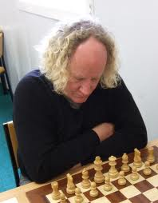
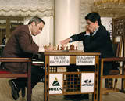

Kasparov v Kramnik
Darryl Johansen

Australian Championship 2012: Winner for the sixth time was Darryl Johansen with 8.5/11 (+6 =5). Full report next week.

SOLUTION: 1.Qxh7+! resigns (1…Nxh7 2.Rxh7+ Kxh7 3.Rg1+ Bh4 4.Rxh4#).

