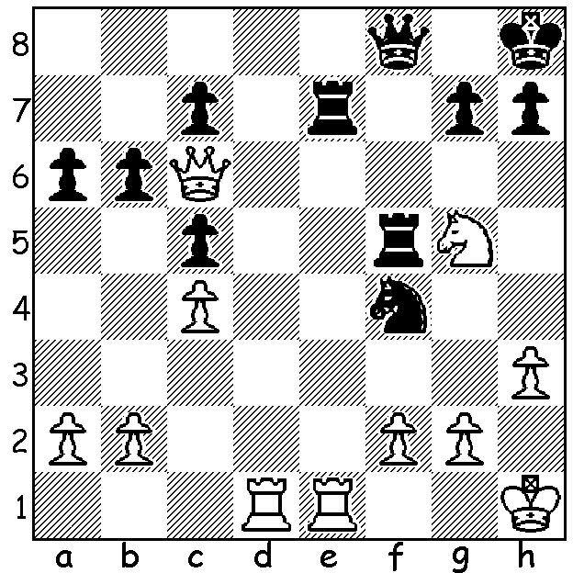
‘Short & Sweet’ (continued)
Short – Mezioud 2002:
White targets Black’s main
weakness to win quickly (5 moves):

Diagram 417

As reported last week the winner of the 30-player 2012 Australian Championship was 52 year old Darryl Johansen. This was Darryl’s sixth title win and he went through the tournament undefeated with a score of 8.5/1, a point or more ahead of a number of much younger and more fancied players. Equal second on 7.5 were Vladimir Smirnov, 2010 champion Zong-Yuan Zhao, 2011 Australian Open champion George Xie and former champion Stephen Solomon, followed by Aleks Wohl and 20 year olds Moulthun Ly and Junta Ikkeda on 6. WA’s Ihsan Ferozkohi started well with 2.5/4 but tailed off badly to finish with 3.5 while in the 76-player Reserves Richard Lilly scored 6/11 and John Summerfield 4. Here a Johansen win from the event against the 2011 Sydney International winner Akshat Khamparia:

D. Johansen - A. Khamparia
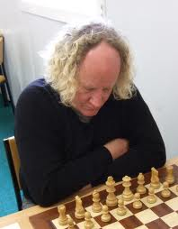
2012 Australian Championship, Geelong
Kings Indian Defence
1.Nf3 Nf6 2.c4 g6
3.Nc3 Bg7 4.e4 d6
5.d4 0-0 6.Be2 Na6(a)
7.0-0 e5 8.Re1 Qe8
9.Bf1 Bg4 10.d5 Nh5
11.h3 Bd7(b) 12.Rb1 Nc5
13.Nb5 Na6 14.b4 f5
15.Rb3 f4 16.a4 Qe7
17.Ba3 Rfc8 18.Rc3 Bf8
19.c5 Nf6 20.Qe2 Be8
21.Rec1 Rd8 22.R3c2 dxc
23.bxc c6 24.d6 Qg7
25.Nxe5! cxb5 26.axb Nxc5(c)
27.Bxc5 Bxd6 28.Bxd6 Rxd6
29.Rc7 Nd7 30.Nf3 Rb6
31.e5 Qf8 32.e6 Nf6
33.Qe5 Nh5 34.Qe4(d) Qd6
35.Rxb7 Nf6 36.Rxb6 Nxe4 Darryl Johansen
37.Rxd6 Nxd6 38.Rc5 Kg7
39.Rd5 Rd8 40.Rd4 Kf6
41.Rxf4+ Kxe6 42.Ra4 Rd7
43.Nd4+ Kd5 44.Nc6 Nc8
45.Rd4+ Kc5 46.Re4 Bf7
47.Ne5 Re7 48.f4 Bd5
49.Re1 Nb6 50.Kf2 Kd6
51.Rd1 Rc7 52.Rd2 Ke6
53.h4 Nd7 54.Nxd7 Rxd7
55.g3 Rc7(e) 56.Bh3+ Kd6
57.Bg2 Rc5 58.Rxd5+ Rxd5
59.Bxd5 Kxd5 60.Kf3 Kc5
61.g4 Kxb5 62.f5 gxf
63.g5! resigns(f)

a) Although a book move I feel it is inferior to systems with …Nbd7 mainly because it deprives Black of the often useful …a5.
b) Losing time: 11…Bxf3 might enable Black to get a kingside attack going, something he never manages.
c) Necessary to avoid being overrun by White’s pawns.
d) White is probably in time trouble now (1st control at move 40) and misses a quick win – 34.e7 Qg7 35.Qd5+ Kh8 36.Qd8. Now he has to squeeze out an endgame win.
e) Avoiding the coming exchanges would still leave White with a winning position – eg 55…Ke7 56.Ke3 Rd6 57.Rc2 Rd7 58.Bh3 Rb7 59.Rc5 Bh1 60.h5.
f) 63…Kc5 64.h5 Kd6 65.g6 hxg 66.h6! wins

SOLUTION: 1.Rxe7 Qxe7 2.Qe4!! (exploiting Black’s back rank weakness) 2…Qxe4 (if 2…Qf8 3.Qxf5!) 3.Rd8+ & mates

