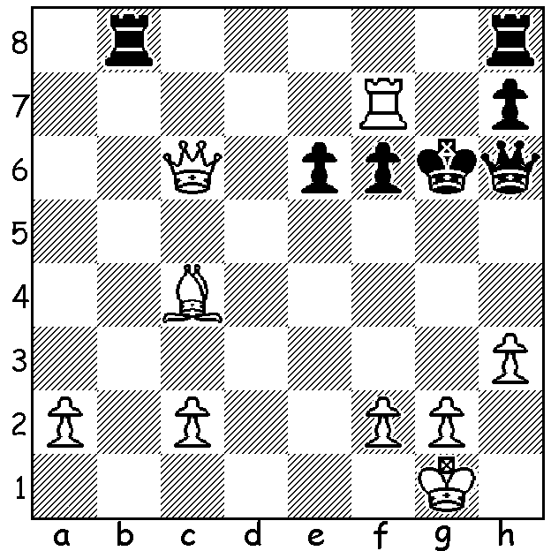

‘Short & Sweet’ (cont)
Short – Adianto 2000:
White mates in 5:

Diagram 418

Another two part ‘Everything Old is New Again’ with a look at two games with striking similarities played 120 years apart. Firstly a win by Wilhelm Steinitz in his one-sided match against Henry Blackburne. Steinitz had been disappointed by his failure to win tournaments in Paris in 1867 and Baden-Baden in 1870 and in consequence dedicated his time to a reappraisal of chess values. “I came to the conclusion that combinative play, although it sometimes gives fine results, is not able to ensure solid success. …. In general an attack has chances of success only when the opponent’s position is already weakened.” This meant, besides attempting to weaken an opponent’s position, Steinitz was prepared to accept a defensive position if it was without weaknesses. His match opponent here, Joseph Henry Blackburne, known as ‘the Black Death’ for his brilliant combinative prowess, was no match for the positional master Steinitz, losing the match 0-7.

Joseph Blackburne - Willhelm Steinitz
1876 London Match, Game 4
Scotch Game
1.e4 e5 2.Nf3 Nc6
3.d4 exd 4.Nxd4 Qh4(a)
5.Nb5 Bb4+ 6.Bd2 Qxe4+
7.Be2 Kd8(b) 8.0-0 Bxd2+
9.Qxd2 a6 10.N1c3 Qe5
11.Na3 b5 12.Bf3 Nge7
13.Rad1(c) Qf5 14.Rfe1 Rb8
15.Qe2(d) d6 16.Ne4 Bd7
17.Qe3 f6 18.g4(e) Qg6
19.Nxd6 cxd6 20.Rxd6 Kc7
21.Bxc6(f) Nxc6 22.Qg3 Kc8
23.Red1 Rb7 24.Qg2 Nb8
25.R1d4 h5 26.Qd5 Qg5
27.Qxg5 fxg5(g)

a) Prepared to subject himself to an attack for the sake of a pawn, Steinitz is confident in the soundness of his position. This variation was played in all three of the games in the match with Blackburne as White. However few players of today would be prepared to play the Black side.
b) The only move – 7…Bxd2+ 8.Qxd2 Qe5 9.f4 Qxb2 11.N1c3 or 7…Qxg2 8.Bf3 Bxd2+ 9.Nxd2 Qh3 10.Bxc6 bxc6 11.Nxc7+ Kd8 12.Nxa8 Nf6 13.Qf3.
c) 13.Rfe1 sets Black more problems 13 …Qd6 (not 13…Qf6 14.Rxe7! Qxe7 15.Bxc6 or 14…Kxe7 15.Nd5+) 14.Nd5 Re8 15.Rad1.
d) Better 15.Bxc6 Nxc6 16.Nd5 Bb7 17.c4 with continued initiative.
e) White recklessly prepares a piece sacrifice which is doomed to fail.
f) 21.Qc5 fails to 21…Qg5 & if 22.Rxe7 Qxc5 23.Rexd7+ Kb6 24.Rxc6+ Qxc6 25.Bxc6 Kxc6 26.Rxg7 Rbg8 winning.
g) In a hopeless position White continued for another 24 moves before resigning.

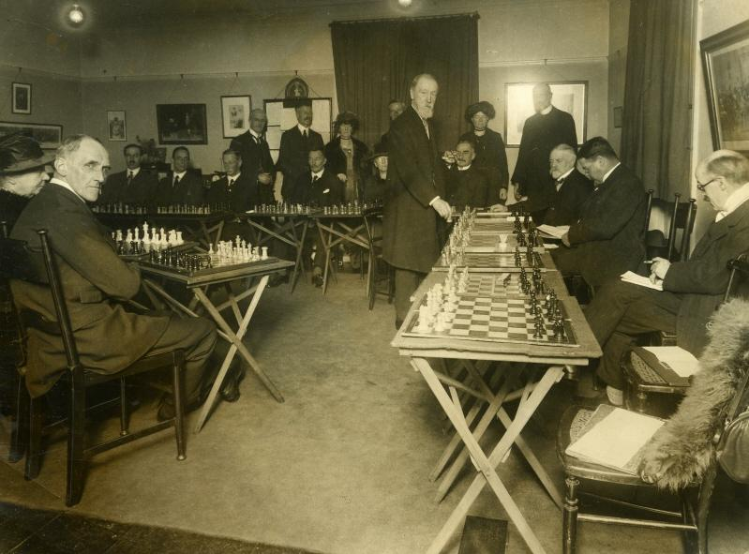

Blackburne giving a simul. It is said that at one simul an opponent had a glass of whiskey beside his board and that after making his move Blackburne downed the whiskey. His explanation – “My opponent left the whiskey en prise and I took it en passant.”

SOLUTION: 1.Qe4+!! Kxf7 2.Qxe6+ Kg6 3.Bd3+ Kg7 (4.. Kg5 4.Qg4#) 4.Qe7+ Kg8 5.Bc4#.

