2012 GIBRALTAR CHESS FESTIVAL

Shirov – Baron (Gibraltar 2012): Tal Baron (Israel)
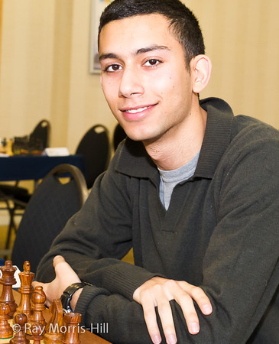
White to play and win (4 moves)

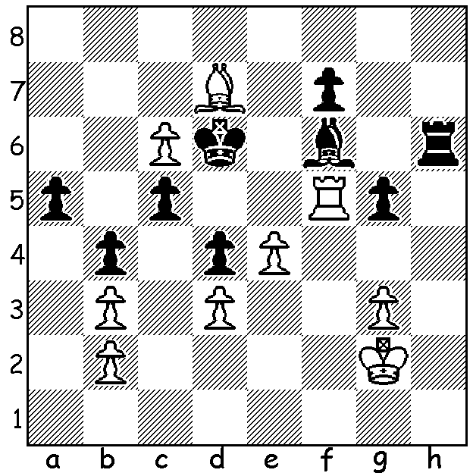

The main open event at the recently completed Gibraltar Chess Festival attracted a strong field with 10 players rated 2700 or above among the 256 competitors. As well as leading English internationals Michael Adams, Nigel Short and David Howell, the participation of the cricket loving Russian Peter Svidler, top Vietnam player Le Quang Liem, the attacking genius Alexy Shirov (Spain) and the legendary 80 year old Viktor Korchnoi all helped create a fitting 10th anniversary for the event. Below is an exciting confrontation between two of the most imaginative players in the competition in a game containing a breathtaking 10 move combination:

David Howell - Alexy Shirov Shirov & Howell at Gibraltar
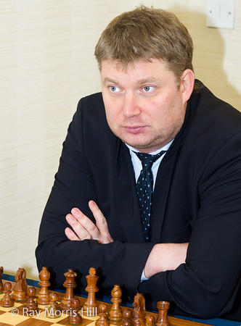
2012 Gibraltar Open
French Defence: Tarrasch Variation
1.e4 e6 2.d4 d5
3.Nd2 Nf6 4.e5 Nfd7
5.Bd3 c5 6.c3 Nc6
7.Ngf3(a) Rb8 8.a3 b5
9.Nf1 cxd 10.cxd b4
11.Ng3 bxa 12.bxa Ba6!(b)
13.0-0 Bxd3 1 4.Qxd3 Be7
15.Nh5 0-0 16.h4 g6
17.Nf4 Na5 18.h5 Rb3
19.Qd1 Qb6 20.Nd2 Rb5
21.hxg hxg 22.Qc2 Kg7
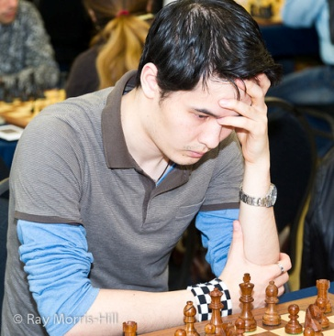
23.a4(c) Rb4(d) 24.Ba3 Qxd4!(e)
25.Qxg6+!!(f) fxg6 26.Nxe6+ Kf7
27.Nxd4 Rxd4 28.e6!+(g) Kxe6
29.Rfe1+ Ne5 30.Bxe7 Kxe7(h)
31.Rxe5+ Kd6 32.Re2(i)

a) Rather than 7.Ndf3 White plays a gambit line offering the d pawn after 7…Qb6 8.0-0, an offer Black declines, preferring to open lines on the queenside to counter White’s central domination and impending kingside attack.
b) Exchanging his bad bishop for White’s good bishop which would be aimed at the Black king after castling (13.Bxa6 Qa5+).
c) Threatening to trap the rook and creating enormous complications.
d) Not 23…Qxd4? 25.axb5 Qxa1 26.Bb2 Qa2 27.Ra1 trapping the queen.
e) Now if 25.Bxb4 Bxb4 26.Nd3 Bxd2 27.Qxd2 Nb3 winning.
f) A bolt from the blue! After this pseudo queen sacrifice White will seemingly finish a piece down. If 25.Nd3 Nxe5 26.Bxb4 Bxb4 27.Nxb4 Qxb4 with two pawns for the exchange and an excellent position.
g) A piece down with his knight attacked White is almost magically still able to gain equality.
h) If 30…Re8 or …Rf5 31.Nf3
i) After the fireworks of moves 23 – 32 the game has levelled out and subsequently drawn after 53 moves: 32…Rff4 33.Rae1 Rf6 34.Ra1 Rxd2! 35.Rxd2 Nb3 36.Rdd1 Nxa1 37.Rxa1 Kc5 38.Kf1 Re6 39.Re1! Ra6 40.Ra1 Kb4 41.Rd1 Kc5 42.Rc1+ Kd6 43.Ra1 d4 44.a5 Kd5 45.Ke2 Rc6 46.Kd2 a6 47.Rb1 Rc5 48.Rb6 Rxa5 49.Rxg6 Ra2+ 50.Kd3 Ra3+ 51.Kd2 a5 52.Rg8 Ra2+ 53.Kd3 draw.

SOLUTION: 1.Rxf6+! Rxf6 2.e5+! Kxe5 3.c7 / 4.c8=Q.

