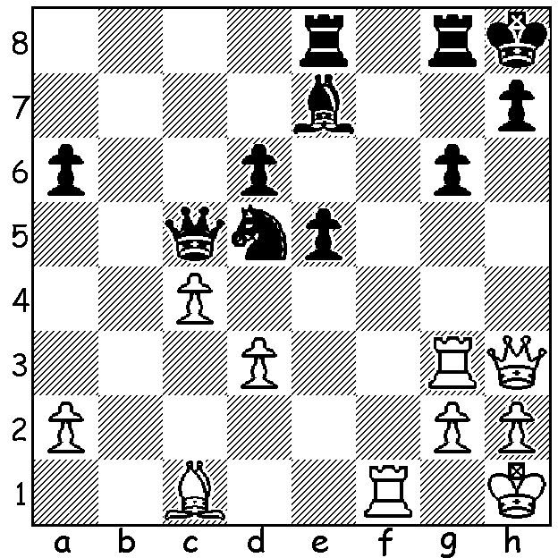



‘SHORT & SWEET’ (cont.)
Short – Ye Jiang Chuan 2004:
White to play & mate in 5.





Diagram 421

A few of the talented females pictured. How many can you name?

GIBRALTAR CHESS FESTIVAL (cont.)
Among the 256 players at the Gibraltar Masters were over 20 women including the strongest ever female Judit Polgar, world women’s champion 17 year old Hou Yifan as well as the female champions of China, Russia, Ukraine, India and USA. The tournament director Stuart Conquest said, “Never before have so many of the world’s top women joined leading male players to compete in the same tournament.”
The Festival celebrated its tenth year as well as the 60th anniversary of Queen Elizabeth’s accession to the British throne and it seemed fitting that the event was opened by beauty queen Miss Gibraltar and commemorative stamps issued to mark the event. An eagerly anticipated clash between Judit Polgar and Hou Yifan resulted in a win for the Chinese world champion with Hou Yifan going on to share first place with 8/10, defeating four players ranked in the top 50 in the world along the way. Here is her fine win against the very talented Le Quang Liem from Vietnam:

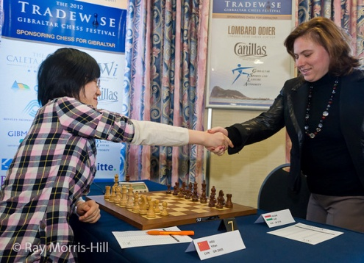

Hou Yifan - Le Quang Liem
2012 Gibraltar Masters, Rd 8
Sicilian, Scheveningen Variation
1.e4 c5 2.Nf3 d6
3.d4 cxd 4. Nxd4 Nf6

5.Nc3 a6 6.f4 e6
7.Be2 Qc7 8.0-0 Be7
9.Kh1 0-0 10.a4 Nc6
11.Be3 Re8 12.Bf3 Na5
13.Bf2 Nd7 14.Qe1 b6 Hou Yifan & Judit Polgar
15.e5 Bb7 16.Bg3 dxe
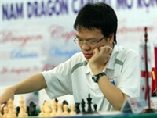

17.fxe Rac8 18.Rd1 Bb4
19.Qf2 Rf8(a) 20.Ne4 Nxe5
21.Bf4 Bxe4 22.Bxe4 Bd6
23.Nf3 f5 24.Bxe5 Bxe5
25.Bd3 Bxb2 26.Rb1 Bc3
27.Ng5 Qe7 28.Qe3 Nc4

29.Bxc4 Rxc4 30.Rxb6 Bd4
31.Qd3 Rxa4(b) 32.Rxe6 Qa3(c)
33.Qe2 h6(d) 34.Rxh6+! gxh6
35.Qe6+ Kg7 36.Qd7+ Kg6
37.Ne6 Bc5?(e) 38.Qg7+ Kh5 Le Quang Liem
39.Nxf8 Bxf8 40.Qf7+ resigns(f)

a) Black could play 19…Bxf3 with a possible continuation 20.Qxf3 Nxe5 21.Bxe5 Qxe5 22.Qxf7+ Kh8 23.Na2 Be7 24.c3 Bd6 25.Nf3 Qf4=.
b) Safer is 31…Rcc8 while if 31…Bxb6 32.Qxc4 Qxg5 33.Qxe6+ Kh8 34.Qxb6.
c) Bad would be 32…Qxg5 33.Qb3 threatening the rook and a devastating discovered check.
d) Allowing a sacrifice that cannot lose: 33…Bf6 sets White more problems – 34.Re8! Bxg5 35.Qe6+ Kh8 36.Qf7! Be7 37.Rxf8+ Bxf8 38.Qxf5 h6 39.Qxf8+=.
e) The losing move: 37…Rf7 38.Nf4+ Kg7 39.Nh5+ Kg8 40.Qe8+ Rf8 41.Qg6+ Kh8 42.Qxh6 Draw.
f) 40…Kh4 41.Qf6+ Kg4 42.Qg6+ Kh4 43.g3+ Kh3 44.Qh5 mating.

KINGSLEY OPEN (WA Grand Prix) tomorrow 12.30 – 7.30, Sun 10.30 - 6. Venue Moresby St. Centre (cawa.org.au for information). Register today for discount entry fee with Hadyn Barber hadix@vianet.net.au (ph) 93984242.

SOLUTION: 1.Qxh7+!! Kxh7 2.Rh3+ Bh4 3.Rxh4+ Kg7 4.Bh6+ Kh7/8 5.Bf8#.

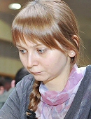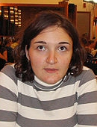

PICTURES of some of the FEMALE PLAYERS (names, countries & scores):

Top: Hou Yifan (China) 8/10, Zhu Chen (Qatar) 6.5
Anna Zatonskih (USA) 6.5, Irena Krush (USA) 5.5, Pia Crampling (Sweden) 6.5:

Middle: Humpy Koneru (India) 6, Anna Muzychuk (Slovenia) 6.5,
Judit Polgar (Hungary) 7, Antoaneta Stefanova (Bulgaria) 6.5:

Bottom: Jovanka Houska (Eng) 5.5, Nadezhda Kostintseva (Russia) 6.5,
Mariya Muzychuk (Slovenia) 6.5, Natalia Zhukova (Ukraine) 6, Nana Dzagnidze (Georgia) 6.

(I managed five)

