‘SHORT & SWEET’ (cont.)
Saleh Salem – Nigel Short (Gibraltar 2012, Rd 9): Black has just taken a pawn with 1…Nxc4 giving White the opportunity to be a piece up with 2.Bxc4. What had Black up his sleeve against this move (2/3 moves)?
Sasikarin begins his Rd 10 game with Short
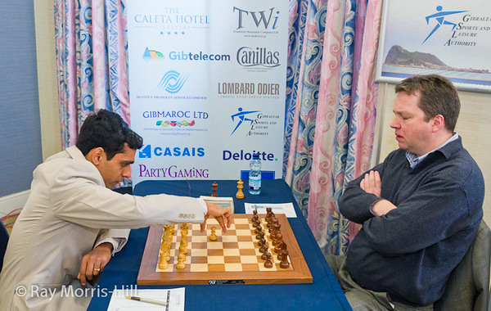
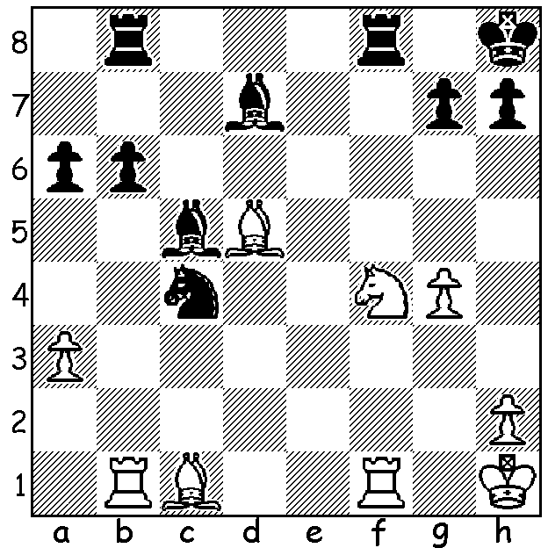

GIBRALTAR CHESS FESTIVAL (cont.)
As reported last week world women’s champion 17 year old Hou Yifan led throughout the Gibraltar Masters to finish with 8/10. However her final round draw with Shakhriyar Mamedyarov enabled English international and one-time challenger for Gary Kasparov’s world title Nigel Short to tie for top spot with a superbly played final round game against Indian number 2 Krishnan Sasikiran.

Krishnan Sasikiran - Nigel Short (picture above)
2012 Gibraltar Masters, Rd 10
Queens Pawn: Modern Benoni Defence
1.d4 Nf6 2.c4 e6
3.g3 c5(a) 4.d5 exd
5.cxd d6 6.Nc3 g6
7.Bg2 Bg7 8.Nf3 0-0
9.0-0 Nbd7 10.a4(b) h6
11.Qc2 Qe7 12.Ra3 a6
13.Nd2 Rb8 14.a5(c) b5
15.axb6 Nxb6 16.b3 Ng4
17.Bb2 f5 18.e3 g5
19.Raa1 Bb7 20.Rae1 Rbe8
21.h3 Ne5 22.f4 Ng6
23.Kh2 gxf 24.gxf Kh7
25.Nc4 Nxc4 26.bxc4 Bc8
27.Rf3 Rg8 28.Rg1 Bf6
29.Bh1?(d) Ne5! 30.Rfg3(e) Rxg3
31.Rxg3 Nxc4 32.Bc1 Bh4
33.Rf3 Qg7 34.Ne2 Nb6
35.e4?!(f) Rxe4! 36.Rb3 Re8!
37.Bf3(g) Bf2(h) 38.Bg4 Qg6
39.Rxb6 fxg4 40.Qxg6+ Kxg6
41.Rxd6+ Kf7 42.Ng3 Re1
43.Bd2 Rg1(i)
a) The Modern Benoni, one of the most aggressive defences against 1.d4. White gains a considerable space advantage but Black has opportunities to advance on the queenside or put pressure on Whites centre via the half-open e file. Sometimes Black might even work up a kingside attack.
b) Usual is 10.Nd2.
c) Preventing Black’s intended …b5/b4 pawn push.
d) This disastrous move, depriving the king of an escape square, is brilliantly exploited.
e) If 30.fxe5 Bxe5+ 31.Rf4 (31.Rfg3 Bxg3+ 32.Rxg3 33.Kxg3 Qxe3+ 34.Kh2 Qxf4+ 35.Kg1 Qg3+ 36.Qg2 Re1#) 31…Rxg1 32.Kxg1 Bxf4+ 33.exf4 Qe1+ 34.Kh2 Re3 35.Qg2 Re7! preparing 36…Rg7 & if 36.Na4 Re2 wins the queen.
f) White sets a trap but Black sees further.
g) The knight cannot be taken: 37.Rxb6? Rxe2+! 38.Qxe2 Qg1#.
h) Threatening 38…Rxe2! 39.Q/Bxe2 Qg3#.
i) White could now resign - 44.N moves g3+ wins a piece. Conclusion: 44.Rf6+ Kxf6 45.Ne4+ Kf7 46.Nxf2 Ra1 47.hxg4 Ra2 48.Be3 Bxg4 49.Kg3 Bf5 50.Bxc5 Ra5
White resigns

Magnus Carlsen Interviews.
Last Sunday CBS Sixty Minutes (USA) broadcast a London interview with world number 1 Magnus Carlsen. Check out on www.60minutes.com or via The Week in Chess. There are two Carlsen videos as well as a 60 Minutes interview with Bobby Fischer prior to his match with Spassky in 1972. Carlsen, who at 19 became the youngest world number 1 ever and claims to know 10,000 Grandmaster games, is seen taking on 10 opponents simultaneously blindfold. He is also shown as talented at soccer and tennis.

SOLUTION: 2…Rxf4! and if 3.Bxf4? Bc6# or 3.Rxf4 Bc6+ 4.Re4 Bxe4#.

