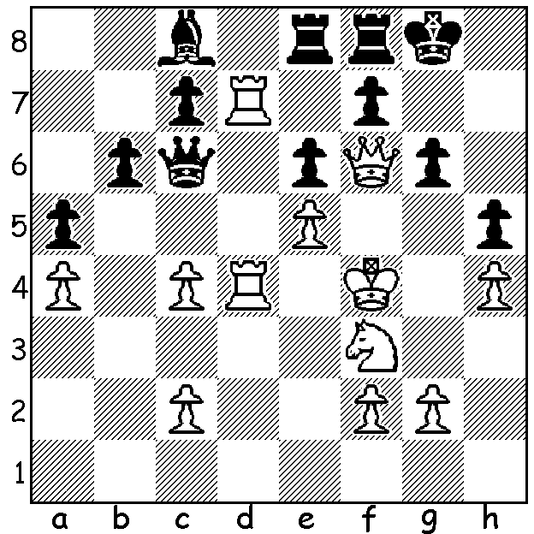
‘SHORT & SWEET’ (conclusion)
Nigel Short – Jan Timman 1991:
a famous position with White to play
& win (3 moves):

Diagram 423

GIBRALTAR CHESS FESTIVAL (conclusion)
After 17 year old world women’s champion Hou Yifan and former world title finalist Nigel Short tied on 8/10 a rapid-play play-off was won by the English international 1.5-0.5. This result continues a run of successes for Short who, with three first places, has not finished below =2nd/3rd in six years of competition at Gibralatar starting in 2003. Renowned for his aggressive approach, Short is often likely to spring an off-beat opening or defence to surprise and disconcert his opponent. Below is such an example from Gibraltar where he beats the Indian Humpy Koneru, the unsuccessful challenger for Hou Yifan’s world title last year:

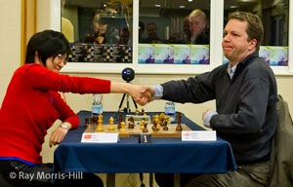
Hou Yifan agrees a draw conceding the
play-off to Nigel Short 2.5 – 1.5

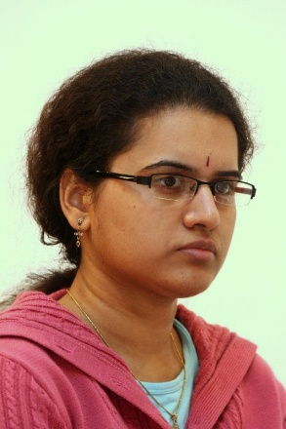
Humpy Koneru - Nigel Short
2012 Gibraltar Masters, Rd 6
Queens Pawn: Queens Knights Defence
1.d4 Nc6(a) 2.c4 e5
3.d5 Nce7 4.Nc3 Ng6
5.g3 a5 6.Bg2 Bc5
7.Na4 Bb4+ 8.Bd2 d6
9.Bxb4 axb4 10.b3(b) Bd7
11.Nb2 Ra3 12.Nf3 Qa8
13.Qb1 Nf6 14.0-0 Bg4
15.Nd1 0-0 16.Ne3 Qa5
17.Nc2 Bf5 18.Nfe1 Ra8 Humpy Koneru

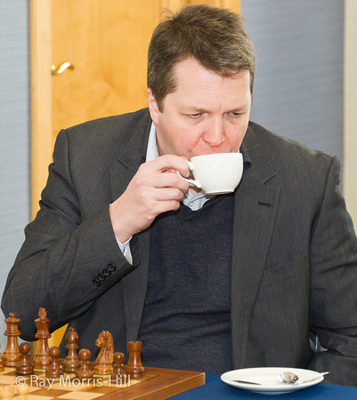
19.e4 (c) Bxe4 20.Bxe4 Nxe4
21.Nxa3 Nd2 22.Qc2 bxa3
23.b4 Qxb4 24.Nd3 Qa5
25.Rfd1 Nf3+ 26.Kg2 Nd4
27.Qd2 Qa6 28.Nb4(d) Qxc4
29.Rac1 Qb5 30.Rxc7 h6
31.Qc3 Ra4 32.Rxd4 exd4
33.Qf3 Qe8(e) 34.Rxb7 Ne5
35.Qb3 Ra8 36.Na6(f) Qd8
37.Nc7 Rc8 38.Nb5 d3
39.Nxa3 d2(g) 40.Nb1 Nc4
41.Qd3 Qa5 42.Re7(h) Qb4
43.Qf5 Rf8 44.Qc2 Rb8 Nigel Short
45.Nc3 Qb2 White resigns

a) Has this defence, a queenside version of Alekhines Defence (1.e4 Nf6 2.e5), ever been played in grandmaster chess before? I doubt it. The most challenging play now is 2.d5 Ne5 3.e4 e6 4.f4 Ng6 5.dxe. Other possibilities are 2.e4 when Black can play the Nimzovitsch Defence 2…d5 or 2…e5 the Kevitz-Mikensas Defence, which leads to lines similar to the game, or 2.Nf3. The move chosen leads to lines similar to the Two Knights Tango (1.d4 Nf6 2.c4 Nc6 3.d5).
b) 10.a3 exchanging her backward a pawn for Black’s isolated b pawn seems best.
c) This gains the exchange but Black gets two extra pawns.
d) White attempts to gain counter play by activating a rook.
e) Not 33...Ne5 34.Rc8+ Kh7 35.Qf5+ g6 36.Rxf7+=.
f) 36.Nd3 is demanded, blockading Black’s advanced passed pawn.
g) Even better is 39…Qa5 (40.Rb4 d2 41.Rb8 Rxb8 42.Qxb8+ Kh7 43.Qb1+ g6 44.Qb3 d1=Q 45.Qxd1 Qxa3).
h) The decisive error allowing Black’s queen to infiltrate: 42.a3 keeps White very much alive.

The WA OPEN CHAMPIONSHIP (7 rounds) will be held on weekends (Sat & Sun) March 10 – 18. Entries at cawa.org.au with enquiries to 9398 4242.

SOLUTION: Ignoring the attack on his rook White exploits the weakness on the black squares around Black’s king with 1.Kg5!! and if 1…Bxd7 2.Kh6! & 3.Qg7# (if 1…Kh7 2.Qxg6+ Kh8 3.Qh6+ Kg8 4.Kf6 or Kxh5 ).

