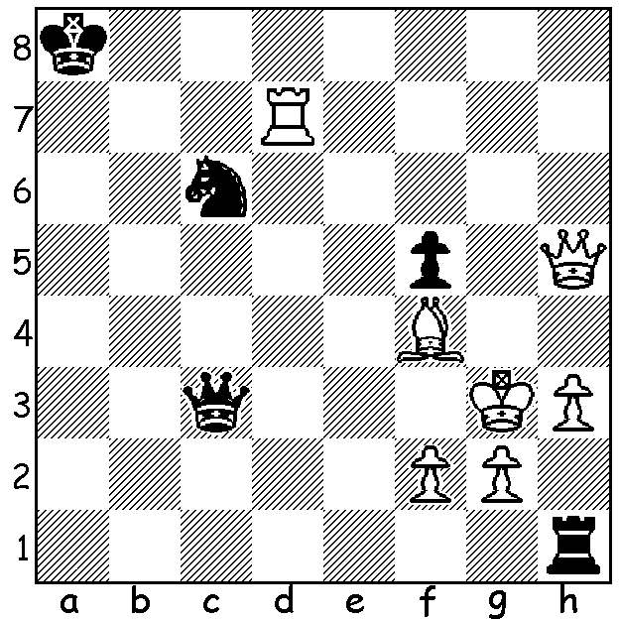
Klenora – Spence 2006:
After Black’s 1…Qc3+ White replies 2.Qf3
and Black resigns. A pity as he has a clever
forced draw. Can you see how (3 moves)?

Diagram 424

Although the reports on the Gibraltar Masters was concluded last week the game today also comes from that event. And what a game with a brilliant positional queen sacrifice!

Manuel Berg - Maxine Vachier-Lagrave
2012 Gibraltar Masters, Rd 10
Sicilian Najdorf, Poisoned Pawn Variation
1.e4 c5 2.Nf3 d6
3.d4 cxd 4.Nxd4 Nf6
5.Nc3 a6 6.Bg5 e6
7.f4 h6 8.Bh4 Qb6
9.Qd3 Qxb2 10.Rb1 Qa3
11.f5 Be7 12.fxe fxe
13.Be2 0-0 14.0-0 Kh8
15.Kh1 Nbd7 16.Nxe6!!(a) Ne5
17.Nxf8 Nxd3 18.Ng6+ Kh7
19.Bxd3 Kxg6(b) 20.e5+ Kh5(c)
21.exf6 Bxf6(d) 22.Bxf6 gxf6
23.Rb3 Qa5 24.Rxf6 Bd7
25.Ne4 Bg4(e) 26.h3 Rg8
27.hxg4+ Rxg4 28.Be2 Qe1+
29.Kh2 resigns(f)

a) Planning a queen sacrifice in which White secures a rook & a minor piece and an attack against Black’s exposed king.
b) Better is 19…Be8 when White might have nothing more than 20.e5 dxe 21.Nxe5+ Kg8 22.Bc4+ Kh7 23.Bd3+ Kg8 24.Bc4+ drawing.
c) 20…Kf7 seems preferable: eg 21.exf6 Bd8 22.Rb3 Qa5 23.Ne4.
d) 21…Qxc3 fxe7 looks scary but gives Black reasonable chances – 22…Bh3! 23.Be1 Qc6 24.Rf3 Be6.
e) White threatened 26.Be2+ Bg4 27.Rh3#.
f) Black loses everything after 29…Qxe2 30.Rh3+ Rh4 31.Rxh4+ Kxh4 32.Rf4+ Qg4 33.g3+! Kh5 34.Nf6+ Kg5 35.Nxg4.

The WA OPEN CHAMPIONSHIP (7 rounds) will be held over the next two weekends starting tomorrow and concluding Sunday March 18. Entries at cawa.org.au with enquiries to 9398 4242.

The (pre) Valentines Day Lightning, held on Sunday 12 February, finished in a tie for first place with WA champion Yita Choong and Tom Donaldson finishing with 9/11. Third was Michael Horstmann with 8 with junior George Carolin-Unkovich (7.5) gaining the Under 1850 award, Dylan Gough (6) the Under 1600 and Adam Kelly (5.5) the Junior.

The Kingsley Open (February 18/19) was won by WA’s top rated player Tristan Boyd (5.5/6) followed by Marc Vliestra (5), David Ellis and Akef Saleh (both 4). Jose Madriaga (4), a newcomer, gained the Under 1900 prize, Aleksa Petranovic and another newcomer George France (both 2.5) shared the Under 1600 prize with George Carolin Unkovich (2.5) the top junior.

SOLUTION: 2..Qg7+!! 3.Rxg7 Rxh3+! 4.K/gxh3 stalemate.
Can you believe a stalemate can occur after only 12 moves with all pieces still on the board?
1.d4 d6 2.Qd2 e5
3.a4 e4 4.Qf4 f5
5.h3 Be7 6.Qh2 Be6
7.Ra3 c5 8.Rg3 Qa5+
9.Nd2 Bh4 10.f3 Bb3
11.d5 e3 12.c4 f4 (Wheeler 1887).

