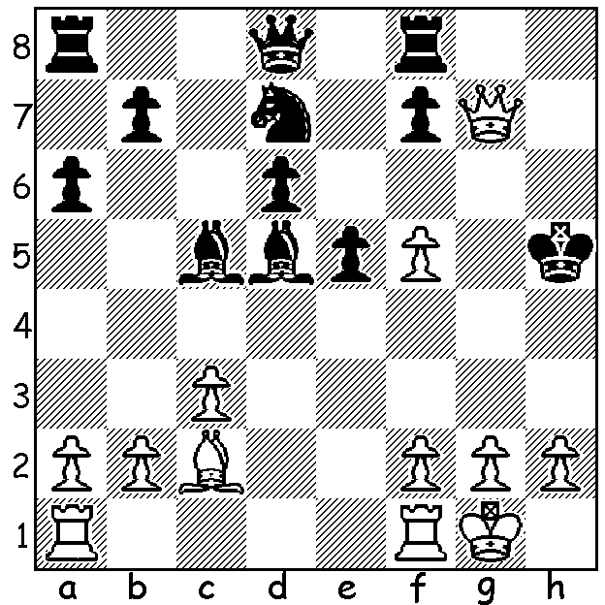

Diagram 425:

Sergey Karjakin – Peter Svidler
(Tal Memorial 2011):
Threatened with mate Black
finds a drawing resource:

On the previous two weeks games from the Gibraltar Masters have featured an unusual defence (1.d5 Nc6 Koneru – Short) and a positional queen sacrifice from Berg – Vachier-Lagrave. Today a game I saw in Malcolm Pein’s column in The Week in Chess which incorporates both an irregular defence and a positional queen sacrifice:

SARNAVSKY - SHTEMBULIAK
2012 Ukranian Under 20 Championship
English Opening
1.c4 a6 2.Nc3 b5(a)
3.cxd axb 4.Nxb5 e5
5.Nf3 Nc6 6.Qc2(b) Ba6
7.e4 Qb8! 8.Qc4(c) Nf6
9.Bd3(d) Nb4!!(e) 10.Nxc7+ Qxc7!!
11.Qxc7 Nxd3+ 12.Ke2?(f) Nxc1+
13.Kd1 Nd3 14.Kc2 Nxf2
15.Qxe5+ Be7 16.Rhc1 Nd3
17.Qd4 0-0 18.Kd1 Nxe4!
19.Rc3(g) Bf6 20.Qe3 Rfe8
21.Qb6 Rab8! 22.Qa7(h) Nef2+
23.Kc2 Rxb2#

a) A move you would be unlikely to find in an opening book.
b) Black obviously has some compensation for the pawn and White has to find the best way to develop. Perhaps White should consider the position a Sicilian Wing Gambit (1.e4 c5 2.b4) with colours reversed and develop as in the Sicilian Scheveningen with d3 / e3 / Be2 / Bd2 / a3.
c) 8.Nc3 looks the most natural but after 8…Bxf1 Kxf1 Black has positional compensation with two half-open files and White unable to castle.
d) Giving his e pawn needed additional protection but placing the bishop on a very vulnerable square.
e) Forcing White to win the queen to obtain a stranglehold on the position.
f) 12.Kd1 is best when Black could take the perpetual draw with 12…Nxf2+ 13.Ke1 Nd3+ 14.Kd1 Nf2+ or keep the game unsettled with 13…Nxh1.
g) Not 19.Qxe4? Nf2+.
h) If 22.Qxa6 Nef2+ 22.Kc2 Nb4+.

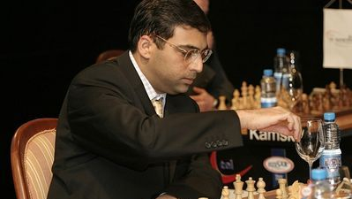
WORLD CHAMPIONSHIP:
The 12 game match between defending
champion Vishwanathan Anand and
challenger Boris Gelfand will take place
in Moscow, May 10th to 30^{th,} with a prize
fund of US$2,550,000. Anand, aged 42
and ranked 4th in the world, has been world
champion since 2007 when he won a world
championship reunification tournament in
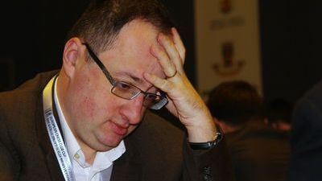
Mexico, scoring 9/14, ahead of ex-champion
Vladimir Kramnik and Gelfand (8), Peter
Leko (7), Peter Svidler (6.5), Alexander
Morozevich & Levon Aronian (6), Alexander
Grishchuk (5.5). Gelfand, aged 43 and ranked
22nd in the world, was born in Belarus but
emigrated to Israel. He won the right to
challenge after winning the 2011 Candidates,
eliminating in turn Shakhriyar Memedyarov,
Gita Kamsky and Alexander Grischuk.

WORLD CHAMPIONSHIP CANDIDATES: This tournament, to be played in London, October 24 to November 12, will decide the next challenger. Competing will be world number 1 Magnus Carlsen, Levon Aronian, ex-champion Vladimir Kramnik, Alexander Grischuk, Vassily Ivanchuk, Teimour Radjabov and the loser of the Anand-Gelfand match. FIDE president Kirsan Illyumzhinov has upset a number of top players and tournament organizers with the October dates with the possibility that a number of high-ranking events scheduled around that time will be cancelled, including the London Classic.

SOLUTION: 1…Bf3! (preventing 2.Bd1+ & if 2.gxf3? Rg8 wins the queen). White now had nothing better than 2.Qh7+ Kg5 3.Qg7+ Kh5 4.Qh7+ with draw by repetition.

