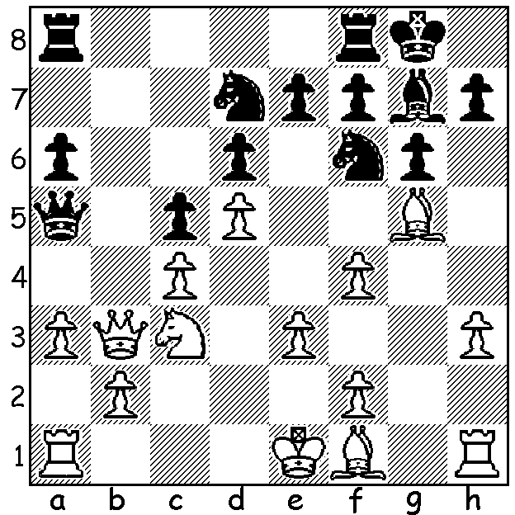
I receive the regular email bulletins from
The Australian Chess Federation which
give news and results worldwide (though
naturally concentrating on Australia) and
advertise events of possible interest to
readers. The most recent bulletin had the
added bonus of some most entertaining
games from the Begonia Open in Victoria,
a well patronized tournament with 131
players including 22 over 2100. Here is a
position from one of the games illustrating
the dangers of grabbing a b pawn and falling
behind in development:
(Cameron – Scharrer) Black to play and win
(5 moves): Diagram 427

And here are a couple of games from the event, the first with a sparkling finish, the second with an advanced passed pawn trying to compensate for a material deficit:

Guy West - Alistair Anderson
Bishops Opening


1.e4 e5 2.Bc4 Nf6
3.d3 Nc6 4.Nf3 h6
5.0-0 Be7 6.c3 d6
7.Bb3 0-0 8.Re1 Bg4
9.h3 Bh5 10.Nbd2 Re8
11.Nf1 Bf8 12.Ng3 Bg6
13.Nh4 Bh7 14.Qf3 a6
15.Nhf5 Na5 16.Bc2 b5
17.b4 Nb7 18.a4 c6
19.Bb3 Rc8 20.axb axb
21.Ra7 Rc7 22.Be3 c5
23.Rea1 Bxf5 24.Nxf5 Kh7
25.Bd2 g6 26.Ne3 Qe7
27.g4 g5 28.Nf5 Qd8
29.Kg2 Bg7 30.h4 gxh Guy West at the Queenstown
31.Rh1 Rh8 32.Rxh4 Ng8 Classic, New Zealand, 2006.
33.g5 Qd7 34.Ne7!!(a) f6
35.g6#

a) A brilliant sacrifice – if 34…Nxe7 (34...Qxe7 Qf5#) 35.Rxh6+! Bxh6 (35.Kg8 36.Qxf7#) 36.Qxf7+ Bg7 37.Qh5+Bh6 38.Qxh6#.

George Xie - Malcolm Pyke
French Defence, Tarrasch Variation

1.e4 e6 2.d4 d5
3.Nd2 Nf6 4.e5 Nfd7
5.Bd3 c5 6.c3 Nc6
7.Ne2 cxd 8.cxd f6
9.Nf4 Nxd4 10.Qh5+ Ke7
11.exf+ Nxf6 12.Ng6+ hxg6
13.Qxh8 Kf7 14.Qh4 e5
15.Nf3 Nxf3+ 16.gxf3 Bf5
17.Bxf5 gxf5 18.Bg5 Be7
19.0-0-0 Rc1+ 20.Kb1 Qb6
21.Bxf6 Bxf6 22.Qa4 Rd8
23.Rd2 a6 24.Rhd1 d4
25.Rd3 Qe6 26.Rb3 b5
27.Qa5 Rd6 28.Qc7+ Kg8
29.Rc1 e4 30.fxe fxe
31.Rg3 Be5 32.Rg5 Bf6
33.Rg6 e3 34.Rcg1 Qf5+
35.Ka1 Qxg6!? 36.Rxg6 exf2
37.Qc8+ Kf7 38.Rxf6+ Rxf6
39.Qd7+ Kf8 40.Qd8+ Kf7
DRAW

The Gufeld Cup (WA Grand Prix event) will be held this weekend (11 - 6.30 Sat, 11.30 -7 Sun). Enter today for $10 discount on entry fee hadix@vianet.net.au or 9398 4242.

SOLUTION: 1…Nxd5! wins: if 2.cxd Rfb8 3.Qc2 Rxb2! 4.Qc1 Bxc3+ 5.Kd1 Qa4+.

