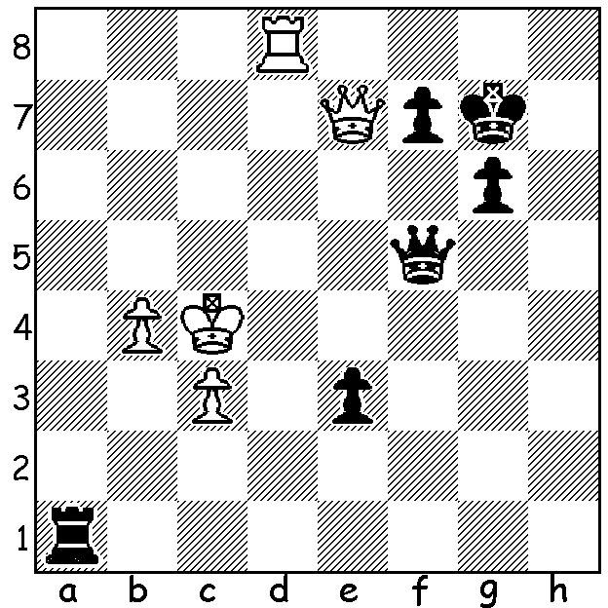

Diagram 428:
Boris Savchenko – Gawain Jones
(European Championship 2012).
Black to play and win (4 moves)

The European Championship played in Bugaria March 20 – 31 was won by 28 year old Russian Dmitry Jakovenko with 8/11 who defeated and overtook Frenchman Laurent Fressinet in the final round. Round 2 brought together two of the most talented teenagers in the world, 17 year old Dutch champion Anish Giri who has already played in tournaments with the select super grandmasters and 15 year old Ukranian Ilya Nyzhnyk:

Ilya Nyzhnk - Anish Giri
2012 European Championship, Rd 2
Catalan Queens Gambit
1.d4 Nf6 2.c4 e6
3.Nf3 d5 4.Nc3 c6
5.g3 dxc 6.Bg2 b5
7.Ne5 a6 8.a4 Bb7
9.0-0 Be7 10.axb axb
11.Rxa8 Bxa8 12.Nxb5 cxb5
13.Bxa8 0-0 14.Bg2 Nd5
15.f4 Bd6 16.e3 Bxe5
17.fxe5 Nc6 18.Qg4 Qd7
19.h4 Ncb4 20.h5 Nd3(a)
21.h6 f5 22.exf6 Rxf6?(b)
23.Bxd5 Rxf1+ 24.Kxf1 Qf7+
25.Bf3 Nxc1 26.d5! Nd3(c)
27.dxe Qe7 28.Bd5 Kf8
29.Qxg7+ resigns(d)

a) Better 20…f5 21.exf6 Nxf6 22.Qh4 h6.
b) This loses: Black should play 22…Nxf6! and after 23.hxg Rf7=.
c) If 26…exd 27.Kg2! wins: 27…Kf8 (27…g6 28.Qc8+ Qf8 29.Bxd5+ Kh8 30.Qxf8#) 28.Qc8+ Ke7 29.Qc7+ Ke8 30.Qb8+ Ke7 31.Qe5+ Kf8 32.Qd6+ Ke8 33.Bxd5 Qe7 34.Qxe7+ Kxe7 35 hxg.
d) 29…Qxg7 30.hxg7+ Kxg7 31.e7 queens.

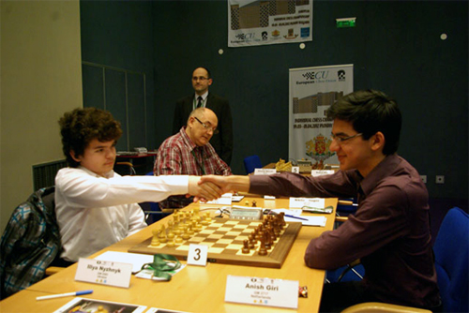

Ilya Nyzhnk &
Anish Giri (rt)
Shake hands
before their
game in the
European
Championship

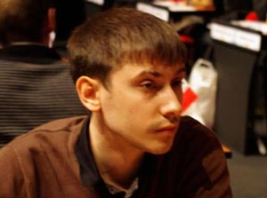
Dress Code: The European Championship
followed recent European Chess Union dress
code regulations which seek to enforce clean
tidy clothing for the men and modest, non
revealing dress for the women. One rule I
might take exception to is the banning of
headwear for men except for religious reasons.
For the shaven headed players (of which I am
one) the thought of not being allowed a beanie
in a particularly cool air-conditioned room
does not appeal.

European champion Dmitri Jakovenko

The Gufeld Cup (WA Grand Prix event) held late last month was won convincingly by Tom Donaldson (5/6) who after winning his first four games drew his final two and still won by a point. Equal second were WA Open champion Akef Saleh, Albert Chin, Marc Vliestra, Gordon Dunlop and David Ellis, all with 4/6. Good to see Albert, who went through undefeated, back playing. Gordon also was unbeaten with his best result for some time. Albany player Gary Donaldson (3/6) took out the Under 1500 rating prize.

The Perth Open (WA Grand Prix) starts tomorrow at N. Woodvale Primary, Trappers Dr., Woodvale at 10am. Rounds 4-6 on Sunday , 10am start. Information on cawa.org.au and entry 9409 9579 or norbert.muller@iinet.net.au

SOLUTION: 1…Qe6+ (simplification) if 2.Qxe6 fxe6 3.Kd3 (the spite check 3.Rd7+ achieves nothing) 3…Rd1+ (skewer) 4.Kxe3 Rxd8

