Diagram 429: Ahmed Hamed – Anand 1984:
Black to play wins material (3 moves):

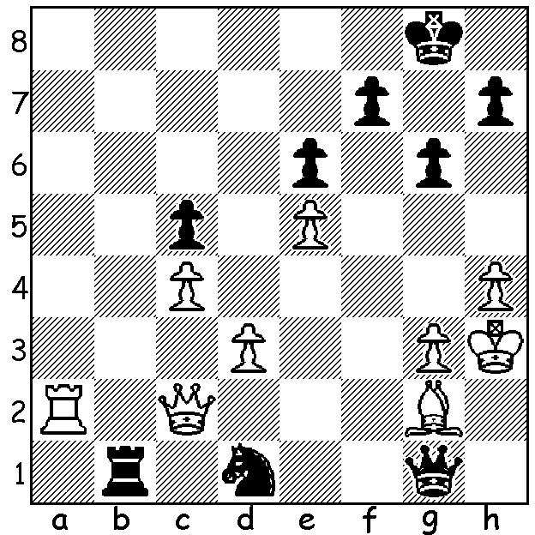

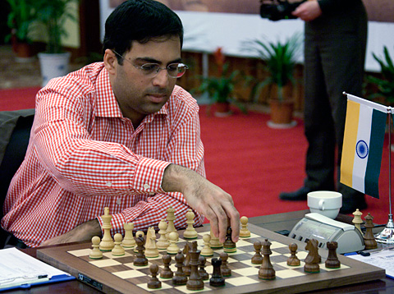
With the 12 game World Championship match
between champion Viswanathan Anand
(India) and challenger Boris Gelfand (Israel)
due to start on May 10th it seems appropriate to
look at these two adversaries, firstly the champion.
Anand, aged 42, now ranked 4th in the world, held
the number 1 spot for 15 months 2007-08 and has
been described by renowned chess writer Lubomir
Kavelek as the most versatile world champion ever,
having has won the title in tournament, match,
knockout and rapidplay competition. He is
considered India’s greatest sportsman (ahead of Viswanathan Anand
cricket great Sachin Tendulkar) and was the only
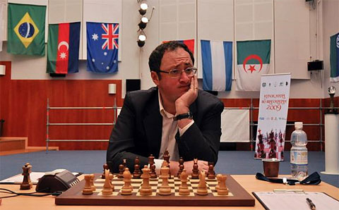
sportsman to be awarded the Padna Vibhushan
award, the second highest Indian civilian award.
He was born on December 11, 1969 to high caste
parents and grew up in Chennai (Madras). He was
taught to play at the age of six by his mother. He
was the youngest Indian to become an International
Master at 15 and he became India’s first Grandmaster
aged 17. He won the Indian championship for the first
time when 16 and became World Junior champion at
18. He broke into the elite ranks in 1991 when he
won the Reggio Emilia tournament ahead of Anatoly
Karpov and Gary Kasparov. Boris Gelfand

(Next week his progress to world champion.)

Teimour Radjabov - Viswanathan Anand
2002 FIDE Grand Prix
Queens Indian Defence (4.a3)
1.d4 Nf6 2.c4 e6
3.Nf3 b6 4.a3 Bb7
5.Nc3 d5 6.cxd Nxd5
7.Qc2 Be7 8.e4 Nxc3
9.bxc3 Nd7 10.Bd3 c5
11.0-0 0-0 12.Bb2 Rc8
13.Qe2 c4(a) 14.Bxc4 Bxe4
15.Ba6 Bxf3 16.Qxf3 Rc7
17.Rad1 Bd6 18.Bd3 b5!
19.Rfe1(b) a6 20.a4!(c) bxa
21.c4 Qb8 22.Ba1 Rd8
23.Re4(d) Nf6 24.Rh4 Be7
25.Rh3 h6 26.Rb1?(e) Rxc4!!
27.Rxb8(f) Rc1+ 28.Bf1 Rxb8
29.Bc3 Rbb1 30.Qd3(g) a3
31.Qxa6(h) a2 32.g4(i) Rxf1+
33.Qxf1(j) Ne4 34.Ba1 Nd2
White resigns

a) An innovation getting rid of one of White’s centre pawns.
b) Not 19.Bxb5 Qb8 20.Bxd7 Qxb2 nor 19.Qh5 g6 20.Qxb5 Qb1 21.Qxb1 Rxb1, in both cases Black has strong queenside pressure.
c) A pawn sacrifice to be able to advance his c pawn and train both bishops on Black’s king.
d) White plays thematically for a kingside attack. However 23.c5 Be7 24.Bc3 was better putting Black under pressure on the other wing.
e) This natural move meets a stunning refutation which leaves Black a queen to a rook down but with a winning position.
f) 27.Qd1 avoids a speedy loss but White will still lose after 27…Rb4.
g) 30.Qa8+ Bf8 31.Qxa6 Ne4 is no better for White.
h) If 31.g4 a2 32.Kg2 Nd5 (threat 33…Nf4+) 33.Qxa6 Nf4+ 34.Kg3 Rxc3+ 35.Kxf4 Rxh3 36.Bxh3 a1=Q or 36.Qxa2 Rxf1 wins.
i) If 32.g3 Rxf1+ 33.Kg2 Rxf2+! 34.Kxf2 Ne4+ 35.Kg2 Nxc3 wins.
j) 33.Kg2 loses to 33…Rg1+ 34.Kf3 Rb3.

SOLUTION: 1…Ra1! (deflection sacrifice): 2.Rb2 loses the exchange while 2.Rxa1 loses the queen to 2…Nf2, in both cases leaving Black with a winning material advantage.

