Diagram 430: Beliavsky-Anand 1991.
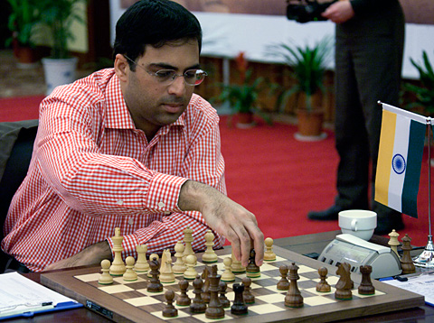
Both sides have breached the defences
around their rival king but it’s Black who
gets in first with a mate in 5.

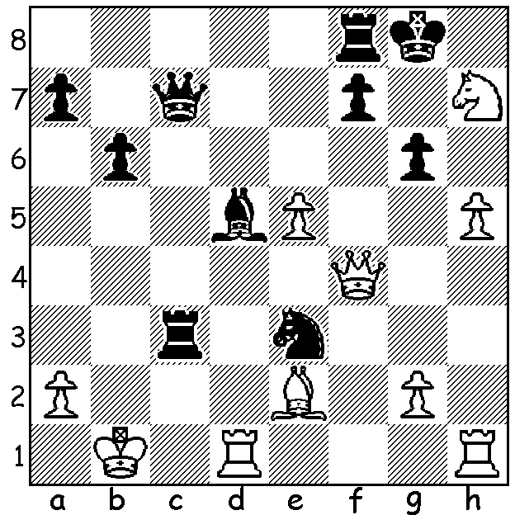

Viswanathan Anand: World Champion

Viswanathan Anand’s quest for the world championship began in earnest in 1993 when he reached the quarter-final of the FIDE Candidates’ quarter final, losing to ex-world champion Anatoly Karpov. However soon afterwards he won through to the final of the Professional Chess Association Candidates, defeating Gata Kamsky to qualify to challenge Gary Kasparov, who was generally considered world champion. Anand started well in their 1995 match winning Game 9 after 8 draws but lost four of the next five to lose 7.5-10.5. He won the FIDE world championship title in 2000 (although Kasparov’s conqueror Vladimir Kramnik was seen as world champion by the chess public) and won the undisputed title in 2007 in an eight player reunification tournament with 9/14, a point ahead of Kramnik and Boris Gelfand. Since then he has defended his title twice, once against Kramnik 6.5-4.5 in 2008 and once against Veselin Topalov 6.5-5.5 in 2010.

Viswanathan Anand - Ivan Sokolov
Played 1992
Sicilian: Kan Variation
1.e4 c5 2.Nf3 e6
3.d4 cxd 4.Nxd4 a6
5.Nc3 d6 6.a4 Nf6
7.Be2 Nbd7 8.0-0 Nc5
9.Bf3 Be7 10.g3 0-0
11.Bg2 Qc7 12.Be3 Rb8
13.f4 Re8?(a) 14.e5 dxe
15.fxe Nfd7 16.Rxf7!! Kxf7(b)
17.Qh5+ Kf8 18.Rf1+ Nf6(c)
19.exf6 Bxf6 20.Ndb5! axb5
21.Nxb5 Qd7(d) 22.Qxh7 Qe7
23.Rxf6+! Qxf6 24.Bxc5+ Re7
25.Qh8+ Kf7 26.Nd6+ resigns

a) Fatally leaving the Black king as the only defender of f7. 13…h5, securing the square g4 for the knight, was better.
b) Declining the sacrifice with 16…Nf8 was marginally better (17.Qh5 Ng6 18.Raf1 Qxe5 19.Qxe5 Nxe5 20.Rxe7! Rxe7 21.Bf4 Ncd7 22.Bh3 and Black is tied up facing many threats).
c) If 18…Bf6 19.exf6 Nxf6 20.Rxf6+! gxf6 21.Nf5! wins (21…exf5 22.Bh6+ Ke7 23.Nd5+)
d) If 21…Qf7 22.Bxc5+ Kg8 23.Qxf7+ Kxf7 24.Nd6+ Kf8/e7 25.Nxc8+ wins.
26…Kg6 27.Be4 Kg5 28.Qh4#.

The SOUTH WEST OPEN will be played in Bridgetown, 16th & 17th June. Entry at cawa.org.au with enquiries to 9409 9579. Book accommodation early if intending to play.

The METROPOLITAN CHESS CLUB OPEN will be a 7 round Swiss, played on successive Thursdays from May 24 to July 7. Please contact Kelvin Taylor on 9381 7854.

SOLUTION: 1…Rb3+! (a clearance sacrifice) 2.axb3 Qc2+ 3.Ka1 Qc3+ 4.Ka2/b1 Qxb3+ 5.Ka1 Qa2#/Nc2# or 5.Kc1 Qc2#.

