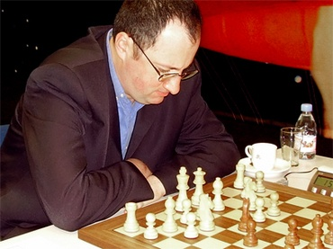
Diagram 431: Gelfand – Nikolic 1994:
Black’s g pawn is a threat but White’s three
attacking pieces ensure a win (4 moves):

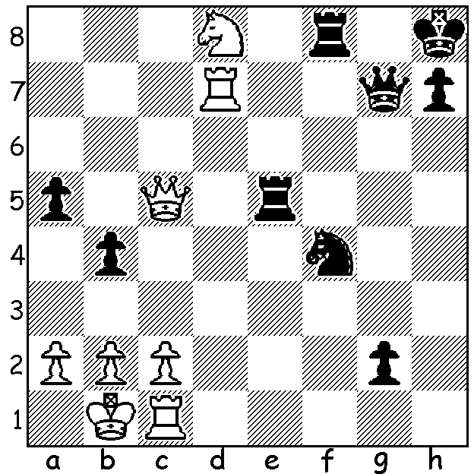

BORIS GELFAND CHALLENGER
Boris Gelfand, who qualified to challenge Viswanathan Nathan for the world title after defeating Russian Alexander Grischuk 3.5 – 2.5 in the final of the 2011 Candidates tournament, was born in Minsk, Belarussia, on June 24, 1968, making him a year and a half older than champion Anand. Gelfand was junior champion of USSR and European junior champion before coming 1st= in the 1988 world junior championship (Frenchman Joel Lautier awarded title on countback). He emigrated to Israel in 1998. He has played in nine Olympiads (for USSR once, Belarus twice & Israel six times) and has won around 30 top ranking tournaments including Wijk aan Zee in 1992 & 1994. His present rating is 2727, ranked 22nd in the world (Anand is 4th) while his highest rating was 2761, ranked 7th, in January 2010.

Boris Gelfand – Lubomir Ftacnik
Debrecen 1989: Grunfeld Defence, Exchange Variation
1.d4 Nf6 2.c4 g6
3.Nc3 d5 4.cxd Nxd5
5.e4 Nxc3 6.bxc3 c5
7.Nf3 Bg7 8.Rb1(a) 0-0
9.Be2 Nc6 10.d5 Ne5
11.Nxe5 Bxe5 12.Qd2 b6
13.f4 Bg7 14.c4 e5
15.0-0 f5(b) 16.Bb2 Qd6
17.Qc3 Re8 18.Bd3 Re7
19.exf gxf 20.fxe Bxe5
21.Qd2 Bxh2+ 22.Kh1 Be5
23.Qg5+ Qg6 24.Qxe7 Qh6+
25.Kg1 Qe3+ 26.Kh1 Qh6+
27.Kg1 Qe3+ 28.Rf2!!(c) Bh2+
29.Kxh2 Qxe7 30.Rf3 Qd6+(d)
31.Rg3+ Kf7 32.Rf1 h5(e)
33.Bxf5 h4(f) 34.Bg6+ Kg8(g)
35.Bh7+! Kxh7 36.Rf7+ Kh6
37.Bc1+ resigns(h)

a) A useful move removing the rook from the line of Black’s fianchettoed bishop. However White may have to sacrifice his a pawn in some variations.
b) Less confrontational is 15…exf 16.Qxf4 Qe7 17.Bb2 Bd7 18.Bd3 Bxb2 19.Rxb2 f6=.
c) A brilliant queen sacrifice which deprives Black of the draw by repetition.
d) After 30.,,Bd7 White maintains an attack with 31.Rf1.
e) If 32…Ke7 33.Re1+ and White can break the pin by Be5.
f) If now 33..Ke7 34.Bxc8 Rxc8 35.Re1+ Kd7 36.Be5 winning (36…Qh6 37.Rg7+ Kd8 38.Rf1).
g) Does this position seem familiar? It was the puzzle May 20th last year.
h) 37…Kh5 38.Rh7+ Qh6 39.Rxh6#.

The SOUTH WEST OPEN will be played in Bridgetown, 16th & 17th June. Entry at cawa.org.au with enquiries to 9409 9579. Book accommodation early if intending to play.

The METROPOLITAN CHESS CLUB OPEN will be a 7 round Swiss, played on successive Thursdays from May 24 to July 7. Players from other clubs welcome. Please contact Kelvin Taylor on 9381 7854.

SOLUTION: 1.Nf7 +! (a deflection and clearance sacrifice): if 1…Rxf7 2.Rd8+ Rf8 3.Rxf8+ Qxf8 4.Qxf8# (if 1…Qxf7 2.Rxf7 Rxc5 3.Rxf8+ Kg7 4.Rxf4).

