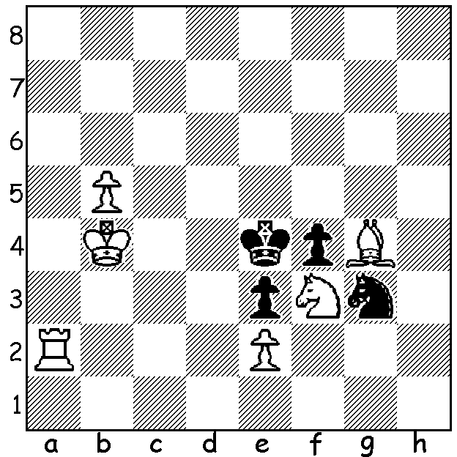
The Perth Open, played at the Perth Club’s rooms at
Kingsley last month, was won by Leon Taylor (5.5/6).
Second was newcomer Brian Chapula (5) and equal 3rd
Robert Maris & Tom Donaldson (4). Two other
newcomers, Aileen Fisher & Oladoyin Fasakin, shared
the Under 1750 prizes with Fred Maris (all 3/6). DOP
Norbert Muller challenged competitors with the problem
below (white to play & mate in 3). Tom Donaldson and
I were the two players able to solve it and win the
welcome additional prizes (advice in problem solving –
there will likely be sacrifices):
Diagram 433

The Metropolitan Championships finished recently with the A Division joint winners being WA champion Yita Choong and Marc Vliestra (6/9). Equal third were Ihsan Ferozkohi, Peter Roza & David Ellis (5). Other division winners: B – Robert
Baumgartner (undefeated with7.5/9): C – Keith Jenkins (7.5/9): D – Bob Pilgrim (undefeated with 5.5/7): E – Peter Zylstra (9/9). Congratulations to all, especially Peter Zylstra in probably his best ever result over many, many years and to fellow veteran Bob Pilgrim. Here is the key game between the joint champions:

Marc Vliestra - Yita Choong
2012 Metropolitan Championship
Sicilian Najdorf
1.e4 c5 2.Nf3 d6
3.d4 cxd 4.Nxd4 Nf6
5.Nc3 a6 6.Bg5 e6
7.f4 Qc7 8.Qf3 b5
9.0-0-0 b4 10.Nd5(a) exd5
11.Bxf6 gxf6 12.exd Bg7
13.Bd3 f5(b) 14.Rhe1+ Kf8
15.Nxf5 Bxf5 16.Bxf5 Nd7
17.Rd3(c) Nc5 18.Rde3 Na4
19.Re7 Qxe7 20.Rxe7 Kxe7(d)
21.Qe4+ Kf8 22.Qxb4 Nc5
23.Qb6 Bd4 24.Qxd6+ Kg7
25.c3 Be3+ 26.Kc2 Rhe8
27.b4 Rad8 28.Qc7 Rxd5
29.bxc5 Rxc5?(e) 30.Qd7 Rec8
31.Qxc8 Rxc8 32.Bxc8(f)

a) A thematic sacrifice.
b) Black judges it too dangerous to castle.
c) Possible was 17.Bxd7 Qxd7 18.Re4.
d) Black, in trying to maintain his material advantage, misses a chance of a strong counter-attack with 20…Bxb2+! and if 21.Kb1 Kxe7 22.Qb3 Bc3 23.Qxa4 Rhe8! 24.Qd7+ Kf6! with mating threats on the back rank.
e) Clearly 29…Rxf5 was the move, meeting 30.Qd7 with 30…Re6.
f) Black has a clearly lost game and capitulated after 32…a5 33.f5 Bf4 34.g3 Be5 35.Kd3 f6 36.c4 Kf437.Ke4 Ke7 38.Kd5 Bc7 39.Kc6 Kd8 40.Be6 h6 41.Kb5 Ke7 42.c5 Kd843.g4 Bxh2 44.Kxa5 Bb8 45.Kb6 Bc7+ 46.Kb7 Ba5 47.a4 Bc7 48.Kc6 Ba5 49.Kb5 Bc7 50.a5 Bb851.Kc6 Ba7 52.a6 resigns

WORLD CHAMPIONSHIP: The first four games of the world championship between champion Viswanathan Anand and challenger Boris Gelfand were drawn. Of these Game 3 was the most exciting with castling on opposite sides and Anand with an extra passed pawn on the 6th being unable to stop Gelfand gaining a perpetual check with doubled rooks on the 7th.

SOLUTION: 1.Ra3! (threatening 2.Rd3 & 3.Rd4#: attempts to reach d4 via the 8th rank fail to 1…Nc5 and if 1.Ra1 Nc1!) 1…Nxe2 (the king cannot run) 2.Rd3!! Kxd3 3.Bf5#.

