Diagram 434: Anand-Gelfand 2012:
Black now plays 1…Qf6.
How should White respond?

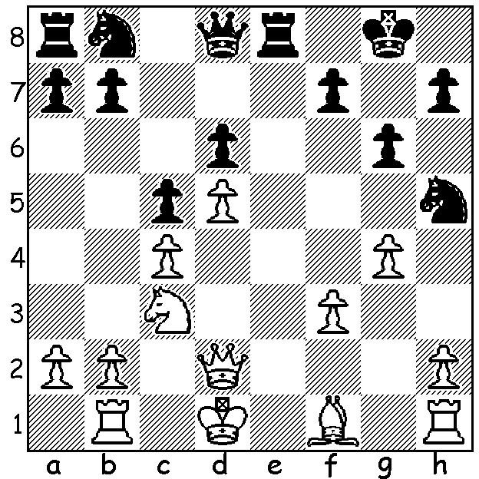

After six draws in the 12 game World Championship match the impasse was broken with Gelfand winning Game 7 with a queenside attack, his first win against Anand since 1993. However his lead was short-lived with Anand winning Game 8 in 17 moves after Gelfand blundered badly. Here is the tense Game 3:

Viswanathan Anand - Boris Gelfand
2012 World Championship, Game 3
Queens Pawn, Pseudo-Grunfeld
1.d4 Nf6 2.c4 g6
3.f3 d5 4.cxd Nxd5
5.e4 Nb6 6.Nc3 Bg7
7.Be3 0-0 8.Qd2 e5
9.d5 c6 10.h4 cxd(a)
11.exd Nbd7 12.h5 Nf6
13.hxg fxg 14.0-0-0 Bd7
15.Kb1 Rc8 16.Ka1(b) e4!
17.Bd4 Na4 18.Nge2 Qa5
19.Nxe4(c) Qxd2 20.Nxf6+ Rxf6
21.Rxd2 Rf5 22.Bxg7 Kxg7
23.d6 Rfc5(d) 24.Rd1 a5
25.Rh4! Rc2 26.b3 Nb2(e)
27.Rb1(f) Nd3 28.Nd4 Rd2
29.Bxd3 Rxd3 30.Re1 Rd2
31.Kb1 Bf5+ 32.Nxf5 gxf5
33.Re7+ Kg6 34.Rc7 Re8
35.Rh1(g) Ree2 36.d7 Rb2+
37.Kc1 Rxa2 DRAW

a) 10…h5 could be played to slow up White’s intended kingside attack.
b) 16.d6, 16.Nh3 or 16.g4 were alternatives.
c) If 19.fxe Nxc3 20.Bxc3 (20.Nxc3 Nxe4! 21.Nxe4 Qxd2 22.R/Nxd2 Bxd4 regaining the piece) 20…Qa4 with a strong attack if White plays 21.e5 (21…Rxc3! 22.bxc3 Bxe5).
d) 23…Nb6 and rounding up the d pawn was expected. Instead Black ignores White’s dangerous passed pawn to attack White’s king.
e) 26…Nb6 was still possible.
f) White chooses the safe option. 27.Rdd4 would give both sides more chances of victory (27…a4 28.bxa b5!? and it gets wild).
g) White could play 35.Re7 and after 35…Rc8 search for an alternative to 36.Rc7.

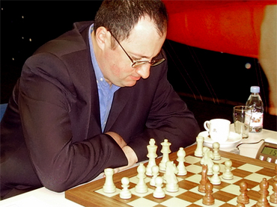
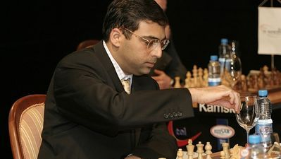

FOUNDATION DAY OPEN (6 round CAWA & ACF Grand Prix event, 90 mins + 30 sec) will be played Sat 2, Sun 3 & Mon 4 June at the Moresby St Centre. Details at

SOLUTION: Game 8: after 1…Qf6?? White played 2.gxh5! and now after 2…Qxf3+ 3.Kc2 Qxh1 4.Qf2 (threat 5.Bd3 trapping the queen) Black resigned. He can save the queen by 4…Nc6 5.dxc6 (not 5.Bd3? Nd4+) 5…Qxc6 but after 6.Bg2 his position is hopeless with White able to mount a decisive kingside attack. Full score: 1.d4 Nf6 2.c4 g6 3.f3 c5 4.d5 d6 5.e4 Bg7 6.Ne2 0-0 7.Nec3 Nh5 8.Bg5 Bf6 9.Bxf6 exf6 10.Qd2 f5 11.exf Bxf5 12.g4 Re8+ (better 12…Bxb1 13.Rxb1 Qh4+ 14.Kd1 Nf6/g7) 13.Kd1 Bxb1
14.Rxb1 Qf6?? 15.gxh5! Qxf3+ 16.Kc2 Qxh1 17.Qf2 resigns.

