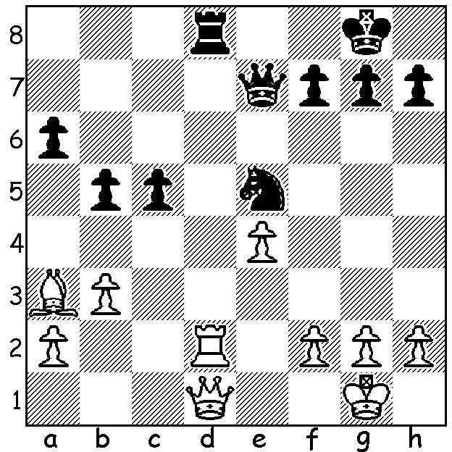

Diagram 435:
Javier Gil Capape -
Viswanathan Anand 1966:
How does Black win (3 moves)

2012 WORLD CHAMPIONSHIP
After the two decisive games, Gelfand’s win in Game 7 and Anand’s in Game 8, the remaining four games were drawn leaving the score at +1, =10, -1 for each player. The contestants now play 4 games of Rapid Play (25 mins with 10 secs per move for each player) and, if the score is still level, two games of Blitz (5 mins + 10 secs per move) will be played and repeated until a winner emerges. Of the final four draws Game 9 was the hardest fought and most interesting with Anand fighting to hold an endgame with rook, knight and pawn for the queen:

Boris Gelfand - Viswanathan Anand
2012 World Championship, Game 9
Nimzoindian Defence
1.d4 Nf6 2.c4 e6
3.Nc3 Bb4 4.e3 0-0
5.Bd3 d5 6.Nf3 c5(a)
7.0-0 dxc 8.Bxc4 cxd
9.exd b6 10.Bg5 Bb7
11.Qe2 Nbd7 12.Rac1 Rc8
13.Bd3 Bxc3 14.bxc3 Qc7
15.c4 Bxf3(b) 16.Qxf3 Rfe8
17.Rfd1 h6 18.Bh4 Qd6
19.c5 bxc5 20.dxc5 Rxc5(c)
21.Bh7+ Kxh7 22.Rxd6 Rxc1+
23.Rd1 Rec8 24.h3 Ne5
25.Qe2 Ng6(d) 26.Bxf6 gxf6
27.Rxc1 Rxc1+ 28.Kh7 Rc7
29.Qb2 Kg7 30.a4(e) Ne7
31.a5 Nd5 32.a6 Kh7
33.Qd4 f5 34.f4 Rd7
35.Kg3 Kg6 36.Qh8 Nf6
37.Qb8 h5(f) 38.Kh4 Kh6
39.Qb2 Kg6 40.Qc3 Ne4
41.Qc8 Nf6 42.Qb8 Re7(h)
43.g4 hxg 44.hxg fxg(g)
45.Qe5 Ng8!(i) 46.Qg5+ Kh7
47.Qxg4 f6 48.Qg2 Kh8
49.Qe4 Kg7 DRAW

a) This is the main line of the Nimzoindian.
b) This move, which surprised commentators, leaves Black with 2 knights against 2 bishops and may allow a white bishop access to a6.
c) Rather than allow White a dangerous passed pawn Black gives up his queen for rook, knight & pawn, judging that the establishment of a knight on d5 will help create a impenetrable defence.
d) Black wants the bishop off the board and is prepared to accept a broken kingside.
e) Intending to advance to a6 when Qb7 might be a threat. 30.Qb8 Re7 31 Qd6/8 might be better preventing Black from immediately setting up a drawing blockade.
f) Creating a weakness on g5 but can White make anything of it?
g) Not 44…Nxg4? 45.Qb7!
h) Better 42…Kh6 repeating the position reached after move 38.
i) Not 45.Nd5? 46.Qg5+ Kh7 47.f5! winning.

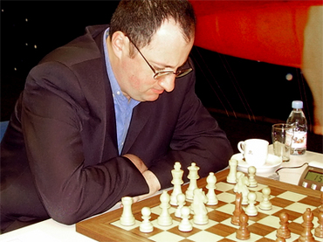
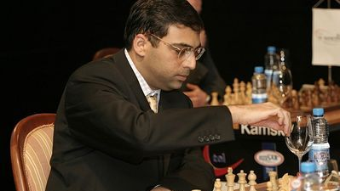

FOUNDATION DAY OPEN (6 round CAWA & ACF Grand Prix event, 90 mins + 30 sec) will be played tomorrow Sat 2, Sun 3 & Mon 4 June at the Moresby St Centre.
One entry from the east is Australia's 3rd highest ranked player, International Master George Xie. George represented Australia in the 2008 Olympiad and came 1st= in the 2009 and 2011 Australian Open Championship.

Details at cawa.org.au and entry to 93984242 or 04014733031.

SOLUTION: 1…Nf3+! 2.gxf3 Qg5+ & 3…Qxd2.

