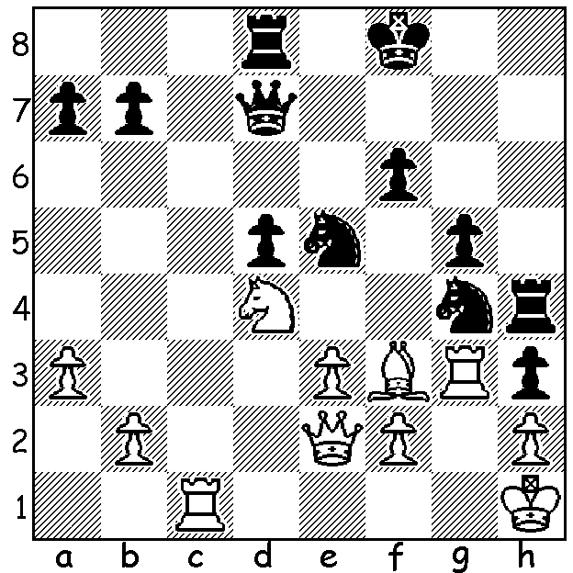
I am at present in Sydney playing in
the Asian Seniors Championship so
this problem is a dedication to the hard
working organizer and DOP, Brian Jones.
Diagram 436: Brian Jones – Al Sulaiti
(Asian Cities 2004): White to play & win
(3 moves):

The World Championship between champion Viswanathan Anand and Boris Gelfand was
decided with the four Rapid Play games (25 mins + 10 sec per move) after the 12 classic games were drawn +1, -1, =10. Anand won Game 2 in a long drawn out game when Gelfand, in serious time trouble, went astray when defending with rook & bishop against rook, knight and pawn, allowing Anand to exchange minor pieces and gain a winning position. Gelfand pressed with White in Games 1 & 3 but Anand was able to hold the draw and by drawing the final Rapid Play game retained the title with two wins to Gelfand’s one. Gelfand will rue his missed opportunity in the third Rapid Play game when he failed to win a piece:

Boris Gelfand - Viswanathan Anand -
2012 World Championship, Game 15 (Game 3 Rapid Play)
Slav Defence
1.d4 d5 2.c4 c6
3.Nf3 Nf6 4.e3 Bf5
5.Nc3 e6 6.Nh4 Bg6
7.Nxg6 hxg6 8.Bd3 Nbd7
9. 0-0 Bd6(a) 10.h3 0-0
11.Qc2 Qe7 12.Rd1 Rac8(b)
13.c5 Bb8 14.f4 Ne8
15.b4 g5 16.Rb1 f5
17.b5(c) gxf 18.exf Nef6
19.bxc bxc 20.Ba6 Rc7
21.Be3 Ne4 22.Rb2 g5
23.Rdb1 gxf 24.Bxf4 e5(d)
25.Bxe5 Nxe5 26.Rxb8?(e) Ng6
27.Nxe4 fxe4 28.Qf2 Qg7
29.Kh2 Rf7 30.Qg3 Nf4
31.R8b3 Qxg3+ 32.Rxg3+ Kh7
33.Rd1 Ne6 34.Be2 Rf2
35.Bg4 Nf4 36.Rb1 Rf7
37.Rb8 Rxa2 38.Rc8 e3
39.Rxe3 Rxg2+ 40.Kh1 Rd2
41.Rxc6 Ne6 DRAW

a) Black could play 9.Ne4 as 10.Nxe4? fxe4 11.Bxe4 loses to 11…Qh4.
b) 12…e5 13.cxd cxd is equal.
c) White’s will break through on the queenside before Black can initiate an attack against White’s king.
d) Better 24…Qg7.
e) Is this the move that loses the match for Gelfand? 26.Nxe4 fxe4 27.dxe5 Qxe5 28.Rxb8 Qd4+ 29.Kh1 Rxb8 30.Rxb8+ Kh7 31.Qb2 Qxb2 32.Rxb2 winning.
f) 42.Rf3 (taking the knight allows mate) 42..Rxf3 Bxf3 is equal.

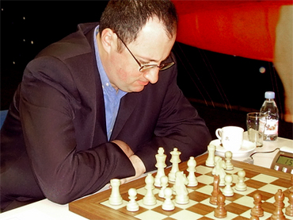
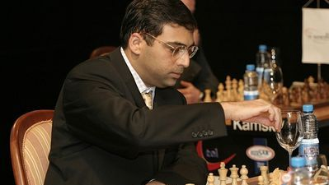

SOLUTION: 1.Rc7! Qxc7 2.Ne6+ Ke7 3.Nxe7 (if 1…Qd6/Qe8 2.Bxg4 wins a piece).

