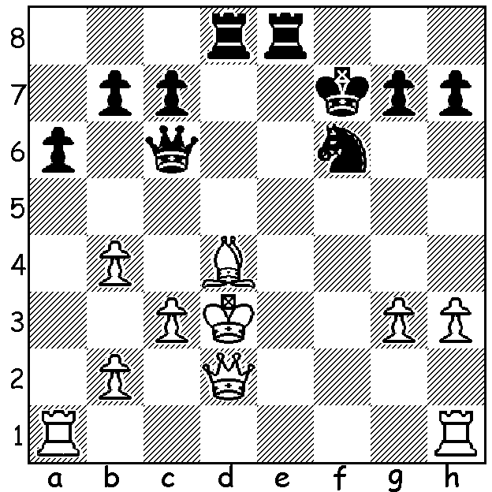
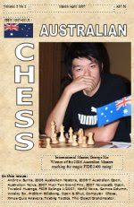

Diagram 437:
Australian George Xie (Black)
quickly gains a winning position
in the 2008 Olympiad against
Christopher (3 moves):

George Xie

The recent USA championship concluded with victory going to America’s top player Hikaru Nakamura with 8.5/11, a point ahead of defending champion Gata Kamsky. Nakamura, aged 24, with a rating of 2848 and ranked 6th in the world, was a child prodigy who became the world’s youngest International Master at 10 and then at 15 broke Bobby Fischer’s record as the youngest ever Grandmaster. He won the US championship in 2005 aged 16 and in 2011 recorded his best tournament result, winning the prestigious Tata Steel International ahead of the world’s leading GMs, a result Gary Kasparov described as the best result by a US player for over 100 years. Ray Robson, America’s most recent prodigy, now 17, had a mediocre tournament coming 7th in the 12 player tournament with 5.5. Here is his win against 20 year old Robert Hess:
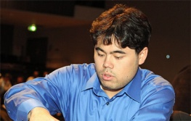

RAY ROBSON - ROBERT HESS
2012 US Championship
Giuoco Piano
1.e4 e5 2.Nf3 Nc6
3.Bc4 Bc5 4.c3 Nf6
5.d4 exd 6.cxd Bb4+
7.Nbd2(a) d5 8.exd Nxd5
9.0-0 0-0 10.h3 Bf5 Hikaru Nakamura

11.a3 Be7 12.Re1 Bg6
13.Ne4 Nf6 14.Nc3 Bh5(b)
15.g4 Bg6 16.Bf4 a6
17.b4 a5 18.b5 Na7
19.Ne5 Ne8 20.Nd5 Bd6
21.h4(c) Bxe5 22.dxe5 Qxh4
23.Bg3 Qd8 24.Qf3 c6
25.bxc Nxc6(d) 26.Rad1 Qg5
27.Bf4 Qh4 28.Bg3 Qg5
29.Bf4 Qh4 30.Kg2(e) h5
31.g5 Qg4+(f) 32.Qxg4 hxg4
33.e6! fxe 34.Rxe6 resigns(g)
Ray Robson

a) While the Giuoco Piano has been resurrected over the last decade or so in international chess, particularly in the UK, it is usually played in its quieter form with d3 rather than d4. The interposing of the knight on d2 rather than 7.Nc3 or 7.Bd2 is new to me and not mentioned in ‘Nunn’s Chess Openings’ (1998), ‘Modern Chess Openings’ nor Horowitz’s ‘Chess Openings: Theory and Practice’ (both from the 1960s). Black could now play 7…Nxe4 but White appears to obtain sufficient compensation – 8.0-0 Nxd2 9.Bxd2 (or 9.Re1+) 9…Bxd2 (9…0-0 10.Bxb4 Nxb4 11.d5) 10.Qxd2 0-0 (10…d5 11.Bb5 0-0 12.Bxc6 bxc6 13.Rac1 Bd7 14.Ne5) 11.d5 Ne7 12.Rfe1.
b) This encourages White to advance his kingside pawns.
c) A pawn sacrifice for attacking chances against Black’s king.
d) 25…bxc6 is better.
e) Threatening to win the queen with 31.Rh1 Qd8 32.Nf6+.
f) This loses: better 31…Bc2 although after 32.Rd2 Bf5 33.Rh1 Qg4+ 34.Qxg4 hxg4 35.f3 preparing to double rooks on the h file keeps up the attack.
g) After 34…Bf7 White wins with 35.Rxc6! bxc6 36.Ne7+ Kh7/8 37.Rh1+.

THE FOUNDATION DAY OPEN, not surprisingly, was won by visiting IM George Xie with 6/6. George is an Australian Olympiad representative and 2009 & 2001 Australian champion. His recent tournament results have met the required norms for the title of Grandmaster, a title he will receive once his rating reaches 2500. Equal second were Mark Vliestra, Jose Madriaga, Peter de Yank & junior George Carolin-Unkovich (4/6).

SOLUTION: 1…Rxd4+! 2.cxd4 (2.Kxd4 Qd5#) 2…Qb5+ wins the queen – 3.Kc2 Re4 or 3.Kc3 Ne4+.

