LARRY EVANS

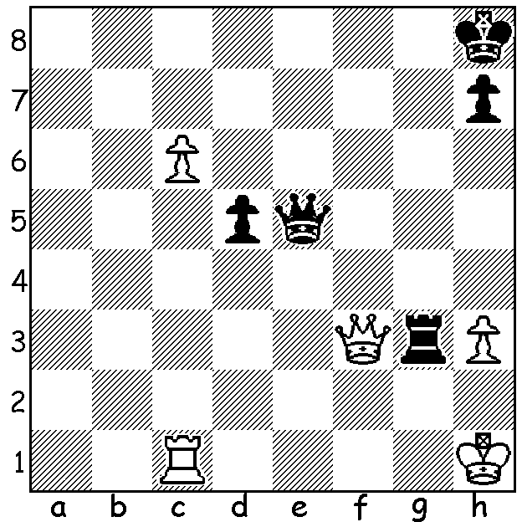
After last week’s article on the US Championship today’s
subject, American Larry Evans, one of the most prominent
American grandmasters, prolific writer and commentator,
who passed away in 2010 at the age of 78, seems quite
appropriate. Aged 19 Evans won his first U.S. championship
ahead of Samuel Reshevsky. He would go on to win four
more U.S. titles as well as four U.S. Opens. In his first
Olympiad in 1950, Evans scored an impressive 9 points in
10 games. In all he played 100 games in eight Olympiads
and scored 64.5 points, winning gold, silver and bronze medals
for his individual efforts. Evans wrote more than 20 books and
his syndicated chess column was read in 50 newspapers. He
Evans-Horowitz 1951: made a large contribution to Bobby Fischer's classic "My 60
White to play and win Memorable Games" and helped Fischer prepare for his world
(4 moves): championship drive in the early 1970s. In the match USA vs.
USSR in New York in 1954 Evans was one of two Americans
with a winning score, beating Mark Taimanov 2.5 to 1.5. Evans writes: "The most thrilling game of my career featured an inspired defence after I walked headlong into a prepared variation against
the Soviet champion Taimanov …. At move 18 he had used only two minutes on his clock, while I consumed close to an hour."
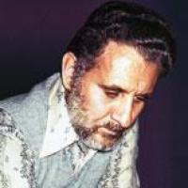
Mark Taimanov – Larry Evans
USSR v USA 1954
Kings Indian Defence
1.c4 Nf6 2.Nf3 g6
3.Nc3 Bg7 4.e4 0-0
5.d4 d6 6.Be2 e5
7.0-0 Nc6 8.d5 Ne7
9.Ne1 Nd7 10.Nd3 f5
11.f3 f4 12.Bd2 g5
13.Rc1 Rf6(a) 14.c5!?(b) Nxc5 Larry Evans
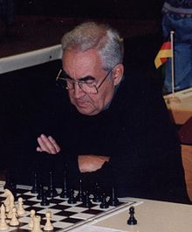
15.Nxc5 dxc5 16.Na4 b6
17.b4 cxb4 18.Bxb4 Bf8?!(c)
19.Rxc7 !?(d) Nf5!!(e) 20.Bxf8 Qxc7
21.Ba3 Ne3 22.Qc1 Qg7!(f)
23.Rf2 Bd7 24.Nc3 g4
25.Bb2 g3 26.hxg3 Qxg3
27.Bf1 Rc8 28.Qe1 b5
29.Ne2 Qh4 30.g3(g) fxg3
31.Nxg3 Nxf1!(h) 32.Nf5(i) Rg6+
33.Kxf1 Qh1+ 34.Ke2 Rc2+
35.Kd1 Qxe1+ 36.Kxe1 Rg1+
White resigns. Mark Taimanov

a) This creates attacking chances along the h-file and defends the pawn on d6 at the same time, although later theory recommended the rook’s deployment on f7 to guard Black’s second rank
b) A prepared positional pawn sacrifice. After 14.b4 h5 15.c5 Rg6 Black has good kingside chances.
c) An alternative is 18...c5 trading the weak c-pawn - 19.dxc6 Qxd1 20.Rfxd1 Nxc6 21.Bd6 with White’s better development compensating for the pawn - eg 21...Bb7 22.Bc4+ Kh8 23.Bb5 Rc8 24.Bxc6 Bxc6 25.Bxe5 Rff8 26.Bxg7+ Kxg7 27.Nc3 Rfd8 with equal chances.
d) "I literally broke out into a sweat! The eyes of over a thousand spectators, it seemed, were focused on our wallboard. It didn't take very long to calculate that the upstart rook could not be captured," - 19...Qxc7 20.d6 Qd8 21.dxe7 Bxe7 22.Bxe7 Qxe7 23.Qd5+ picking up the queen's rook or 20…Rxd6 21.Bxd6 Qc6 22.Qb3+ Kg7 23.Bxe5+ with advantage. However increasing the pressure with 19.Qb3! was better.
e) An inspired counter, leaving many White pieces hanging.
f) Rather than winning more material Black attacks. After 22...Qd7 23.Qb2! Qxa4 24.Qxe5 White has worrying threats.
g) Desperation otherwise Black mates with 30...Rh6.
h) Simple but 31...Qxg3+!? was playable - 32.Rg2 Nxf1 33.Kxf1 - 33.Rxg3+ Nxg3 34.Bxe5 Rc1! wins - 33...Qxg2+ 34.Kxg2 Rc2+ 35.Kh1 Rxf3 36.Bxe5 Bh3 winning.
i) If 32.Rg2 Rg6 33.Qxf1 (33.Kxf8 Bh3) 33…Rxg3 34.Bxe5 Rg6! wins.

SOLUTION: 1.c7!! Rxf3 2.c8=Q+ Kg7 3.Qg4+ K moves 4.Qxf3.

