Diagram 439: The South West Open, one of the WA Grand Prix weekenders,
White to play & mate in 2. was first played in 1994. Unfortunately since the demise of the
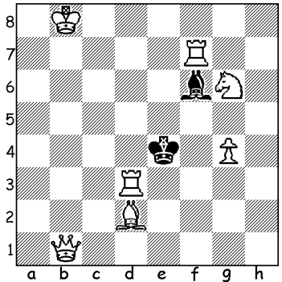
Bunbury club it had only been played once since 2005. However the Perth Club’s energetic president Norbert Muller set about resurrecting the event, arranging a venue in Bridgetown for June 16/17. The tournament was well supported with players from Albany, Busselton, Bunbury and Bridgetown as well as from
Perth. Overall winner and WA country champion was Julian Painter from Bunbury who defeated and overtook Robert Maris in the final round, scoring 5.5/6. Equal second were husband and wife, Robert and Natalie Maris, with 5. Other prize winners: Under 1700 – 1st Malcolm Smith 4.5, 2nd Adam Kelly 4, =3rd Jacques Meyer and George Carolin- Uncovich 3.5: Under 1000 -1st Steven Wood 3.5, 2nd Alan Kelly 3, =3rd Cathy Farelly, Bert Reynolds, David Johnston 2. Malcolm Smith’s result was
outstanding, beating the two former state champions and drawing with the winner. Junior Adam Kelly also played particularly well, losing only to the state ex-champions. Here’s a game by talented junior George Carolin-Uncovich, notable for two unusual combinative ideas, the clearance sacrifice and the interruption sacrifice:

George Carolin-Uncovich - Stewart Hunt
2012 SW Open, Rd 5: Vienna Gambit
1.e4 e5 2.Nc3 c6 3.Bc4(a) Nf6 4.f4 d5
5.exd cxd(b) 6.Bb5+ Bd7
7.fxe Ne4 8.Nf3 Nxc3
9.Bxd7+ Nxd7 10.dxc Nc5
11.0-0 Qd7(c) 12.e6! Nxe6(d)
13.Ne5 Qc7 14.Nxf7 Qc5+(e)
15.Kh1 Rg8 16.Qe2 Qe7
17.Ne5(f) 0-0-0 18.Be3 d4
19.cxd Nxd4 20.Qg4+(g) Ne6(h)
21.Rf7 Qd6 22.Bf4 g5
23.Nc4! Qd4(i) 24.Qxe6+ Rd7
25.Nd6+!(j) Kc7 26.Rxd7+ resigns

a) Here and on the next move changing plan with d4 was best.
b) With 5…e4 6.dxc Nxc6 Black would obtain a good position at the cost of a pawn.
c) Blockading with 11.Ne6 would prevent White’s clearance sacrifice (giving up a piece or pawn allowing another piece to occupy the sacrificed piece’s square).
d) If 12…fxe 13.Ne5 Qc7 14.Qh5 g6 15.Nxg6 wins.
e) Much better was 14.Bc5+ 15.Kh1 0-0! f) 17.Bd2 / 18.Rae1 is a logical continuation.
g) 20.Qc4+ wins more quickly. h) Better 20…Qe6.
i) Better 23…Qd5 although the pin on Black’s knight makes his position untenable.
j) Now an interruption sacrifice (where a player loses protection of a piece or vital square by being forced to place one of his own pieces in between the attacked piece or square and the defending piece). If now 25..Bxd6 26.Qxd7+.

One unique feature of chess is the possibility of players of vastly different ages competing against each other. At Bridgetown a difference of nearly 70 years separated eight times WA champion Wolfgang Leonhardt at 83 and Adam Kelly at 14.

Leonhardt – Kelly (Benoni Defence) 1.c4 c4 2.Nc3 Nf6 3.d4 g6 4.d5 d6 5.e4 Bg7 6.Be2 0-0 7.Be3 h5? 8.h3 Qb6 9.Qd2 e5 10.0-0-0 Na6 11.g4! hxg 12.hxg Bxg4 13.Bh6 Bh5
14.Bxh5 gxh5 15.Bxg7 Kxg7 16.Qg5+ resigns.

SOLUTION: 1. Ne7: if 1…Bxe7 Rxd7#: if 1…Be5+ 2.Rd6#: if 1.Bg5 Rd5#: if 1.Bd4 Re6#: if 1…Ke5 2.Qe1#. (This was the problem given by Norbert at Bridgetown. Thank you Norbert for the bottle of red for solving the problem.)

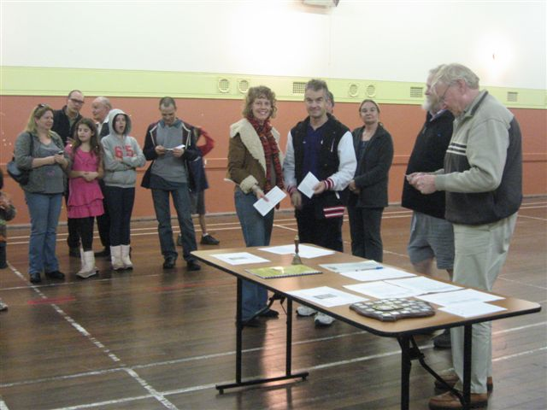
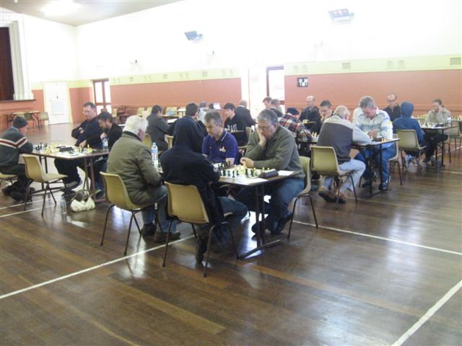

Play at Bridgetown: winner Julian Painter is in At Prizegiving: in foreground joint runners up
foreground right facing camera with Rob Maris, Natalie & Rob Maris with DOP Norbert Muller
who is playing Wolfgang Leonhardt, next to Julian. and CAWA president Haydn Barber (obscured).

