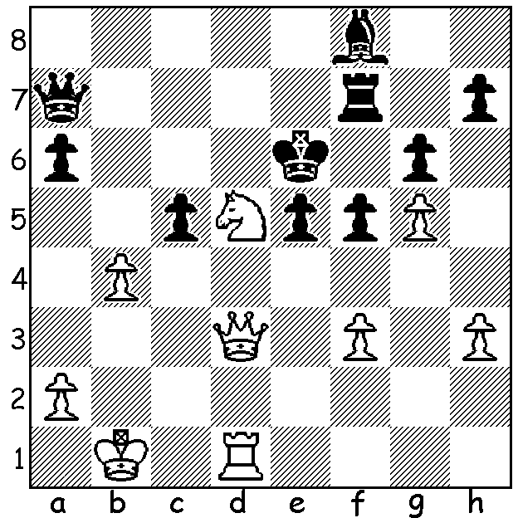

Diagram 440:
McShane – Leech 1994:
White to play & mate in 2:

The 7th Tal Memorial, played in Moscow between June 8 and June 18, boasted eight of the top eleven rated players in the world as well as the 19th and 32nd. The ten player event was won by world number 1 Norwegian Magnus Carlsen with 5.5/9. Carlsen’s last round win against Luke McShane enabled him to overtake Italian Fabiano Caruana who lost his final game to Levon Aronian when only needing a draw to be certain of first place on tie break. Other scores: =2nd Fabiano Caruana, Teimour Radjabov 5, =4th Levon Aronian, Alexander Grischuk, Vladimir Kramnik , Alexander Morozevich 4.5, =8th Luke McShane, Hikaru Nakamura 4, 10th Evgeny Tomashevsky (European champion 2009) 3.5. The selection of England’s number 2 Luke McShane was something of a surprise but with wins against world number 2, 3 and 9 was an imaginative and well justified choice with two of his wins exhibiting Tal-like attacking flair:

Levon Aronian - Luke McShane
7th Tal Memorial 2012
Slav Defence, Chebanenko Variation (4…a6)
1.d4 d5 2.Nf3 Nf6
3.c4 c6 4. Nc3 a6
5.Bg5 dxc 6.a4 h6
7.Bh4 b5! 8.axb cxb
9.Nxb5 axb5! 10.Rxa8 Bb7
11.Ra1 g5 12.Bg3 e6(a)
13.e3 Bb4+ 14.Ke2(b) Nc6
15.Ne1 Na5 16.Be5 0-0
17.h4(c) g4 18.Nc2 Be7
19.Ke1 Nb3 20.Ra2 h5 N 19.Ke1 Nb3 20.Ra2(d) h5
21.Be2 Bd6 22.f3 Nd5
23.fxg4 Bxe5 24.dxe5 Qb6
25.Bf3(e) Nxe3 26.Nxe3 Qxe3+
27.Qe2 Qc1+ 28.Qd1 Qe3+
29.Qe2 Qc1+ 30.Qd1 Bxf3
31.gxf3(f) Qe3+ 32.Qe2 Qc1+
33.Qd1 Qe3+(g) 34.Qe2 Qf4!
35.Qh2(h) Qxf3 36.Rf1 Qe4+
37.Kf2(i) Nd2 38.Rg1 Qf3+
White resigns (j)

a) For the exchange Black is able to misplace White’s king and hinder his development (now if 13.Qd2 Nc6 threatening 14…Bb4).
b) Not 14.Nd2 Ne4.
c) If 17.f3 Nd7 18.Bg3 f5 is good for Black as is 17…Nd5.
d) If 20.Bxf6 Bxf6 21.Qxg4+ Kh8 22.Rd1 (22.Ra2 e5!) 22…Qa2.
e) If 25.Rh3 Rd8 26.Qb1 Nf4! or 25.Kf2 Rd8 26.Qe1 Nf4.
f) Not 31.Qxc1? Nxc1 32.Ra1 Nd3+ winning.
g) Black’s repetition of moves between 26 and 33 has gained him valuable time on the clock (for much of the game McShane was in serious time trouble and had consumed over an hour more than Aronian).
h) If 35.Kf2 Rd8 36.Rd1 Qh2+ 37.Ke3 Qxe5+ 38.Kf2 Qh2+ 39.Ke3 Qxh4 winning.
i) Not 37.Qe2? Qb1+
j) 39.Ke1 Qe3+ Qe2 Nf3+ wins.

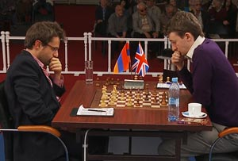
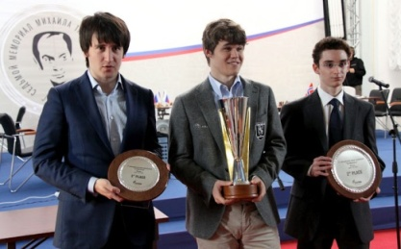

Tal Memorial winner Magnus Carlsen (centre) Levon Aronian (left) v Luke Mc Shane.
flanked by runners-up Timour Radjabov (left)
and Fabiano Caeuana( right).

SOLUTION: 1.Nf4+! (clearance and deflection sacrifice) if 1…exf4 2.Re1# and if 1…Ke7 2.Qd8#.

