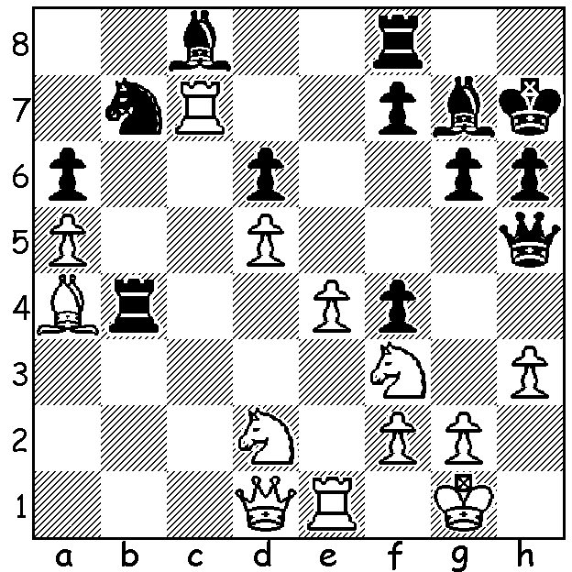

Diagram 441:
McShane – McFarland 2000:
White to play & win (3 moves):

Luke McShane, born January 1994, is the UK’s second highest rated player after Michael Adams. He was world under 10 champion at the age of eight, became Britain’s youngest Grandmaster at the age of 16 (a record later broken by David Howell) and was the second highest rated world junior in 2004. He is a superb lightning player and won the British Blitz championship in 2003, scoring 14.5/16. A trader by profession, he has been described as the world’s best amateur. His fine play at last year’s London Classic, in which he was =2nd behind Magnus Carlsen, would undoubtedly have helped secure his inclusion in the recent Tal Memorial which included eight of the world’s top eleven players. Last week I published one of his three fine wins at this event. It was very difficult to decide which of two of these games to select so I’ve decided to show the second today:

Alexander Morozevich - Luke McShane
7th Tal Memorial Rd 8, June 2012
Queens Gambit, Slav Defence (Chebanenko Variation, 4…a6)
1.d4 d5 2.c4 c6
3.Nf3 Nf6 4.Nc3 a6(a)
5.e3 b5 6.b3 Bg4
7.h3 Bxf3 8.gxf3(b) Nbd7
9.Bg2 e6 10.Bd2 Be7
11.f4 0-0 12.0-0 bxc
13.bxc Nb6 14.c5 Nc4
15.Be1 Kh8!(b) 16.Ne2 Rg8
17.Ng3 g5 18.Qf3 g4
19.hxg Nxg4 20.Rc1 Qf8(c)
21.Bh3 Nf6 22.Kh2 Rb8
23.e4 Rxg3!! 24.fxg3(d) dxe4
25.Qc3 Nb2(e) 26.Rb1 Nd5!
27.Qd2 Nc4 28.Rxb8 Qxb8
29.Qe2 Nce3 30.Rh1 Bf6
31.Bg2 Bxd4 32.Bxe4 Nxf4!
33.gxf4 Qxf4+ 34.Bg3 Qxe4(f)
35.Re1 Qf5 36.Bd6 Ng4+
37.Kg2 Ne3+ 38.Kh2 e5(g)
39.Rg1 Qf4+ 40.Kh3 Qh6+
White resigns(h)

a) As in last week’s game Aronian – Mc Shane. Aronian continued 5.Bg5.
b) This capture strengthens control of central squares and may provide an avenue to attack the Black king via the half-open g file.
b) An imaginative idea – Black plans to open the g file.
c) Planning …Qh6 to menace White’s king.
d) If 24.Qxg3 Nxe4 25.Qg4 Qh6 followed by …f5 & …Bf6 when White’s bishops remain ineffective.
e) Also good is 25…Qh6! and if 26.Qxc4 Ng4+ 27.Kg1 (27.Kg2? Ne3+) Qxh3 with a winning attack.
f) Threatening 35…Ng4+ winning the queen.
g) Depriving the king of the bishop’s protection.
h) 41.Kg3 Nf5+ 42.Kg2 Qg5+ 43.Kh3 (43.Kf3 Qf4+ 44.Kg2 Qg3+) 43…Qh4+ 44.Kg2 Qg3+ 45.Kf/h1 Qxg1#.

.
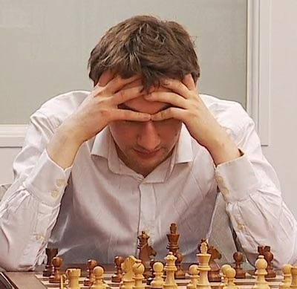


Luke Mcshane aged 8 when winning Luke McShane at the 2012 Tal Memorial
world under 10 championship

2012 WEST AUSTRALIAN CHAMPIONSHIP begins this coming Sunday at the Moresby St. Centre, Kensington, at 1pm and continues each Sunday until 16 September (no play Fathers Day Sept. 2). While the field for the ten-player Championship has been finalised further entries for the reserves are welcome. Check details on cawa.org.au and contact Haydn Barber 9398 4242 or 0401 473031. Spectators are welcome.

SOLUTION: 1.Rxc8! Rxc8 2.Bd7 & if rook moves 3.Bg4 trapping the queen

