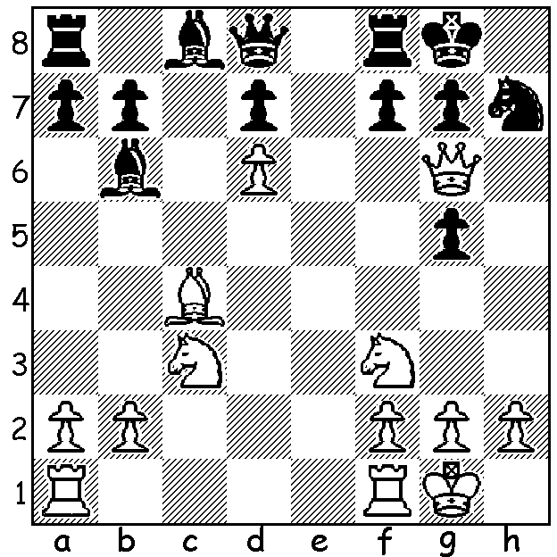

Diagram 442:
Albin – Shipley (New York 1894):
White plays a sensational move,
mating in 3:

In February 1999 I began an alphabetical series of articles commencing with Alekhine and concluding with Zukertort in November 2011. Today I begin another series based on players or tournaments with openings named after them. Firstly the Romanain Adolf Albin (1848-1920), whose legacy to the chess world is the Albin Counter Gambit against the Queens Gambit. Although the moves 1.d4 d5 2.c4 e5 had been played before, the defence became known as the Albin Counter Gambit after Albin employed it against Lasker in New York in 1893.
Albin only began competing in international tournaments at the age of 43 and his only tournament first place was Dresden 1892, although he twice was runner-up in New York, to Emmanuel Lasker in 1892 and Wihelm Steinitz in 1894. His performances then tailed off considerably and he achieved only a 37% score over his whole career.
In the game below he defeats the famous theorist Tarrasch, an unsuccessful challenger to Lasker for the world title:

ADOLF ALBIN - SIEGBERT TARRASCH
Giuoco Piano
1.e4 e5 2.Nf3 Nc6
3.Bc4 Bc5 4.c3 Nf6
5.d4 exd 6.cxd Bb4+
7.Bd2 Nxe4(a) 8.Bxb4 Nxb4
9.Bxf7+! Kxf7 10.Qb3+ d5
11.Ne5+ Kf6(b) 12.Qxb4 c5
13.Qa4 Qe8(c) 14.Qd1 Ng5(d)
15.f4 Ne6 16.Nc3 g6
17.Nxd5+ Kg7 18.0-0 cxd
19.f5 Nf4(e) 20.f6+(f) Kf8
21.Ne7(g) Qb5 22.Rxf4 Qxe5
23.Qxd4 Qxd4+ 24.Rxd4 Be6
25.Rd6 Kf7 26.Re1 Bxa2
27.Nd5 Rhd8 28.Re7+ Kf8
29.Rxd8+ Rxd8 30.Nc3 Bf7
31.Rxb7 a6 32.Ra7 Rd2(h)
33.Ne4 Rxb2 34.Ra8+ Be8
35.Nd6 resigns(i)

a) Safer is 7…Bxd2 8.Nbxd2 d5.
b) A later improvement is 11…Ke6 12.Qxb4 Qf8.
c) Better 13…Qb6 14.Nc3 Rd8 (14…Qxb2 15.Nxd5+ Ke6 16.Nc7+ Kf6 17.0-0 Qxd4 18.Qa3 & White retains an advantage).
d) The double-edged 14…Qb4 is preferable ( 15.Qf3+ Ke7 16.Qf7+ Kd6).
e) If 19…Rf8 20.Nxg6! hxg6 21.fxe6 Rxf1+ 22.Qxf8.
f) Also 20.Nxf4 Qxe5 21.f6+ Kh6.
g) Also 21.Qd2! Qxe5 (if 21…Nxd5? 22.Qh6+ wins) 22.Rae1! Qd6 23.Rxf4.
h) Leaving the back rank hastens the end.
i) After 35…Re2 36.f7 is crushing.

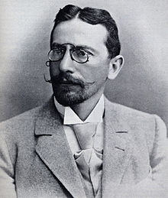
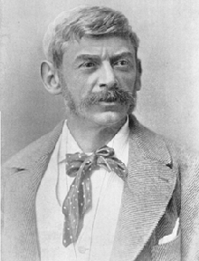

Adolf Albin Siegbert Tarrasch

SOLUTION: 1.Nd5!! (unpinning Black’s f pawn) 1…fxg6 2.Ne7+ Kh8 3.Nxg6#.

