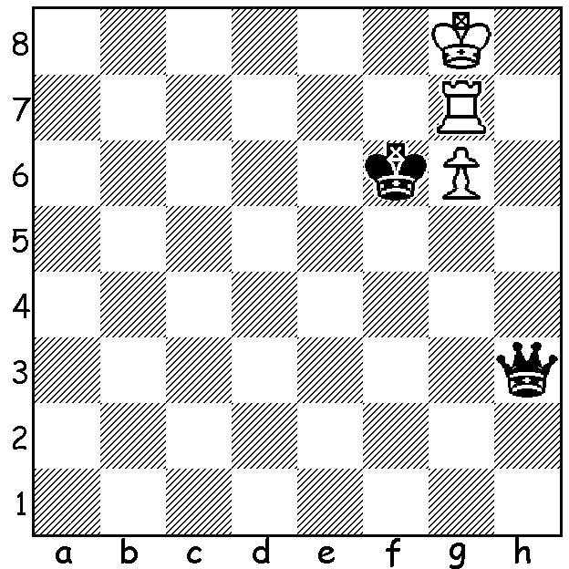

Diagram 443
The problem today sees queen v rook & pawn on 6th
(Stanec-Kosten 1997).
Black played 1…Qh6 and White resigned.
Can you
a) work out how White could have now saved the game
b) find a better first move for Black?

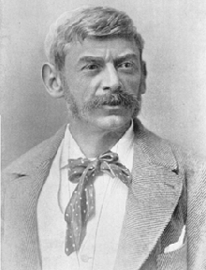
Last week we were introduced to the Romanian
Adolf Albin (1848-1920). Today we see his
defence to the Queens Gambit, the Albin Counter
Gambit, given that name after Albin employed it
against Emanuel Lasker at New York in 1893.
It contains an opening trap known as Laskers Trap
in which Black obtains a third knight on the board
after a promotion:

Adolf Albin

Blumenfeld, Bogarkov & Falk
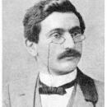
in consultation against Emanuel Lasker
Moscow 1899
1.d4 d5 2.c4 e5
3.dxe d4 4.e3? Bb4+
5.Bd2 dxe! 6.Qa4+(a) Nc6
7.Bxb4 Qh4 8.Ne2(b) Qxf2+
9.Kd1 Bg4 10.Nc3 0-0-0+
11.Bd6 cxd6 12.e6 fxe
13.Kc1 Nf6 14.b4 d5
15.b5 Ne5 16.cxd Nxd5
17.Qc2 Nb4 18.Ne4+ Nxc2
19.Nxf2 Rd2 White resigns(c) Emanuel Lasker

a) The well known continuation is 6.Bxb4 exf+ 7.Ke2 fxg1=Q+! when the promoted knight can not captured because of 8…Bg4+ winning the queen.
b) 8.g3 loses to 8…exf+ 9.Kxf2 Qd4+ 10.Ke1 Qe4+ 11.Kf2 Qxh1.
c) After 20.Rb1 Na3 sets up mate.

The defence has never been popular but has been occasionally essayed by the more adventurous such as the German Jacques Mieses (1865-1954) who won many brilliancy prizes but suffered as many short defeats. Here he defeats the Austrian Carl Schlechter (1874-1918) who drew a world championship match with Lasker (+1 -1 =8):

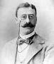
Carl Schlechter – Jacques Mieses
Paris 1900
1.d4 d5 2.c4 e5
3.dxe d4 4.Nf3 Nc6
5.g3 Be6 6.Qa4 Qd7
7.Bg2 0-0-0 8.0-0 Bh3
9.e6(a) Bxe6 10.Ne5 Nxe5
11.Qxa7 Qd6 12.Qxb7+ Kd7
13.f4 Ng4 14.b3 f5
15.Qb5+(b) c6 16.Qb7+ Ke8 Jacques Mieses
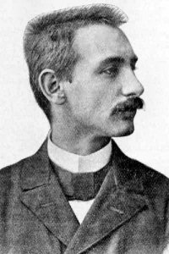
17.c5 Qe7(c) 18.Bxc6+ Bd7
19.b4 N8f6(d) 20.Bf3 Ne3
21.Bxe3 Qxe3+ 22.Kh1(e) h5
23.a4 h4 24.Ra3 Qe6
25.Rg1(f) hxg 26.Rxg3 Ng4
27.Rg2(g) Ne3 28.Rg5 Be7
29.Rh5 Rxh7 30.Bxh5 g6
31.Bf3 Qc4 White resigns

Carl Schlechter

a) An imaginative continuation involving a piece sacrifice to attack Black’s king.
b) Also 15.Rd1 Ke8 16.e3.
c) Risky but possible is 17…Qxc5 18.Ba3 Qc2.
d) Preferring development over pawn-grabbing with 19…Qxe2.
e) 22.Better 22.Kg2, not placing the king on the same file as Black’s rook.
f) A serious error, 25.gxh should be played.
g) If 27.h3 d3! 28.Rxd3 Nf2+.

SOLUTION: After 1…Qh6 White can draw with 2.Rf7+ Kxg6 3.Rf6+! Kxf6 stalemate.
If 2…Ke6 3.g7 or 2..Kg5 3.Rh7! (3…Qxg6 4.Rg7=). Black should play 1…Qh2 or …Qh1 and White is in zugzwang.

