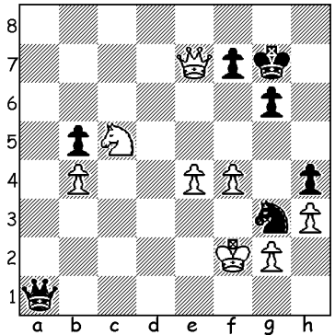

Diagram 444
(Schneider – Federau 1979):
White threatens Ne6+ winning
but Black gets in first (3 moves):

This is the third and final column on the Albin Counter Gambit, named after the Romanian Adolf Albin (1848-1920) who employed it against Emanuel Lasker at New York in 1893. While gaining some popularity around the turn of the 20th century among the more adventurous players like Marshall and Mieses it has now practically disappeared from top chess. Today few would risk the defence, Alexander Morozevich, a top Russian, and US champion Hikaru Nakamura being two exceptions, both imaginative players prepared to take risks.

Dimitri Gurevich - Hikaru Nakamura
US Championship 2007
1.d4 d5 2.c4 e5
3.dxe d4 4.Nf3 Nc6
5.g3 Nge7 6.Bg2 Ng6
7.Qa4 Bd7 8.0-0 Bc5
9.Bg5 f6 10.Qb5 Bb6
11.exf gxf 12.c5 Nce5(a)
13.Qb3 Bxc5 14.Nxe5 Nxe5
15.Qxb7 Rc8(b) 16.Qd5 Bb6
17.e3(c) Ng4 18.Bf4 dxe
19.Qh5+ Kf8 20.fxe Qe8
21.Bh6+ Ke7 22.Qh4 Qg6
23.Bf4 Be6 24.Nc3 Rcd8
25.Kh1 Rd2 26.e4(d) Nf2+
27.Rxf2 Rxf2 28.e5 Kf7
29.Rd1 Ba5 30.Be4 f5
31.Nd5 Re8(e) 32.Be3 fxe4(f)
33.Bxf2 Qf5 34.Qf6+(g) Qxf6
35.Nxf6 Rb8 36.b3 Rb5
37.Bd4 e3! 38.Bxe3 Rxe5
39.Bd4 Re2(h) 40.Nxh7 Bd5+
41.Kg1 Rg2+ 42.Kf1 Rxh2
43.Ng5+ Kg6 44.Be3(i) c6
45.a3 Bc3 46.b4(j) Bf6
47.Rxd5 cxd5 48.Nf3 Ra2
49.Bxa7? Rxa3 White resigns

a) Or 12…fxg5 13.cxb6 axb6 14.Qxg5 Qxg5 15.Nxg5 Bg4 with some compenation for the pawn.
b) White threatened 16.Bxf6!
c) This loosens White’s solid position.
d) White must Block the b1-h7 diagonal for if 26.h3? Rxg2 (27.Kxg2 Qc2+) 27.hxg4 Rxb2 winning but better was 26.Be4!
e) Not 32…fxe4? 33.Qe7+ Kg8 34.Nf6+.
f) If 32…Rxb2? 33.Nf4 Qg7 34.Qh5+ Kf8 35.Bc5+ wins.
g) Better 34.Kg1.
h) Not 39…Kxf6? 40.Rf1+ Bf5 41.g4.
i) This loses – 44.Bg1 Rd2 45.Rxd2 Bxd2 would draw.
j) 46.Ne6! Bxe6 47.Rd6 Kf7 48.Rxc6 leaves Black the task of working up a mating attack with the extra piece.

Hikaru Nakamura
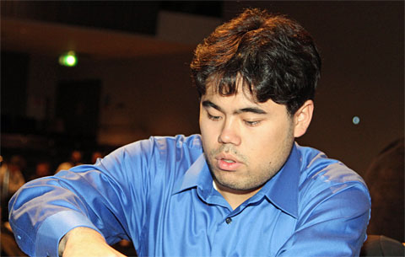

SOLUTION: 1…Qf1+ 2.Ke3 Nf5+! 3.exf5 Qe1+ winning the queen through a combination of fork, deflection sacrifice and skewer.

