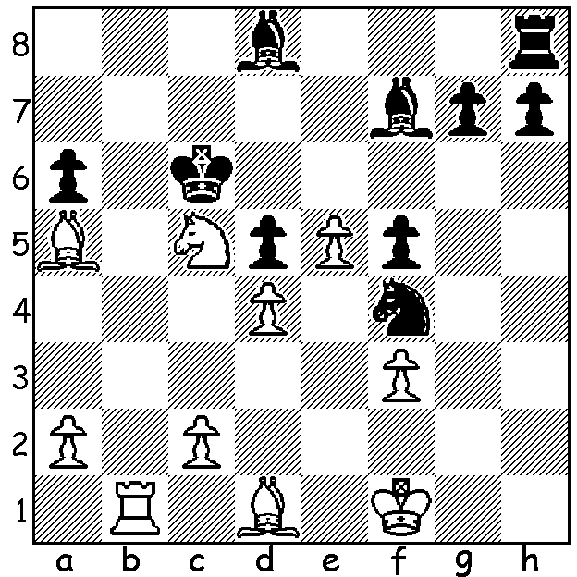
Diagram 445
Bologan – Palo 2003:
White to play and win
(3 moves)

The city of Biel at the heart of the Swiss
watch making industry, with a population
of about 50,000, has been running chess
festivals for the past 45 years. Last month
around 500 players competed in 11 different events with the main event being a 6 player GM invitation double round robin. Unfortunately Russian star Alexander Morozevich fell ill after two rounds and was substituted by Victor Bologan. The scoring system gave 3 points for a win and 1 for a draw. Last year’s winner, world number 1 Magnus Carlsen, had the best result, +4 =6, but despite defeating Wang Hao in both their games finished a point behind the Chinese player who with +6 =1 -3 scored 19 points. Other scores: Anish Giri & Hakaru Nakamura 16, Etienne Bacrot 7, Bologan 4 (from 8 games). You may have heard of combined chess/boxing matches but not the combined chess/tennis competition which was played for the second year at Biel and included a number of GMs in the 6 pairs competing. Below a thematic Kings Indian with White meeting Black’s kingside attack with pressure on the queenside and centre. White finishes the double exchange down in the ending but united passed pawns ensure victory. The winner, Dutch teenager Anish Giri, and his opponent, French number 1 Etienne Bacrot, both became GMs at the age of 14.

ANISH GIRI - ETIENNE BACROT
2012 Biel, Rd 3
Kings Indian Defence Line
1.d4 Nf6 2.c4 g6
3.Nc3 Bg7 4.e4 d6
5.Nf3 0-0 6.Be2 e5
7.0-0 Nc6 8.d5 Ne7
9.b4 Nh5 10.g3 f5
11.Ng5 Nf6 12.f3 f4
13.b5 fxg 14.hxg h6
15.Ne6 Bxe6 16.dxe6 Qc8
17.Nd5 Qxe6 18.Nxc7 Qh3
19.Rf2 Rac1 20.Rh2 Qxg3+
21.Rg2 Qh3 22.Qxd6 Rf7
23.c5 Nf5!?(a) 24.exf5 Rfxc7
25.Be3 Qxf5 26.Raf1 Bf8
27.Bd3 e4(b) 28.fxe Qxf1+
29.Bxf1 Bxd6 30.cxd6 Rc3(c)
31.Bd4 Rf3(d) 32.e5 Rf4
33. Bb2 Nh7(e) 34.e6 Ng5
35.Rxg5! hxg5 36. d7 Rg4+
37.Bg2 resigns

a) If 23…Nxe4!? 24.fxe4 Qc3 white maintains an advantage with 25.Bb2! Qxb2 26.Rd1.
b) A clever but inadequate resource which nets the exchange but leaves White with united passed pawns.
c) White’s central pawns constitute a winning advantage but a better try was 30…Rd7 31.e5 g5 32.exf6 Rxd6.
d) 31…Nxe4 32.Rxg6+ Kf8 33.Bxc3 Nxc3 34.Rxh6 sets White more problems.
e) If 33.Nd7 34.e6 g5 35.Rh2! winning easily.

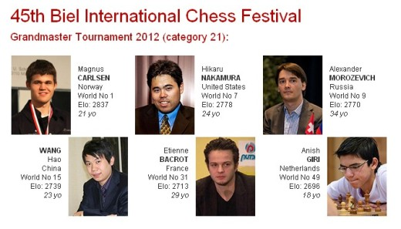

WA Championship: After 4 rounds leading scores are Haydn Barber, defending champion Yita Choong, Marc Vliestra all 3/4. In the Reserves Saroha Chirag leads with 3/4 followed by Natalie Maris 2/3, Fred Maris & Ned Tomic 2/4.

SOLUTION: 1.c3! Bxa5 2.Rb7 & 3.Ba4#.

