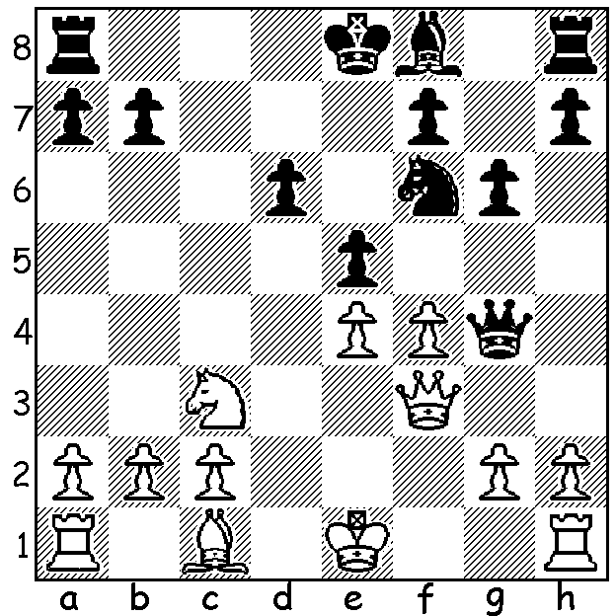

Diagram 446
Korchnoi – Spassky 1948
White to play & win (4 moves)

CHESS LEGENDS DEMOLISH GENEVA
After Biel last week we move across Switzerland to its second most populous city Geneva, home to many UN agencies. The city’s chess club organised a match, played Aug 4 – 10, between five of its top players and five living legends of the game ranging in age from 58 to 81, all of whom had been national champions and among the top GMs of their day, with all players playing two games against each of the opposition. Geneva’s players were rated 2332 - 2408 while the Legends were 2475 – 2595 so the Legends win by 33 -17 was not unexpected. Star attraction was 81 year old Viktor Korchnoi, a two-time challenger for Anatoly Karpov’s world championship title. Despite his age and being confined to a wheelchair Korchnoi was equal top scorer with 7/10 (+6 =2 -2). Other Legend scores: Kevin Spraggett (Canada) & Zoltan Rubli (Hungary) 7/10, Ulf Andersson (Sweden) 6.5, Vlastimil Hort (ex-Czech champion) 5.5.

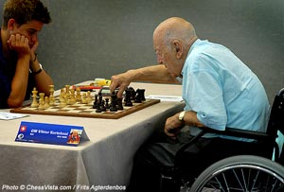
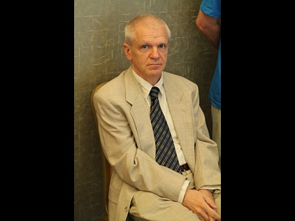
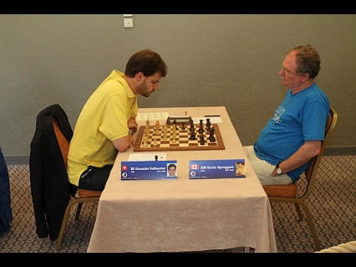

Korchnoi in play against Lars Vuilleumier v Spraggett Zoltan Ribli
Rindisbacher who made a IM norm
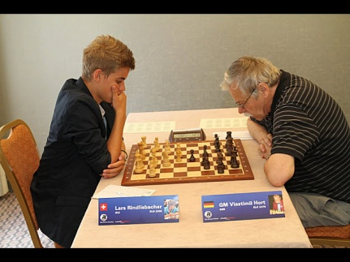
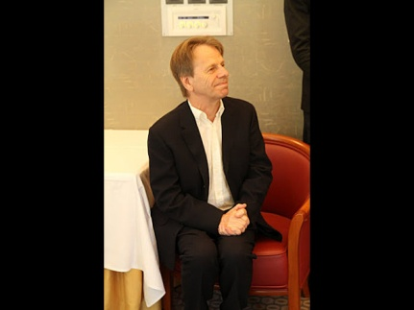

Ulf Andersson Vlastimil Hort v Rindisbacher
Here is one of Korchnoi’s wins showing his continuing flair for combinations and fine endgame technique:

Viktor Korchnoi - Alexandre Vuilleumier
Legends v Geneva, August 2012
Nimzoindian Defence, Classical Variation (4.Qc2)
1.d4 Nf6 2.c4 e6 3.Nc3 Bb4
4.Qc2 0-0 5.Bg5 c5 6.e3 h6
7.Bh4 cxd 8.exd Nc6 9.Rd1 d5
10.Nf3 b6(a) 11.cxd exd 12.Bb5 Bd7(b)
13.0-0 g5 14.Bg3 Bxc3 15.Qxc3 Ne4
16.Qb3 Nxg3(c) 17.fxg3 Ne7 18.Ne5 Be6
19.Qd3 Kg7 20.Ba4 Rc8 21.Bc2 Rh8
22.Rde1 Qc7 23.Bb1 Qd6 24.g4 Nc6
25.Ng6!(d) Bxg4 26.Nxh8 Rxh8 27.Re8!(e) Nb4
28.Qe3 Rxe8 29.Qxe8 Be6 30.Bf5 a5
31.a3 Nc6 32.Bxe6 Qxe6 33.Qxe6 fxe6
34.Rd1 a4 35.Rd3 Na5 36.Kf2 Nc4
37.b3 axb 38.Rxb3 Kg6 39.g4 h5
40.gxh+ Kxh5 41.Kg3 Kg6 42.a4 Kf5
43.Rb1 Ke4 44.Kg4 Kxd4 45.Kxg5 Kc3
46.h4 Kc2 47.Rf1 resigns(f)

a) 10…Be7 would break the annoying pin on the knight – 11.Be2 dxc 12.Bxc4 a6 13.0-0 b5 14.Be2 Nb4 15.Qb1 Bb7 16.Ne5=.
b) 12…Re1+ 13.Kf1 Bb7 14.Bxf6 Qxf6 15.Nxd5 Qd6 leaves Black with a good position for the pawn sacrifice.
c) Dubious, exchanging his most active piece and opening the f file for White’s rook. 16…Na5 17.Qb4 Bxb5 18.Qxb5 a6 looks better.
d) A spectacular move exposing Black’s weaknesses around his king: if now 25…Rhe8 26.Ne7! Nxe7 27.Qh7+ Kf8 28.Qxh6+ Kg8 29.Bh7+ Kh8 30.Bg6+ Kg8 31.Qh7+ Kf8 32.Rxf7+ Bxf7 33.Qxf7# or 25…Rhd8 26.Nh4! gxh4 27.Qh7+ Kf8 28.Qh8+ Ke7 29.Rxf7+! Kxf7 30.Qh7+ mating.
e) White’s plan is to exchange pieces and pawns to reach an endgame where the rook will be too strong for the knight.
f) White’s h pawn promotes too quickly – 47…Ne3 48. h5! Nf4 49.Rxf4!

SOLUTION: 1.Nd5! If 1…Qxf3 2.Nxf6+ Ke7 3.Nd5+ K moves 4.gxf3 and White is a piece up: if 1…Qh4+ 2.g3. Note the two zwichenzugs on moves 2 & 3. Korchnoi was a teenager while future world champion Spassky was only 11.

