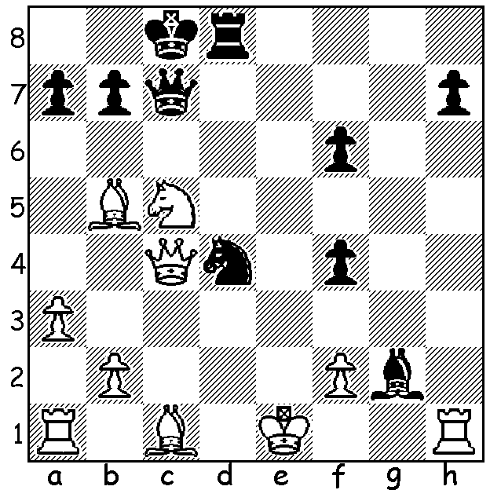

Diagram 447
Svidler – Vitiugov (Russian Ch.2012):
Black to play and win (4 moves):

Gary Kasparov again arrested in Moscow

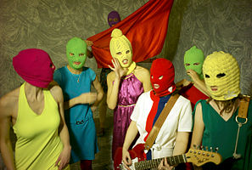

Readers may well have followed the story of
the three members of the Russian feminist punk rock group Pussy Riot who were sentenced to
two years imprisonment for their unauthorised
rendition in March of an anti-Putin song at
Moscow’s Cathedral of Christ the Saviour.
There have been demonstrations against the
convictions in many countries and in one, in
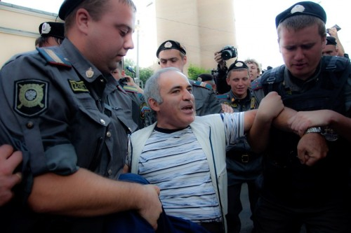
Moscow itself, about 40 of around 400
demonstrators were taken into police custody,
among them former world chess champion
Gary Kasparov who was being interviewed
by a reporter. Police allege Kasparov bit the
hand of one arresting officer while Kasparov
claims he was beaten up while in custody.

Russian Championship

Still in Moscow, the Russian Championship Super Finals with 10 players resulted in a six player tie, all with 5/9, among them Sergey Karjakin and defending champion Peter Svidler, who after 8 successive draws defeated Alexander Grischuk in the final round.
In all there were 34 draws in the 45 games, evidence of the high standard. Winner was 22 year old Dmitri Andreikin, the 2010 World Junior champion, who scored4/5 in the Rapid Play-Off. Here is one of his exciting games from the event:

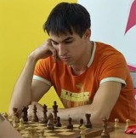
Dmitri Andreikin - Sanan Sjugirov
2012 Russian Championship Finals
Caro-Kann Defence
1.e4 c6 2.d4 d5
3.Nd2 dxe 4.Nxe4 Nd7
5.Bc4 Ngf6 6.Ng5 e6
7.Qe2 Nb6 8.Bd3 h6
9.N5f3 c5 10.dxc Bxc5
11.Ne5 0-0 12.Ngf3 a6
13.g4! Nbd5 14.Rg1 Bb4+
15. Kf1(a) Be7 16.g5 hxg
17.Nxg5 Bd6 18.Nh7!! Qc7(b)
19.Bh6 Ne8 20.Bxg7!! Nxg7
21.Rxg7+! Kxg7 22.Qg4+ Kh8
23.Nf6! resigns(c) Dmitri Andreikin

a) Not 15.c3? Nxc3!
b) If 18…Nxh7 19.Bxh7+ Kxh7 20.Qh5+ Kg8 21.Rxg7+! Kxg7 22.Bxh6+ Kg8 23.Qg4+ Kh8 24.Qg7#.
c) If 23…Bxe5, 24.Qh4+ Kg7 25.Qg5+ Kh8 26.Qh6#.

SOLUTION: 1…Qa5+: if 2.b4 Qxb5 3.Qxb5 Nc2+ 4.Ke2 f3#: if 2.Qc3 Qxc3+ 3.bxc3 Nc2+ 4.Ke2 f3#: if 2.Bd2 Nf3+ 3.Ke2 Qxd2#: if 2.Kd1 Bf3+ 3.Qe2 Nxe2+ wins. Black failed to find the win and took a perpetual check with 1…Nf3+ 2.Ke2 Nd4+ 3.Ke1 Nf3+.

