
Kasparov found not guilty
The charge against ex-world champion Gary Kasparov that he took part in an illegal demonstration after he was arrested at a protest against the sentences handed out to members of the female pop group Pussy Riot was thrown out. The Moscow court found the police case unreliable after video evidence was provided by the defence. At a press conference after his release Kasparov
Vowed to press charges against the police for illegal arrest, false testimony and slander.
Kasparov at press conference after release

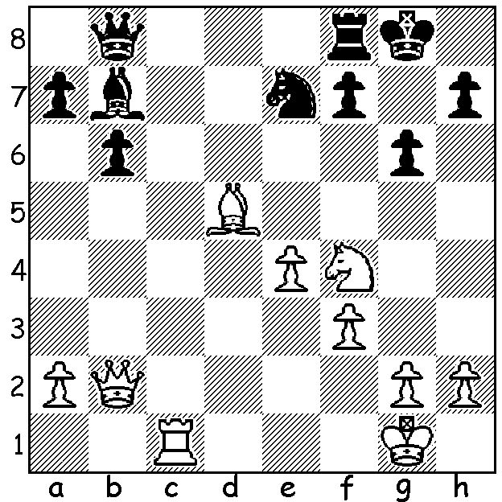

Diagram 448 Gligoric-Pachman:
Whte to play & win
(on move 7 White establishes a
winning material advantage:
moves 1 & 3 are the tricky ones):

SVETOZAR GLIGORIC (1923 – 2012)
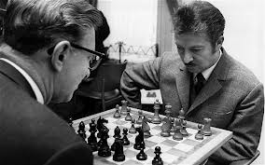
The legendary Serbian Grandmaster Svetozar Gligoric
died on August 14 in Belgrade after a stroke aged 89.
He, together with Samuel Reshevsky (USA), Miguel
Najdorf (Argentina) and Laszlo Szabo (Hungary), was
a member of a select group of players able to challenge
the domination of the Soviet Union post WWII and
during the 1950s and 60s was one of the world’s top ten
player. Gligoric learnt chess at the age of eleven from
a boarder at his family home. After becoming a Master
his chess career was interrupted by WWII and as a
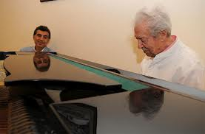
teenager he joined the partisan resistance. He was Yugoslav champion 12 times and represented his country with great success in 15 Olympiads, gaining 2 gold medals, 6 silver and 5 bronze. He made significant contributions to the theory of the Ruy Lopez and especially the Kings Indian Defence. He was also an accomplished pianist and during his chess career would bring home records of jazz and
popular music from abroad, helping to familiarise Yugoslavs with contemporary western culture. As late as 2011 he had a number of his own compositions (words & music) published and performed.
Gligoric v Vassily Smyslov & Gligoric at piano 2011.

Svetozar Gligoric - Pave Bidev
Belgrade 1946
Ruy Lopez: Closed System, Flohr-Zaitsev Variation
1.e4 e5 2.Nf3 Nc6
3.Bb5 a6 4.Ba4 Nf6
5.0-0 Be7 6.Re1 b5
7.Bb3 d6 8.c3 0-0
9.h3 Bb7 10.d3 Nd7
11.Nbd2 Nc5 12.Bc2 d5
13.exd Qxd5(a) 14.Nf1 Rad8
15.Ne3 Qd7 16.d4 exd(b)
17.cxd Qc8 18.Bd2 Na4
19.d5(c) Nb8 20.Nf5 Bf6
21.Ng5 g6(d) 22.Nxh7! Kxh7
23.Ne7 Bxe7 24.Qh5+ Kg8
25.Bxg6 fxg6 26.Qxg6+ Kh8
27.Rxe7 resigns

a) Black appears to have an advantage as he is well developed in contrast to White.
However once White unravels and Black, lacking a defensive knight on f6, will face an attack on the kingside.
b) White retains an advantage after 16…e4 17.dxc5 Qxd1 18.Bxd1 exf3 19.Bxf3 Bxc5 20.Nf5.
c) Much superior to 19.Bxa4 bxa4 20.Qxa4 Bf6.
d) Even worse is 21.h6 22.Nh7! Kxh7? 23.Ne7+ winning the queen.

SOLUTION: 1.Ne6!! fxe6 (Black must capture as 2.Qg7# was threatened) 2.Bxe6+ Rf7 3.Qf6! (better than 3.Qb3 as it keeps Black’s king from g7) 3…Qf8 4.Rc7 Qg7 5.Bxf7+ Qxf7 6.Qxf7+ Kxf7 7.Rxb7.

