Diagram 449 Wim Blijstra – David Smerdon (Curacao 2012): Black to play and win:
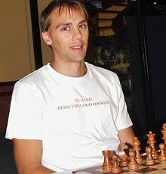
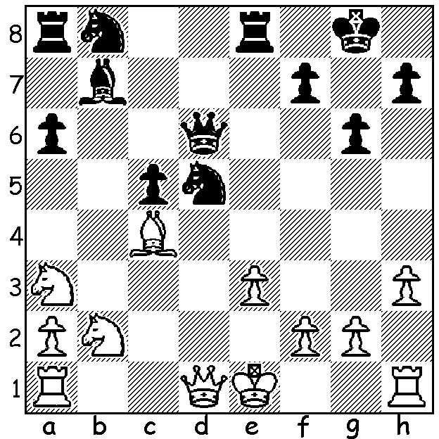

2012 CHESS OLYMPIAD: While the Olympics and Paralympics have received much media attention, few in the general public would be aware of the 2012 Chess Olympiad which started in Istanbul on August 27 with 158 teams competing in the Open and 126 in the Women’s event. Australia has a five player team and non-playing captain in each event but, despite the considerable costs involved, receives not one penny in government assistance. Contrast this with the estimated $380,000,000 it cost the Australian public to prepare and send representatives to the Olympics. Unfortunately three of our top players, expected top board Zhao Zong-Yuan, George Xie and 2012 Australian champion Daryl Johansen, are not available with our open team being David Smerdon, Moulthon Ly, Aleks Wohl, Stephen Solomon and Max Illingworth. After 5 rounds Armenia & Russia are the only teams to have won all their matches while Australia has 3 wins, a draw and a loss. After sitting out Rd 1 David showed his attacking flair in Rd 2:

David Smerdon (Australia) - Frode Elsness (Norway)
2012 Olympiad Rd 2, Bd 1. Evans Gambit Accepted
1.e4 e5 2.Nf3 Nc6
3.Bc4 Bc5 4.b4 Bxb4
5.c3 Be7(a) 6.d4 Na5
7.Be2 exd 8.Qxd4 Nf6(b)
9.e5 Nc6 10.Qh4 Nd5
11.Qg3 g6 12.0-0 0-0
13.Rd1 Nb6 14.c4 Na4(c)
15.Bh6 Re8 16.c5(d) Nxc5
17.Nc3 d6 18.h4?(e) Be6?
19.h5 Qc8 20.hxg hxg
21.Rac1 Rd8 22.Bg5 dxe
23.Qh4 Re8(f) 24.Bb5 Bf8
25.Bxc6 bxc6 26.Nxe5 Qa6
27.Bf6 Bg7 28.Bxg7 Kxg7
29.Qd4 Nb7 30.Ng4+ Kf8
31.Qh8+ Ke7 32.Qf6+ Kf8
33.Ne5 Kg8(g) 34.Rd4 Qa3
35.Rh4!!(h) Qxc1+ 36.Kh2 Qxc3
36.Rh8#

a) Other accepted moves are 5…Ba5 & 5…Bc5.
b) 8…d6 9.Qxg7 Bf6 10.Qg3 Qe7 11.0-0 was Shirov-Timman 1995). The game follows Kasparov-Anand 1995.
c) Preventing 15.Nc3.
d) Enabling White to develop his knight to its best square: now 16…Bxc5 would lose time as the bishop will have to return to cover the weak black squares.
e) Better 18.Bc4 as Black could now play18…Nxe5! & if 19.Nxe5 Bxh4 20.Nxf7 Kxf7 21.Qf3+ Qf6 with advantage.
f) Black could lessen the attack with 23…f6! 24.Bxf6 Bxf6 25.Qxf6 Bf7; now White gets a winning attack.
g) 34.Nxg6+ was threatened.
h) Brilliant play (moving the rook would allow Black to defend with 35…Qf8).

CHESS OLYMPIAD APPEAL: Readers wishing to make contributions can find details on the Australian Chess Federation or WA Chess Association websites (auschess.org.au or cawa.org.au).

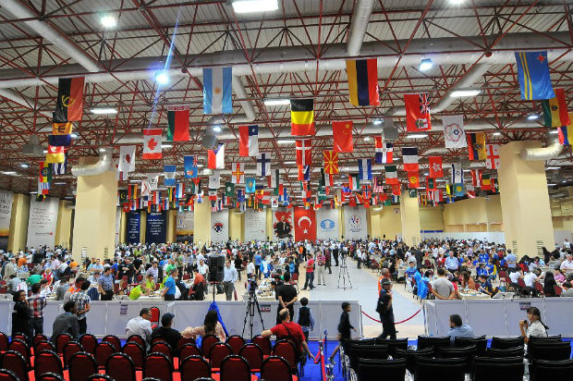

SOLUTION: 1…Nxe3! If 2.Qxd6 Nxc4+ & 3…Nxd6 winning a piece. Game continued 2.fxe3 Rxe3+ 3.Be2 Qg3+ 4.Kd2 Rxa3 5.Qc2 Nc6 & White resigned in the face of an overwhelming attack.

