Russia crash to USA at Olympiad
Russia seemed headed for the Olympiad title after being sole leader after eight rounds in the Olympiad in Istanbul. However a surprise loss to USA which was out-ranked on all boards in Rd 9 left four teams, Russia, USA, China and Armenia, locked on the same score. Hikaru Nakamura defeated Vladimir Kramnik, Gata Kamsky won a R + B v R ending (no pawns) against Alexander Grischuk and despite Ray Robson losing to Dmitry Jakovenko, a draw from Alexander Onischuk against Sergey Karjakin meant a 2.5-1.5 victory to the Americans.

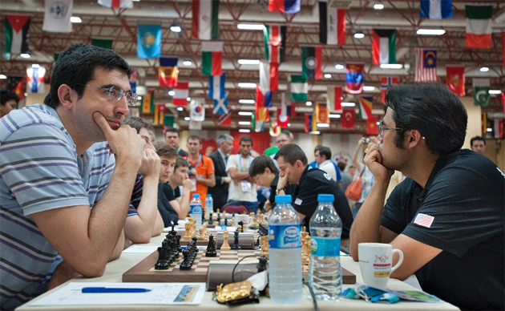
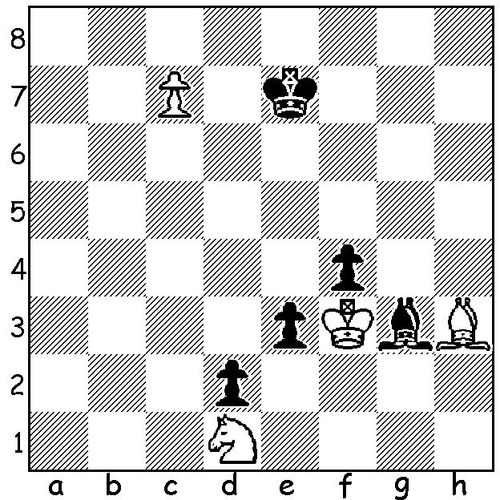

Diagram 450 Nakamura – Kramnik
(2012 Olympiad, Rd 9): Black to play:
can you work out the next move of each
side as Black tries to draw and White Nakamura (W) v Kramnik (B)
refutes his attempt?

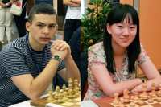
The World Junior Championships were
held in Athens between 2 & 15 August with
130contestants in the Open (12 GMs) and
67 in the Girls’ (7 WGMs). Winner was
19 year old Alexander Ipatov (Ukraine)
and runner-up 16 year old Richard Rapport
(Hungary), both with 10/13. Australia had
two players in the Open, Andrew Brown (6.5)
& Fedja Zulfic (5).

Below is a game from the winner employing
an unusual defence:

World Junior champion Alexander Ipatov (Ukraine)
and World Girls champion Guo Qi China)

Nib Grandelius - Alexander Ipatov
2012 World Junior Championship
Queens Pawn: Two Knights Tango Defence
1.d4 Nf6 2.c4 e6
3.Nf3 Nc6 4.a3 d6
5.Nc3 g6 6.g3 Bg7
7.Bg2 0-0 8.0-0(a) a6
9.d5 Na5 10.Nd2 Rb8
11.b4 Nxc4! 12.Nxc4 Nxd5
13.Nxd5 Bxa1 14.Bh6 Bg7
15.Bxg7 Kxg7 16.Qd4+ f6
17.Nc3 d5!(b) 18.Na5?(c) c5!
19.Qf4(d) Bd7 20.Rd1(e) b6
21.Nb3 c4 22.Nd2 e5
23.Qf3 d4 24.Nd5 Rc8
25.e4 c3 26.Nf1 Bb5
27.h4 f5! 28.Rc1 Bc4
29.h5 b5 30.hxg hxg
31.g4 Qg5 32.Qg3 Rfe8?(f)
33.gxf Qxg3 34.f6+! Kf8
35.fxg Bxd5 36.exd5 e4
37.d6 Rcd8 38.g4 e3
39.g5 e2 40.Kf2 d3!
41.Ne3 Rxe3! 42.Rh1 e1=Q
Resigns

a) This position occurred in Voon-Ellis (in article Aug 2011 with …Nc6 played on move 2). I now played 8…e5. The move chosen leads to a position similar to the Yugoslav Variation of the Kings Indian Defence.
b) With rook and 2 pawns for the 2 minor pieces Black will use his extra pawns to cramp White, making it impossible for him to utilize his extra piece.
c) 18.Nb2 a5 19.Nd3 should be played.
d) If 19.Qxc5? b6 wins.
e) 20.Nb3 would give White better chances of checking the advance of Black’s pawns.
f) An insignificant slip missing the zwischenzug on move 34.

SOLUTION: 1…e2! & if 2.Kxe2 f3+! 3.Kxf3 Bxc7 drawing. Unfortunately for Black White has 2.c8=N+! and White wins with his extra 2 minor pieces.

