DEATH BRINGS HALT TO FRENCH CHAMPIONSHIP

The French Championship (13 -25 August) was halted after the 10th of 11 rounds after the death
of the four month son of leading player Christian Bauer. The final round was cancelled with

Bauer, Etienne Bacrot, Romain Edouard & Maxine
Vachier-Lagrave all equal and undefeated on 7/10
(the final round would have pitted Bauer against
Edouard). It was then agreed that, rather than a series
of play-off games, the title would be shared between
the four players. This has been described as ‘an
honourable and praiseworthy decision by the players
and organizers, out of respect for GM Bauer’.

Christian Bauer
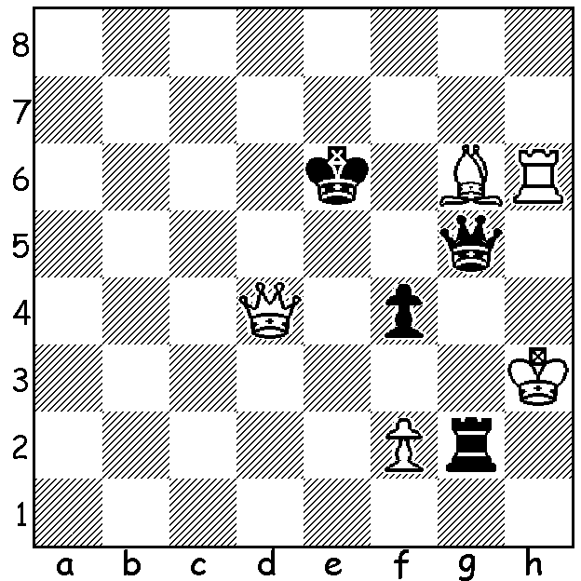

Diagram 451
Vachier-Lagrave – Vaissier
(French Ch 2012):
despite Black’s many threats
White wins quickly.

Romain Edouard - Andrei Istratescu
2012 French Championship, Rd 1
Sicilian, Velimirovic Attack
1.e4 c5 2.Nf3 d6
3.d4 cxd 4.Nxd4 Nf6
5.Nc3 Nc6 6.Bc4 e6
7.Be3 Be7 8.Qe2 a6
9.0-0-0 Qc7 10.Bb3 0-0
11.Rhg1 Nd7 12.g4 Nc5
13.Nf5! b5(a) 14.Bd5! Bb7(b)
15.g5 Rfc8!(c) 16.Rg3(d) Bf8
17.Qh5 g6 18.Nh6+ Kh8
19.Qh4 b4 20.Rh3 bxc3
21.Ng4 f5 22.Nf6 h6
23.Qxh6+! Bxh6 24.Rxh6+ Kg7
25.Rh7+ Kf8 26.Rh8+ Kg7
27.Rh7+ Kf8 28.Rh8+ Kg7
29.Rh7+ Draw(e)

a) 13…exf5 14.gxf5 Ne5 15.Nd5 Qd8 16.f4 or 13…Rd8 14.Nxe7+ Qxe7 15.g5 b5 16.Qh5 Bb7 17.Rg3 g6 18.Qh6 both with a fearsome attack: 13…Nxb3+ 14.axb3 b5 15.Nxe7+ Nxe7 16.Qd3 d5 17.exd Nxd5 18.Nxd5 exd5 is slightly better for White.
b) If 14…exd5 15.Nxd5 Qb7 16.e5! Ne6 17.exd Bd8 with a wild game.
c) Black needs to be very accurate in defence – 15…b4 16.Qh5! Ne5 17.Rg3 exf5 18.exf5 bxc3 19.g6 cxb+ 20.Kb1 hxg 20.fxg Nxg6 21.Qxg6 wins or 15…exf5 16.g6! hxg 17.Rxg6 Ne5 18.Rxg7+! Kxg7 19.Rg1+ Ng6 20.exf with advantage.
d) 16.Qh5 Ne5 17.f4 Ng6 18.Rg3 b4 19.Rh3! Nf8 20.Bd4 exd5 (20…bxc3 21.Qh6!!) 21.Bxg7 Bd8 22.Bd4 f6 23.gxf6 Ng6 24.f7+ wins (Ginsburg-Lanka 1997) but there must be improvements for Black.
e) What imaginative attacking play by White and what resourceful defence by Black, you might think. Well, no, the two players were following Onishchuk – Shirov 1996/97, a fact I found when consulting Nunn’s Chess Openings. This game is therefore a good argument for Randomised Chess where the pieces occupy different places from the usual set-up on the back rank, thus negating the intense opening study necessary for success and placing more reliance on a player’s imagination and calculation from a very early stage.

OLYMPIAD: After defeating Russia, USA lost to China in Rd 10 while both Russia and Armenia won, leaving China, Armenia and Russia joint leaders. Australia’s score is +5, =3, -2.

SOLUTION: 1.Bf5+! resigns (1…Kxf5 2.Qd5# ).

