ARMENIA WIN CHESS OLYMPIAD


The recently completed Chess Olympiad in Istanbul
(157 teams) was won by Armenia on tie-break from
Russia after both teams finished on 19/22 (+9 =1 -1).
China (+8 =1 -2) had led into the final round but a
loss to Ukraine (+9 -2) relegated them to 4rd place.
2010 winners Ukraine gained the bronze medals while
USA (+7 =3 -1) , the only team to defeat Russia,
finished 5th. Armenia’s top board and world number
2 Levon Aronian gained the gold medal for best
performance on Bd 1 while Armenia’s success was
their 3rd in the last four Olympiads. Australia with
14 pts (+5 =4 -2) finished in a group 19th to 33rd but
was placed 32nd on tie-break. In the Women’s
Olympiad (127 teams) Russia and China both scored Levon Aronian
19/22 (+8 =3) with Russia declared winners on tie-break.

Diagram 452: Wang Yue (Black) punishes Movsesian for his lack of development and helps China defeat Armenia with a brilliant sacrificial attack (6 moves):

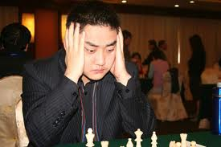
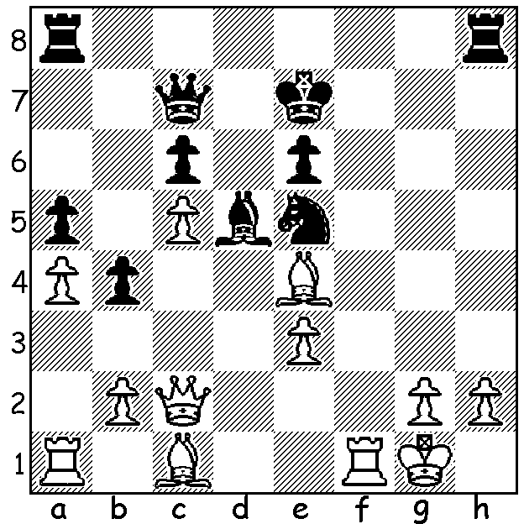 Wang Yue

Here is a fascinating game from the final round with former challenger to world champion Viswanathan Anand, Veselin Topalov, defeating his Venezuelan oppenent in a complex game with rook, bishop & knight battling against a queen + 2 pawns:

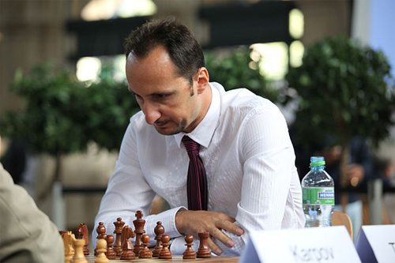
Veselin Topalov (Bugaria)
Eduardo Itturrizanga (Venezuela)
2012 Olympiad Rd 11, Bd 1
Queens Indian Defence
1.d4 Nf6 2.c4 e6
3.Nf3 b6 4.g3 Ba6
5.Qc2 Bb4+ 6.Bd2 c5
7.Bxb4(a) cxb4 8.Nbd2 Nc6
9.e4 0-0 10.Bd3!(b) Rc8(c)
11.e5 Ne8 12.Bxh7+ Kh8
13.Bd3 d5 14.exd6(d) Nxd6
15.0-0 Qf6 16.c5!?(e) Nxd4 Veselin Topalov
17.Nxd4 Rxc5 18.Bxa6 Rxc2
19.Nxc2 Qxb2 20.Rfc1 Rd8 21.Kg2 g6
22.Nb3 Ne4 23.Bb7 Nc5 24.Rab1 Qf6
25.Bf3 Nxb3(f) 26.axb3 Rd2 27.Ne3 Qd4
28.Kg1 Qf6 29.Kg2 Qd4 30.Rc8+ Kg7
31.Re1 a5 32.Ng4 f5(g) 33.Rc7+ Kf8
34.Ne3 Qb2 35.Rf1 b5 36.Rb7 Qc3
37.Re1 a4 38.bxa bxa 39.Nd1 Qb3
40.Re5 Rd8?(h) 41.Reb5 Rd4 42.Ne3 a3
43.Nd5!! resigns(i)

a) Giving Black a useful queenside majority but gaining domination of the centre.
b) The bishop is more aggressively placed on d3 than on g2.
c) Offering a pawn to gain some initiative attacking White’s centre.
d) White could play 14.c5 but after 14…Bxd3 15.Qxd3 bxc 16.dxc f6 17.Nd4 Nxd4 18.Qxd4 fxe Black’s strong centre gives good counter-play.
e) Leading to severe complications and a considerable imbalance in material with Q+2p v R, B & N.
f) 25…Na4 26.Rd1 Nc3 is better.
g) This may be the best move but it leads to the king becoming severely exposed to attack.
h) 40.Rxd1 41.Bxd1 Qxd1 42.Ra5 Qd8 43.Raa7 b3! 44.Rh7 Kg8 45.Rhg7+ (not 45.Rag7+ Kf8 46.Rh8+ Kxg7 47.Rxd8 b2 or a3 queening) 45…Kf8 46.Rh7 draw. Now the game slips away from Black.
i) 43…exd5 44.Ra5 mating or 43…axb 44.Rb8+ Kg7 45.R5b7+ Kh6 46.Rh8+ Kg5 47.h4#.

SOLUTION: 1…Nd3! (clearance sacrifice) 2.Qxd3 Qxh2+ 3.Kf2 Raf8+ 4.Ke2 Rxf1 5.Kxf1 Qg3 threatening 6…Rh1+ . White could now only play 7.Ke2 & lost after 7…Rh1 8.Bd2 Rxa1 (8.Kd2 Qe1+ 9.Kc2 Bxe4 10.Qxe4 Qd1#).

