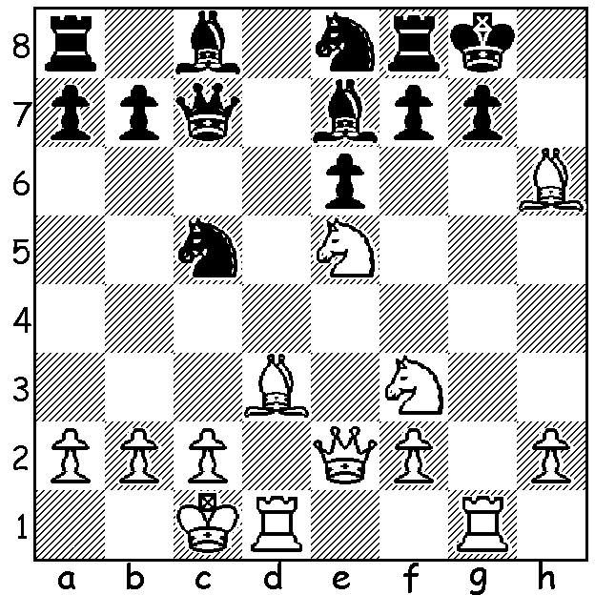
Stephen Solomon – John Harris 1998:
Hervey Bay Open 1998
Caro-Kann Defence
1.e4 c6 2.d4 d5 3.Nc3 dxe
4.Nxe4 Nd7 5.Bc4 Ngf6 6.Ng5 e6
7.Qe2 Nb6 8.Bd3 h6 9.N5f3 Qc7
10.Ne5 Bd6 11.Ngf3 0-0 12.g4 c5
13.dxc Bxc5 14.Rg1 Nbd7 15.g5 hxg
16.Bxg5 Be7 17.0-0-0 Nc5 18.Bh6 Ne8
Now work out White’s winning plan
(look ahead a minimum of 4 moves):

At the recently completed Chess Olympiad in Istanbul, won by Armenia, Australia with 14 pts (+5 =4 -2) finished in a group 19th to 33rd out of 157 teams but was placed 32nd on tie-break. While Australia’s team was well under strength with previous Bd 1 Zhao Zong-Yuan, George Xie and Australian champion Darryl Johansen all missing, the result was well above expectation built on three excellent performances by Bd 2 Moulthun Ly (7/10), Bd 3 Stephen Solomon(6/9) and Bd 4 Max Illingworth (7/10). Bd 1 David Smerdon began well, reaching 4/7 before losing his last three games, in one of which he forgot his clock and lost on time in a winning rook & pawn ending. Aleks Wohl, who had previously performed well at Olympiads, was very much out of sorts, scoring a solitary draw in his 5 games.

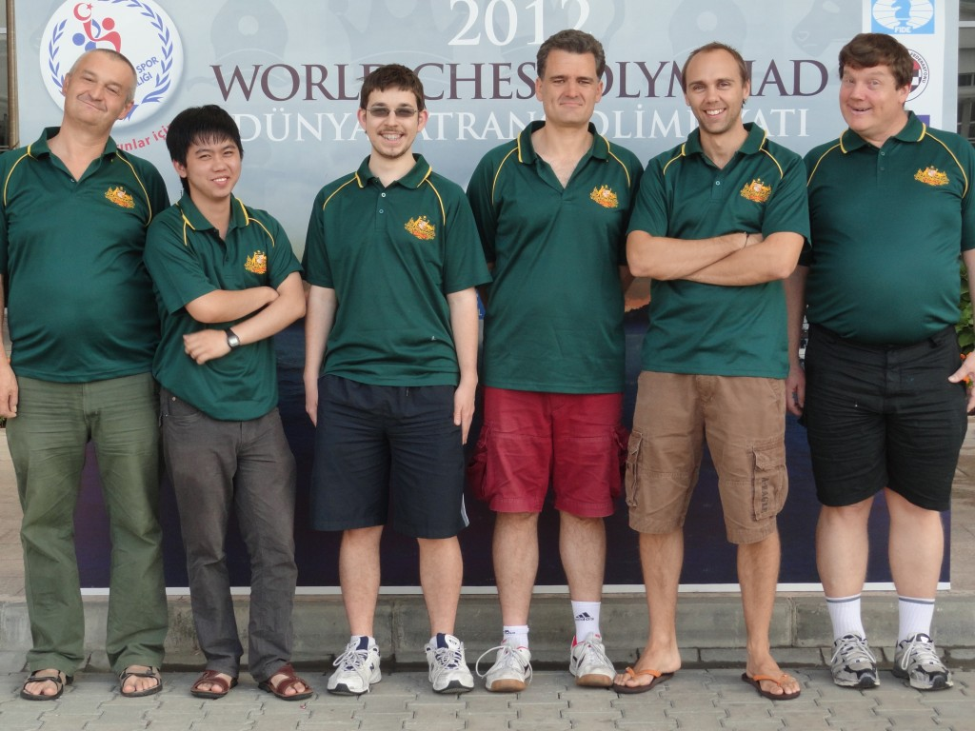

Wohl, Ly, Illingworth, Manuel Weeks (captain), Smerdon, Solomon

Stephen Solomon, born in 1963, a former Australian Junior champion and twice Australian champion, was the veteran of the side having played previously in seven Olympiads. Here is a sparkling win of his from the 2012 event:

Stephen Solomon (Australia) Ryan Rhys Griffiths (Ireland)
2012 Olympiad Istanbul, Rd 8
Sicilian Defence, Najdorf Variation
1.e4 c5 2.Nf3 d6
3.d4 cxd 4.Nxd4 Nf6
5.Nc3 a6 6.Bg5 Nbd7
7.Bc4 Qb6 8.Bb3 e6
9.Qd2 Be7 10.0-0-0 Nc5
11.f3 Qc7 12.Kb1 0-0(a)
13.g4 b5 14.a3 Rb8
15.h4 Bd7 16.Bxf6 Bxf6(b)
17.g5 Be7 18.h5 a5
19.g6 Bf6(c) 20.h6 hxg(d)
21.Qh2 Rfc8(e) 22.Nf5! exf5
23.Nd5(f) Qd8 24.hxg Kxg7(g)
25.Nxf6 Qxf6 26.Rxd6! Be6
27.e5 Qg5 28.Qh7+ Kf8
29.Bxe6 resigns(h)

a) Black could keep his king in the centre while preparing a queenside advance.
b) White has a strong attacking position and if now 16…gxf6, 17.Nf5! Qd8 18.Rhg1.
c) If 19…fxg 20.Nd5! Qd8 (20…exd5 21.Bxd5+ Kh8 22.hxg h6 23.Rxh6+! gxh6 24.Qxh6#) 21.hxg hxg 22.Ba2 with advantage.
d) 20…Nxb3 seems logical while 20…fxg is also possible – eg 21.Nd5! Nxb3 22.Nxf6+ Rxf6 23.Nxb3 a4 24.Qxd6! Rc8 25.Qxd7 Qxc2+ 26.Ka1 Rf7 27.Qxe6 axb3 28.hxg b4=.
e) Black should play 21…Rfe8 – eg 22.Nf5 exf5 23.Nd5 Qd8 24.Nxg6+ gxf6 25.h7+ Kh8 26.Bxf7 fxe 27.Bxe8 Qxe8 28.Qxd6 Qe5 29.Qxe5 fxe5 30.b4 axb 31.axb Nd3 cxd3 exf3.
f) 23.hxg first is better.
g) This loses: Black has a defence in 24…Bh4! (25.exf Bxf5).
h) 29…Nxe6 30.Rd7 mating.

WA CHAMPIONSHIP: Defending championYita Choong retained the state title with 7.5/9 (+6 =3) with many times champion Haydn Barber in second place with 6.5 (+4 =5). Peter de Yaak and Natalie Maris tied for the Reserves championship, both on 5/6 (+5 -1), with Natalie also retaining the WA Women’s title.

SOLUTION: 19.Bxg7!! Nxg7 20.Rxg7+! Kxg7 21.Rg1+ Kh8 22.Qe3: Black now struggles to avoid mate but White is relentless – 22…Nxd3+ 23.Nxd3 Kh7 24.Nfe5 Qd8 25.Rg4 Rg8 26.Nxf7 Rxg4 27.Qh6+ Kg8 28.Qh8+! Kxf7 29.Ne5# (White is two rooks & a bishop down - brilliant!)

