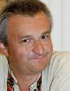
Diagram 454 Aleks Wohl – John Hodgson
(2010 London Classic Open):
White to play and win (4 moves):
after something of a blood bath
White’s final move wins a piece.

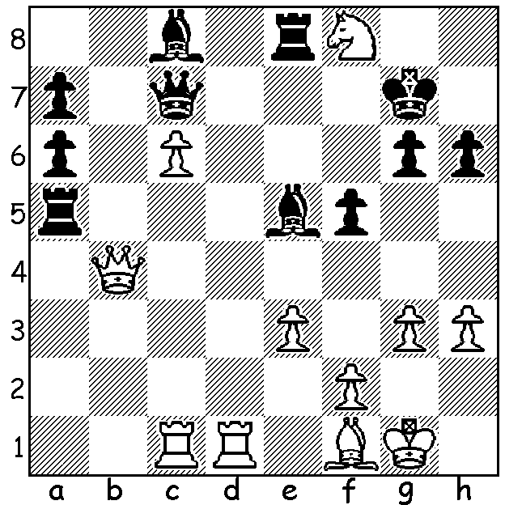 Aleks Wohl

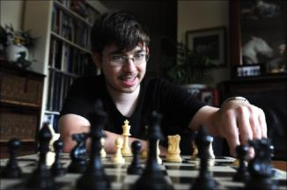
Continuing with a review of members of Australia’s team at last month’s Istanbul Olympiad we look at a game of Board 4 Max Illingworth who with 5 wins, 4 draws and only one loss played an important part in Australia winning 5 and drawing 4
of its 11 matches. Max is an IM (International Master)
and will be hoping to achieve the rank of GM
(Grandmaster) in the not too distant future. He
is the current NSW champion (as he was in 2011)
and with a current rating of 2394 is ranked seventh
in Australia and its top junior. In his game below an
enterprising sacrifice leads to a complex position. His
opponent appears to be getting on top in the ending
as both sides seek attacks against the king but Max is
able to conclude with a pretty sacrifice for mate. Max Illingworth at Thai Open 2011

Max Illingworth (Australia) - Haseeb Ahmed (Pakistan)
2012 Olympiad Istanbul
Evans Gambit Declined
1.e4 e5 2.Nf3 Nc6
3.Bc4 Bc5 4.b4 Bb6
5.a4 a6 6.c3 Nf6
7.d3 d6 8.0-0(a) Bg4
9.h3 Bh5 10.Nbd2 0-0
11.Re1 d5 12.exd Nxd5
13.Ne4 Kh8 14.Bd2 f6
15.Ng3 Bf7 16.Bb3 Qd7
17.Bc2 Rad8 18.Nh4 a5
19.b5 Nce7 20.Qf3 Ng6
21.Nhf5 Ndf4 22.d4(b) Ne6
23.Be3(c) exd 24.cxd Rfe8
25.Rad1 Nef8 26.Nxg7!?(d) Bd5!(e)
27.Qxf6 Qxg7 28.Bg5 Ne6(f)
29.Nh5 Qxf6 30.Bxf6+ Kg8
31.Bxd8 Rxd8 32.Nf6+ Kf7
33.Nxd5 Rxd5 34.Bb3(g) Rd6
35.Rd3 Nf4 36.Rf3 Kg7
37.Re4 Rxd4 38.Re1(h) Ng5
39.Rg3 Kh6(i) 40.h4 Ne4
41.Rf3 Nd2 42.Rg3 Nxb3
43.Rxb3 Rd2 44.Rf1(j) Nd3
45.Kh2 Nxf2 46.Rg3 Bd4
47.Rg8 Ra2 48.Re1 Kh5
49.Re6 Rxa4 50.Kg3(k) Nh1+
51.Kf3 Ra3+?(l) 52.Kf4 Be3+
53.Rxe3+ Ra4+ 54.Kf5 Nf2
55.Rg5+ Kxh4 56.Rh3+! resigns(m)

a) Declining the gambit has resulted in a transposition to the Giuoco Pianissimo.
b) Not 22.Qxb7?? Bd5 23.Qa6 Ra8 trapping the queen.
c) Again not 23.Qxb7?? Nxd4! 24.Nxd4 Bd5.
d) Very speculative – safer was 26.Qg4 Bd5 27.h4.
e) Not 26…Kxg7?? 27.Nh5+ Kh8 28.Qxf6+ Kg8 29.Qg7# or 27…Kg8 28.Nxf6+ Kg7 29.Nxd7.
f) 28…Rxe1+ could result in a draw after 29.Rxe1 Rd6 30.Qxg7+ Kxg7 31.Nf5+ Kf7 32.Nh6+ Kg7 33.Nf5+ Kf7 etc.
g) After this pin Black has to take great care he doesn’t lose a piece.
h) Better 38.Re5 (38…Nc5 39.Re7+ Kf6 40.Rf7+ Ke5 41.Re3+ Re4 42.Rxe4+ Nxe4 43.Bc2=). Now Black’s pieces become very active, putting White on the defensive.
i) Black’s king is in danger from the rooks on the edge but worse is 39…Kf6 after 40.h4.
j) If 44.Rf3 Bxf2+! (not 44…Rxf2? 45.Rxf2 Nd3 46.Re6+ Kh5 47.Rxb6 winning) 45.Rxf2 Rxf2 46.Kxf2 Nd3+ 47.Ke2 Nxe1 48.Kxe1 Kh5 winning.
k) If 50.g3 Bf6! 51.Rxf6 Ng4+ 52.Rxg4 Kxg4 53.Rf7 Ra2+ 54.Kg1 Rb2 winning.
l) Better 51...Nf2 and if 53.g4+ Nxg4 53.Rg5+ Kxh4 54.Rxg4+ Kh5 and Black should win (55.Re7? Ra3+).
m) A delightful obstruction sacrifice to finish – 56…Nxh3 57.g3#.

SOLUTION: 1.Rd7+! Bxd7 2.cxd7 Rxf8 3.Rxc7 Bxc7 4.Qc3+ wins the bishop. A fine win from
Australia’s Wohl who was sadly out out of form at the Olympiad.

