Diagram 455 Moulthun Ly – Joar Gullestad Pettersen (Gibralter 2007): White is a piece up but facing mate: can you see how he escapes to reach a roughly even position (clue – simplification, 4 moves):
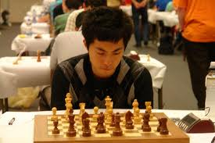
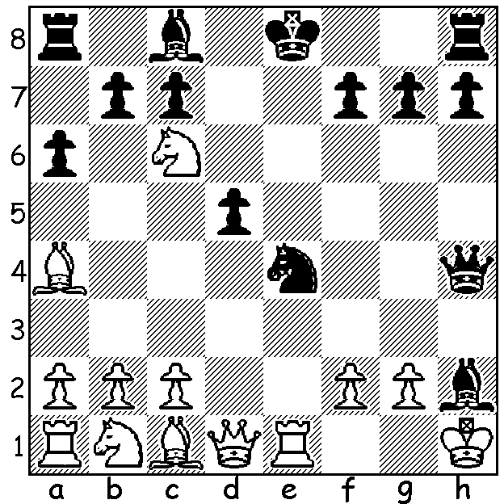
Moulthun Ly at Dutch Championship 2011

Continuing with a review of members of Australia’s team at last month’s Istanbul Olympiad we look at a game of Board 2 Moulthun Ly who with 6 wins, 2 draws and 2 losses was the undoubted star of the Australian team and together with Bd 4 Max Illingworth (also 7/10) played a major part in Australia winning 5 and drawing 4 of its 11 matches. Moulthun is an IM (International Master) and will almost certainly gain the rank of GM (Grandmaster) in the near future. He was Australian Junior champion at the age of 13 years 2 months, tied for first place in the Australian Open 2011 and is currently ranked fifth in Australia. In his game below Black seems to reached an excellent position with logical play on the queenside but White turns the tables completely thanks to an imaginative pawn sacrifice:

Moulthun Ly (Australia) - Vlatko Bogdanovski (Macedonia)
2012 Olympiad Istanbul, Rd 6
Caro-Kann Defence, Short Variation
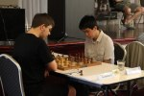
1.e4 c6 2.d4 d5
3.e5 Bf5 4.Nf3 e6
5.Be2 Nd7 6.0-0 Ne7
7.Nh4 Bg6 8.Nd2 c5
9.c3 Nc6 10.Nxg6 hxg6(a)
11.Nf3 Qb6 12.g3 Be7
13.Kg2 Rc8 14.Rb1 a6(b)
15.Be3 cxd 16.cxd Na5
17.Bd3 Nc4 18.Bc1 Qa5
19.b3 Na3 20.b4!(c) Bxb4
21.Bxa3 Qxa3 22.Rb3 Qa4
23.Qb1 Be7 24.Rxb7 0-0(d) Illingworth – Ly
25.Ra7 Ra8 26.Bc2 Qc6 (Australian Lightning 2012)
27.Qb7 Qxc2(e) 28.Rxa8 Rxa8
29.Qxa8+ Nf8 30.Qxa6 g5
31.h3 Qf5 32.Qb7 Ng6
33.Qb1 resigns

a) The position resembles a French Defence with Black without his generally passive white-squared bishop. This may seem in Black’s favour but the broken king side is likely to deprive him of the thematic break …f6.
b) Unecessary – 14..0-0 and then continue operating on the queenside although this would not worry White.
c) A most imaginative pawn sacrifice. White will regain the pawn with pressure on the 7th rank with Black’s pieces there under attack.
d) The contorted 24…Qa3 25.Ra7 Nb8 26.Bb5+ Kf8 leaves Black struggling.
e) If 27…Qxb7 28.Rxb7 Rfd8 29.Ba4 wins.

Here’s another Ly win: M. Ly – J. Fraser-Mitchell (Isle of Man International 2007: French Tarrasch) 1.e4 e6 2.d4 d5 3.Nd2 Nf6 4.e5 Nfd7 5.f4 c5 6.c3 Nc6 7.Ndf3 Qa5 8.a3 Be7 9.Rb1 Nxd4 10.Nxd4 cxd4 11.b4 Qc7 12.cxd4 Nb6 13.Nf3 Bd7 14.Bd3 Ba4 15.Qe2 Rc8 16.0-0 0-0 17.f5 Bc2 18.f6! gxf 19.Bh6! Bxb1 20.Bxb1 Qc3 21.Qf2 Kh8 22.Qh4 Rg8 23.exf Black resigns.

SOLUTION: 1.Rxe4+! (deflection) 1…dxe4 2.Qd8+! Qxd8 3.Nxd8+ Kxd8 4.Kxh2. With N + B for R +2p White was able to outplay his opponent and win in less than 20 further moves.
Full score: 1.e4 e5 2.Nf3 Nc6 3.Bb5 a6 4.Ba4 Nf6 5.0-0 Nxe4 6.d4 exd 7.Re1 d5 8.Nxd4 Bd6
9.Nxc6 Bxh2+ 10.Kh1 Qh4 11.Rxe4+! dxe4 12.Qd8+ Qxd8 13.Nxd8+ Kxd8 14.Kxh2 Be6 15.Nc3 c5 16.Bg5+ Kc8 17.Nxe4 b5 18.Nxc5 bxa4 19.Nxa4 Rb8 20.b3 Rb5 21.Be3 Re5
22.c4 Rd8 23.Nc5 a5 24.Rc1 h5 25.Rc3 Bf5 26.a3 f6 27.b4 g5 28.bxa Kc7 29.Rb3 Rxc5 30.Bxc5 Rd3 31.Rb1 Rxa3?? & resigns

