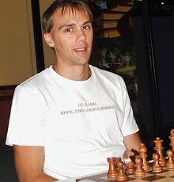
Diagram 456: David Smerdon – Gary Lane 200:
White to play and win (5 moves): 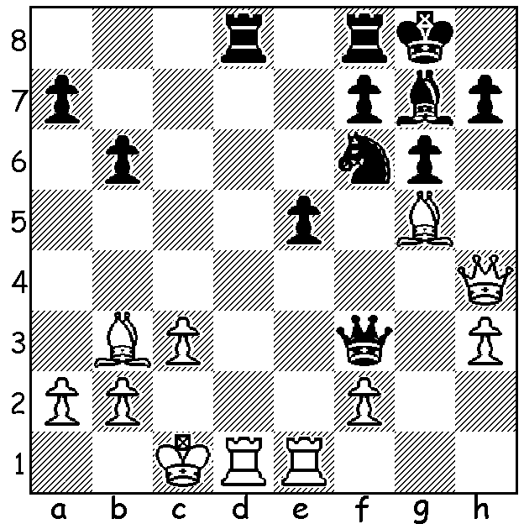

David Smerdon (pictured above), Australia’s Board 1 at the 2012 Chess Olympiad, is not only an adventurous and successful player but also a talented writer. His recent article on his use of the Dutch Stonewall Defence in the Olympiad in which he scored two draws from four games makes interesting and entertaining reading. In ‘An Open Letter to the Stonewall’ he writes: “It’s all over. I’m sorry. I’m breaking up with you once and for all. Please don’t try to convince me otherwise. I knew we said we’d be together forever but sometimes things have to end. I can’t put up with the hurt any more. You’re not to be trusted. You sucked me in with promises of a partnership full of joy and success (but) despite your outward allure, I know now that deep down you’re simply unsound.” I encourage readers to read the article in full on David’s blog.
Let’s see a game from the greatest exponent of the Dutch Stonewall, Mikhael Botvinnik, world champion between 1948 and 1963 (and Botvinnik himself also gave up the Dutch Stonewall after 1953, preferring the Grunfeld, Nimzoindian and Slav). In a typical game White attempts to counter Black’s kingside attack with play in the centre (e3-e4) and on the queenside, opening up the c file.

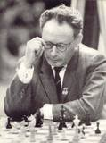
Mikhael Yudovitsch - Mikhael Botvinnik
Leningrad 1934
Dutch Stonewall Defence
1.c4 f5 2.d4 Nf6
3.g3 e6 4.Bg2 Be7
5.Nf3 d5 6.0-0 0-0
7.Nc3 c6 8.Qc2 Qe8
9.Bf4 Qh5 10.b3 Nbd7
11.Rad1 Kh8 12.Kh1 Rg8
13.e3 g5 14.Bc7 Ne8
15.Be5+ Nxe5 16.Nxe5 Nf6
17.f3 Bd6 18.e4 Nd7
19.g4(a) Qe8 20.Nxd7 Bxd7
21.e5 Bb4 22.gxf exf
23.cxd Bxc3 24.dxc6(b) Bxc6
25.Qxc3 Qe6 26.Qd2 Bd5
27.Rc1 Rg7 28.Rc2 f4
29.Qc1 Rag8 30.h3 h5 Mikhael Botvinnik
31.Kg1 g5 32.hxg hxg
33.Kf2 Rh7 34.Rh1 g3+
35.Ke1 Rxh1+ 36.Bxh1 Qh6
37.Bg2 Bc6(c) 38.a4 Bd7
39.d5 Bf5 40.Rc7 Qh2
41.Qb2 Qg1+ 42.Bf1 Qe3+
43.Be2 Be6!!(d) 44.Qc2 Rg7
45.dxe6(e) Qf2+ 46.Kd2 Qd4+!
47.Ke1 Rxc7 White resigns (f)

a) Not 19.Nxd7? Bxg3!
b) A double edged move, giving White united passed central pawns but freeing Black’s ‘bad’ bishop: safer was 24.Qxc3.
c) 37.Be6 was better.
d) A clever obstruction sacrifice, preventing e6+.
e) Losing – 45.Rc8+! Bg8 46.Qf5 planning a perpetual check with Rxg8+ (45.Rxg7 fails to 45…Kxg7 46.Qc7+ Kg6 47.Qd6 Qc1+ 48.Bd1 Qc3+ 49.Kf1 – 49.Ke2 Qe3+ 50.Kf1 Qf2# - 49…Qd3+ & 50…Qxd5) .
f) 48.Qxc7 g2 49.Qc8+ Kg7 50.Qc7+ Kh6 & Black escapes the checks.

SOLUTION: 1.Bxf7+!! Kxf7 2.Qc4+ Nd5 3.Re3 Qg2 4.Bxd8 Rxd8 5.Rg3 wins (game continued 5…b5! 6.Qg4! Bh6+ (6…Qh2 7.Qf3+ & 8.Rh1 or 6…Qxf2 7.Rf3+) 7.Kb1 Nxc3+ 8.bxc3 Rxd1+ 9.Qxd1 and the advantage of the exchange up enabled White to win the endgame.

