A fortnight ago I was waiting at Perth International Airport for the arrival of my son on a short visit to WA from Hong Kong. What better way of whiling away the hour of waiting than by using the free internet service at the airport checking chess web sites? I played through a number of games from the Spice Cup games played in St Louis, USA, last month. The SPICE program, headed by Susan Polgar and based at Webster University, St Louis, is designed ‘to promote chess as a vehicle of global diversity and academic excellencence, for enriching the education of children and promoting women’s chess’.
Winner of the 6 player event was Frenchman Maxime Vachier-Lagrave (+2, =8) who celebrated his tournament victory and his 22nd birthday on the same day. Equal second were Vietnamese champion and number 1 Le Quang Liem and Ding Liren, 3 times and current Chinese champion who is ranked 3rd best junior in the world. Fourth was Philippines number 1 and champion, Wesley So, like Ding aged 19. Internationals Csaba Balogh (Hungary) and Georg Meir (Germany) filled the last two places. Youth was again to the fore in the Open at St Louis with 17 year old US international Ray Robson the winner (+5 =4).

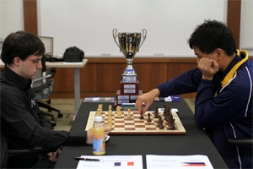
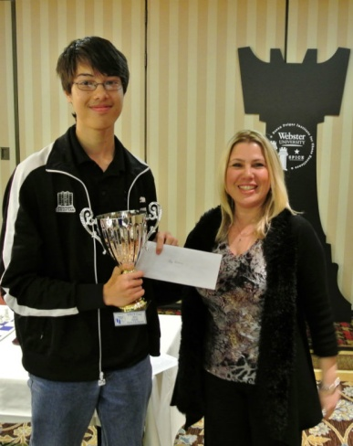

Vachier-Lagrave (W) v Wesley So (B) Open Winner Ray Robson receiving
from their first game. trophy from Susan Polgar
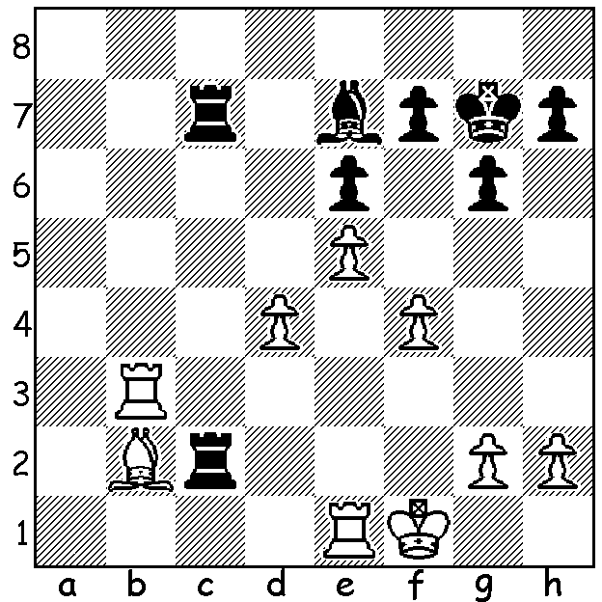

Here is a position from Vachier-Lagrave’s
second game against So. Can you see how
he turns the tables on his opponent
(Black to play, 4 moves)?

Diagram 457

A game from the event I found fascinating was the following long tussle between the tournament winner and Hungarian international Csaba Balogh. Material remains unbalanced from move 16 to the end of the game with the outcome impossible to predict:

Csaba Balogh - Maxime Vachier-Lagrave
2012 Spice Cup (St Louis)
Sicilian, Rossolimo Attack
1.e4 c5 2.Nf3 d6
3.Bb5+ Bd7 4.Bxd7 Qxd7
5.c4 Nf6 6.Nc3 g6
7.d4 cxd 8.Nxd4 Bg7
9.f3 0-0 10.Be3 Rc8
11.b3 a6 12.a4 Nc6
13.0-0 Qd8 14.Rb1 e6
15.Nde2 Qa5 16.Qxd6 Ne8
17.Qd2 Rd8 18.Qe1 Rd3
19.Nd1 Qb4 20.Nc1 Rd7
21.Qxb4 Nxb4 22.Nf2 Nc2
23.Bc5 b6! 24.Bxb6 Na3
25.Ncd3 Nxb1 26.Rxb1 a5
27.e5 f5 28.Kf1 Rb7
29.c5 Nc7 30.Nb2 Bxe5
31.Nc4 Bxh2 32.Bxa5 Nd5
33.b4 Ne3+! 34.Nxe3 Rxa5
35.c6 Rb8 36.Nd3 Rxa4
37.f4 Ra3 38.Ke2 g5
39.Nc4 Rc3 40.Nce5 Bxf4
41.Nxf4 gxf4 42.Kd2 Re3
43.Nc4 Rd8+ 44.Kc2 Rg3
45.b5 Rc8 46.Nd6 Rc7
47.Ra1 Kf8 48.Ra8+ Ke7
49.Ne8 Rd7 50.cxd7 Rxg2+
51.Kc3 Kxd7 52.Ra7+! Kxe8
53.b6 Rg1 54.b7 Rb1
55.Ra8+ Kf7 56.b8=Q Rxb8
57.Rxb8 e5 58.Kc4 Kf6
59.Kd5 e4 60.Rf8+ Kg5
61.Ke5 Kg4 62.Rxf5 e3
63.Rxf4+ Kg3 64.Re4 Kf2
65.Kf4 e2 66.Kg5 h6+
67.Kxh6 e1=Q 68.Rxe1 Kxe1

SOLUTION: 1… Bh4 2.g3 (not 2.Re2?? Rc1+! 3.Bxc1 Rxc1+ mating nor 2.Rd1 Rf7+ 3.Kg1 Rcc2) 2…Rxh2!!. Now if 3.gxh4 Rcc2 theatening …Rh1# & …Rxb2 leaving Black with a winning ending. White played 3.Kg1 losing after 3…Bxg3 (3.d5 gave better chances of saving the game).

