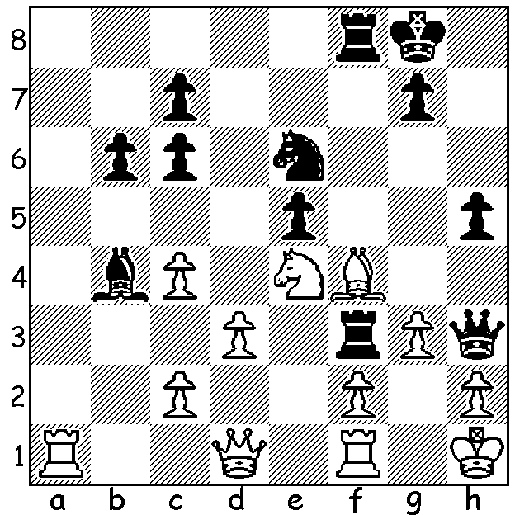

Diagram 458: Carlsen – Aronian
(5th Masters Finals 2012, Rd 4):
White has played 1.Bf4. Can you
find a win for Black (5 moves –
)? look for a stunning sacrifice on
move 3 or 4)?

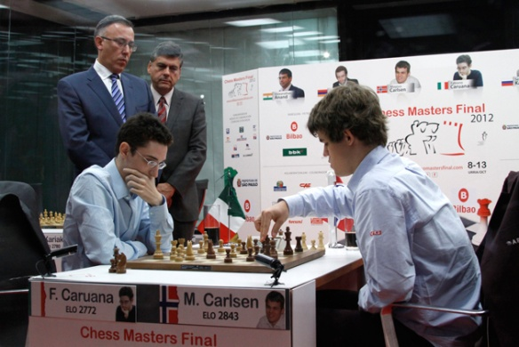
The 5th Masters Finals, played last month in Sao
Paulo and Bilboa, Spain, saw Spanish number 1
Francisco Vallejo-Pons in battle with five of the
world’s top players in a double round-robin with
3 points for a win and 1 point for a draw. Fabiano
Caruana (Italy) made all the running, establishing
a four point lead over world number 1 Magnus
Carlsen (Norway) after 4 rounds. However Carlsen
was able to haul back that margin and defeated
Caruana 2-0 in a blitz play-off. Caruana at 20 is
Caluana v Carlsen in Play-Off touted as a challenger to Carlsen, 21, if Carlsen, as
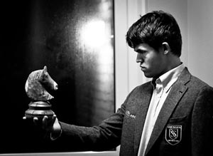
expected, becomes world champion. Scores: Carlsen
& Caruana 17 (from 10 games), Levon Aronian
(Armenia) 11, Sergey Karjakin (Russia) 10, world
champion Viswanathan Anand (India) 9 (=9, -1),
Vallejo-Pons 6. Interestingly the French Defence
(1.e4 e6) was played 6 times with 5 White wins and
a draw (by Carlsen), a seemingly damning of the
defence, but 3 losses were by tail-ender Vallejo- Pons, who announced his retirement from chess
after his disappointing result, one by Carlsen
Magnus admiring his trophy or who tried too hard a pawn up in an ending against
auditioning for Hamlet –‘Alas poor Caruana in Rd 1 and one by Caruana in his return Yorick, I knew him well.’ game with Carlsen. Here is one of the French
losses which shows its fighting possibilities:

Sergey Karjakin - Francisco Vallejo-Pons
5th Masters Finals, October 2012
French Defence: Winawer Variation
1.e4 e6 2.d4 d5 3.Nc3 Bb4
4.e5 c5 5.a3 Bxc3+ 6.bxc3 Ne7
7.Qg4 0-0 8.Bd3 Nbc6 9.Qh5 Ng6
10.Nf3 Qc7 11.Be3 c4 12.Bxg6 fxg6
13.Qg4 Qf7 14.Ng5 Qe8 15.h4 Ne7
16.a4 a5 17.Qe2 Bd7 18.g4 Ra6
19.Bc1 Bxa4 20.Ba3 h6 21.Nh3 b5
22.Bc5 Rc6 23.Bd6 Rf7 24.h5 gxh
25.g5 Nf5 26.gxh Nxh6 27.Kd2 Rf5
28.Rhg1 Rb6 29.f3 b4 30.Qe3 Nf7
31.Bc5 Rb7 32.Rg2 Qb5 33.Rag1 bxc+?(a)
34.Ke2 Nxe5?(b) 35.Qh6! Rff7?(c) 36.Qxe6 Ng4
37.Ng5 Qb2??(d) 38.Qc8+ resigns

a) Right idea but wrong order of moves – 33…Nxe5! 34.Ng5 (34.dxe5 bxc+ 35.Ke2 Bxc2 winning) 34…bxc+ 35.Qxc3 Ng4 36.fxg4 Rxg5 is better for Black.
b) Now Black should play 34…Nd8 (35.Qh6 Qd7 36.Bb6! Bxc2 37.Bxd8 Bd3+).
c) 35…Ng4 would allow Black to fight on – 36.Qxe6+ Kh8 37.fxg4 (37.Qxf5?? Qe8+ mating) 37…Rf6 38.Qc8+ Qe8+ 39.Qxe8 Bxe8 40.Ke3 Bd7 41.g5 Re6+ 42.Kf3 is slightly better for White.
d) The last in a series of errors, almost certainly brought on by time trouble (90 mins + 10 secs per move): 37…Qxc5! 38.dxc5 Rbe7 39.fxg4 Rxe6+ 40.Nxe6 Re7 41.gxh5 Rxe6 survives for a while.
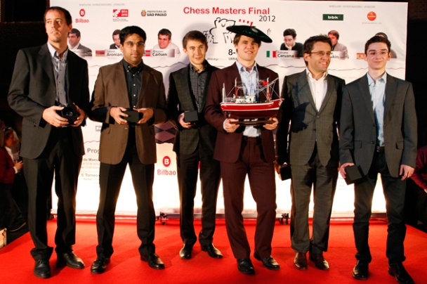
On the last day all players were asked,
“Do you feel like a sportsman, a scientist
or an artist?”
World champion Vishy Anand answered,
“You feel like a sportsman every day.
Some days you feel like a scientist,
some days like an artist,
some days like an imbecile.”

Players (L-R) Vallejo-Pons, Anand, Karjakin, Carlsen, Aronian, Caruana

SOLUTION: 1…Rxf4 2.gxf4 Nxf4 3.Ra8+ Bf8 (not 3…Kh7?? 4.Ng5+) 4.Rg1 Qxh2+!! 5.Kxh2 Rh3#. Aronian had seen the mating idea but missed he could interpose his bishop after 3.Ra8+. Instead he played the imaginative but inferior 1…Bc3!?? Hoping for 2.Nxc3? R8xf4 3.gxf4 Nxf4 4.Ra8+ Kh7 5.Rg1 Qxh2+!! 6.Kxh2 Rh3#. White played 2.Qxf3 and after 2…Bxa1 the game was eventually drawn.

