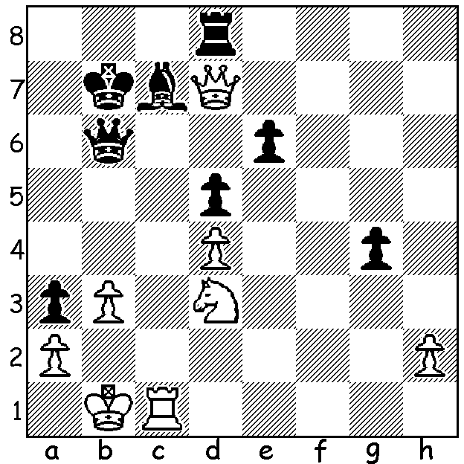

Diagram 460:
Bogoljubov-Alekhine
(World Championship 1929):
White to play and win (5 moves):

The second player in the alphabet series of those who have given their names to openings or defences is Efim Bogoljubov (1889-1952), Ukranian by birth who took German citizenship in 1927. His main contribution to chess opening theory is the Bogoljubov-Indian Defence (usually abbreviated to Bogo-Indian), 1.d4 Nf6 2.c4 e6 3.Nf3 Bb4+, an alternative to the Queens Indian Defence, 3...b6. It was World War I which provided the opportunity for Bogoljubov to develop his considerable skills after being imprisoned together with a number of other Russian players competing in an international event in Mannheim at the outbreak of hostilities between Germany and Russia. There is a story that the Russians were in danger of being shot as spies when their chess notes were examined, the German authorities believing them to be coded imformation. Bogoljubov won five and came runner up in two of the seven tournaments arranged within the POW camp. (Alekhine was also interned but secured release through the influence of his family and served in the Red Cross on the Austrian front.) Bogoljubov’s greatest success was Moscow 1925 which he won ahead of such players as Lasker, Capablanca, Marshall and Rubinstein. He twice challenged Alekhine in 30 game matches for the world title, losing in 1929 by 9.5-15.5 (+5 =9 -11) and in 1934 by 10.5-15.5 (+3 =15 -8). These matches seem to have destoyed Bogoljubov’s self-confidence and he gained no further significant tournament successes although he did win the German championship as late as 1949.

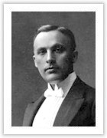
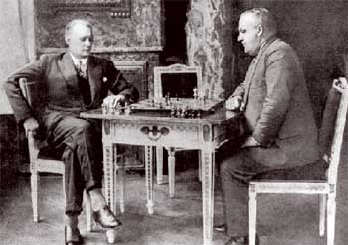
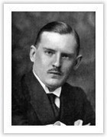

Alexander Alekhine Efim Bogoljubov

Efim Bogoljubov - Jacques Mieses
Baden Baden 1925
Dutch Stonewall Defence
1d4 f5 2.g3 Nf6 3.Bg2 e6
4.Nf3 d5 5.0-0 Bd6(a) 6.c4 c6
7.Nc3 Nbd7 8.Qc2 Ne4(b) 9.Kh1 Qf6
10.Bf4(c) Bxf4 11.gxf4 Qh6 12.e3 Ndf6
13.Ne5 Nd7 14.Rg1 Nxe5 15.dxe5 Nxc3
16.bxc3 Bd7 17.Rad1 b5 18.Qb2(d) 0-0
19.Qa3 Rfd8 20.cxb cxb 21.Qa6 Qh5(e)
22.Bxd5!! exd5 23.Rxg7+! Kxg7 24.Qf6+ Kg8
25.Rg1+ Qg4 26.Rxg4+ fxg4 27.f5 Rdc8
28.e6 Bc6 29.Qf7+ Kh8 30.f6 Rg8
31.Qc7 Rac8 32.Qe5 d4+ 33.Kg1 Bd5
34.f7+ Rg7 35.Qxd4 resigns

a) Somewhat strangely this is referred to as the Modern Stonewall as it has supplanted the once popular development of the bishop on e7.
b) If 8…0-0 9.cxd exd (or 9…cxd when White has strong play along the c file) 10.Qxf5.
c) The biggest defect in Stonewall set-ups is the ‘bad’ queen’s bishop, hemmed in by its own pawns, hence the offer of exchanging the black-sqared bishops.
d) White plays for domination of the black squares. Black could now try 18…bxc (19.Qb7 Rd8 20.Qxa7 0-0) with reasonable chances.
e) Black hurries to get his queen back to defend but should play 21…Kh8 preventing White’s coming brilliancy which leaves White with an easily won game despite a material disadvantage.

THE CHRISTMAS OPEN (final 2012 Grand Prix event) Sat & Sun 1-2 Dec starting 1pm Sat at Moresby St Centre, Kensington. Details at cawa.org.au & entries & information Haydn Barber 9398 4242.

SOLUTION: 1.Rxc7+! Qxc7 2.Nc5+ Kb6 3.Qxc7+ Kxc7 4.Nxe6+ Kd7 5.Nxd8 resigns (after 5…Kxd8 White has an easily won king & pawn ending).
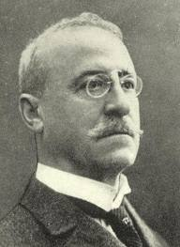
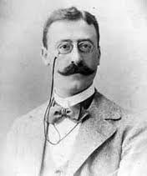
German Jewish GM Jacques Mieses
(1865-1954) became a British citizen
after fleeing nazi persecution.
A dangerous attacking player, he
enjoyed a number of brilliant victories.
As a tournament organiser he began
the practice of paying players travelling
expenses (San Sebastian 1911)

