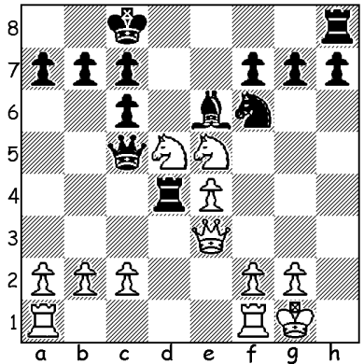

Diagram 461:
Bogoljubov-Muller 1934:
White to play gains a winning
material advantage (5 moves):

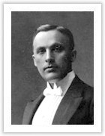
Last week we were introduced to Efim Bogoljubov
(1889-1952), Ukranian by birth who took German
citizenship in 1927 and who twice unsuccessfully
challenged Alexander Alekhine for the world title.
There was considerable hostily between Alekhine
and Bogoljubov and I remember hearing a story
that Alekhine related a dream in which he died
and was interviewed at the Pearly Gates by St Peter
who asked him what he had done in life to deserve
admission to heaven. Alekhine told him he had
devoted his life to chess and had become world
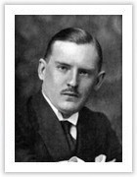
champion but St Peter was unimpressed and stated
that chess was a frivolous activity and no chess
players would ever go to heaven. Looking around
Alekhine saw Bogoljubov inside and pointed this
out to St Peter who replied, “Bogojubov is no chess
player, he only thinks he is.”

Today two games using the defence named after him,
the Bogoljubov or Bogo-Indian Defence, 1.d4 Nf6
2.c4 e6 3.Nf3 Bb4+, both showing the common idea
of exchanging bishop for queens knight to secure
control of the e4 square:

Bogoljubov (above) and Alekhine


DAHLBERG - KORCHNOI
Lone Pine, USA, 1981
1.c4 Nf6 2.Nf3 e6 3.d4 Bb4+
4.Nbd2 c5 5.a3 Bxd2+ 6.Qxd2 b6
7.e3 Bb7 8.Be2 Nc6 9.0-0 0-0
10.b3 Ne4 11.Qc2 f5 12.Rd1 Ne7
13.dxc bxc 14.Bb2 d6 15.Nd2 Ng6
16.Bf3 Nh4 17.Bxe4 fxe4 18.Nxe4(a) Nxg2!!
19.Qc3(b) Qe7 20.Nxd6 Bf3 21.Rd2 Nh4
22.Qe5 Be2! White resigns
Korchnoi
a) Losing – White should play 18.Nf1
b) If 19.Kxg2 Qh4 20.f3 Rxf3! 21.Kxf3 Rf8+ 22.Ke2 Bxe4 is decisive.
c) White is lost, eg 23.Qxg7+ Qxg7 24.Bxg7 Nf3+ 25.Kg2 Nxd2 26.Bxf8 Bf3+ 27. Kg3 Rxf8

VIDMAR - NIMZOVITSCH
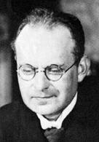
New York 1927
1.d4 Nf6 2.c4 e6 3.Nf3 Bb4+
4.Bd2 Qe7 5.Nc3 0-0 6.e3 d6
7.Be2(a) b6 8.0-0 Bb7 9.Qc2 Nbd7
10.Rad1 Bxc3 11.Bxc3 Ne4 12.Be1 f5
13.Qb3 c5(b) 14.Nd2 Nxd2 15.Rxd2 e5
16.dxe dxe 17.f3 g5 18.Bf2 Nf6
19.Rfd1 Rae8 20.Qa4 Ba8 21.Rd6 Qg7
22.Bf1 e4 23.Be1 exf 24.Bc3 Qe7
25.R6d3(c) fxg 26.Bxg2 Bxg2 27.Bxf6 Qe4
28.Rd2 Bh3 29.Bc3 Qg4+ White resigns
Nimzovitsch
a) If 7.Bd3 e5 threatening 8…Bxc3 / 9…e4 winning a piece.
b) Depriving White of the possibility of c5.
c) White originally intended 25.Bxf6 but this loses to 25…Qxe3+ 26.Kh1 fxg+ 27.Bxg2 Qe1+! 28.Rxe1 Rxe1#.

THE CHRISTMAS OPEN (final 2012 Grand Prix event) Sat & Sun 1-2 Dec starting 1pm Sat at Moresby St Centre, Kensington. Details at cawa.org.au & entries & information Haydn Barber 9398 4242.

THE TEAMS LIGHTNING CHAMPIONSHIP Sunday 16 December 1pm. 3 players per team (not restricted to clubs). Information cawa.org.au & enquiries DOP Gordon Dunlop 93686412.

SOLUTION: 1.Qxd4!! (a delightful deflection sacrifice) 1…Qxd4 2.Ne7+ Kb8 3.N7xc6+! bxc6 4.Nxc6+ & 5.Nxc5.

