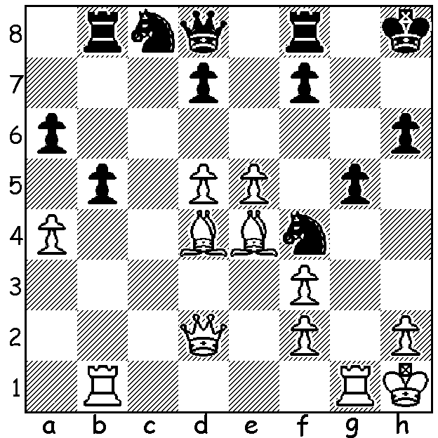

Diagram 462:
C W Sandilands – J Veverka:
White to play (5 moves):

Three weeks ago I wrote about the success of Kendenup Primary in winning the WA ChessKids finals. This entitled the team to compete in the Australia-NZ national finals in Melbourne, Nov 26/27 where they finished 2nd from 14 teams. Jayden Williams scored 5.5/7 with James Gray, Alex Bolton and Ethan Palfrey all scoring 5/7 to give the team 20.5/28. Other team members were Sebastian Garvisson and Izaak Bateman. The tournament proved an inspiring experience for the team with lectures, films and top players ready to analyse their games. The team is indebted to Heather Fergie and other members of staff, coach Bill Sandilands and also sponsor Mt Barker Bendigo Bank for meeting the cost of the air flights.

WA was also well represented in the Secondary Championships with Perth Modern fielding a very strong team and gaining third place with 22.5/28 - Aston Taminsyah 5/7, Varum Mukhedkar 5, Jonathan Israel 4.5, Neville Shah 4, Joseph Thompson 4.

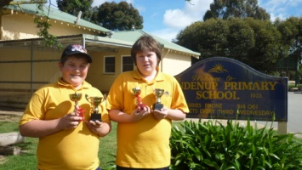
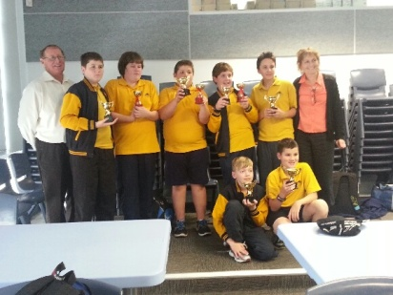

Kendenup Primary team after WA schools
championship: Back L-R Bill Sandilands,
Sebastian Gavisson, Jayden Williams,
James Gray, Alex Bolton, Izaak Bateman,
Heather Fergie: Front L-R Ethan Palfrey,
Kyle Thill.
Kendenup’s top players James Gray (L)
& Jayden Williams (see game below)

I asked Kendenup’s coach Bill Sandilands, whom I played in the 1974 & 1976 WA Correspondence Championships, to send me some games of his. The isolation of country chess players meant that postal chess was likely to be the only outlet for enthusiasts for competitive chess but the advent of computer chess programmes has sadly turned many away from this activity. Bill learned chess at school but didn’t get involved until his early twenties. He cites among his postal opponents ex-Australian champion David Hamilton and prominent WA players Paul Foster, Simon Fitzpatrick and Stan Webster.

C W Sandilands - W H Johnson
WA Correspondence Championship 1974
French Advance: Milner-Barry Gambit
1.e4 e6 2.d4 d5 3.e5 c5
4.c3 Nc6 5.Nf3 Qb6 6.Bd3 cxd
7. cxd Bd7 8.0-0 Nxd4 9.Nxd4 Qxd4
10.Nc3 Qxe5 11.Re1 Qd6(a) 12.Nb5 Qb8(b)
13.Qf3 Bd6(c) 14.Nxd6 Qxd6 15.Bf4 Qe7
16.Qg3 g6 17.Bd6 Qd8 18.Be5! f6
19.Bxg6+! Kf8 20.Bc7!(d) Qc8 21.Bd6+ Ne7
22.Qh4 Kg8 23.Bh5 Nf5 24.Qxf6! Nxd6
25.Re3 resigns

a) The immediate 11…Qb8 would be my choice (12.Nxd5 Bd6 13.Qg4 Kf8).
b) 12…Bxb5 13.Bxb5+ Kd8 accepting loss of castling is essential.
c) Meeting the threat of 14.Bf4 but handing over control of the black squares.
d) Forcing Black’s queen away from protecting the knight.

THE CHRISTMAS OPEN, the final Grand Prix event of the year and played last weekend attracted 5 over 2000 players and another 4 players over 1900 among the 24 entries. Winner was WA’s top player Tristan Boyd with 5.5/6 closely followed by Ihsan Ferozkohi with 5 and Ian Sutton on 4.5. George Carolin-Unkovich, who drew with Ihsan, gained the Junior prize.

THE WA TEAMS LIGHTNING will be held Sunday 16 December starting at 1pm. Three players per team (not restricted to clubs). Information & entries Gordon Dunlop 9368 6412

SOLUTION: 1.Qxf4! gxf4 2.e6+ f6 3.Rg6 Rg8 4.Rxf6 wins (cont. 4…Rg7 5.Rf7 Nd6 6.Rxg7 Nxe4 7.Rxd7+ Qf6 8.Bxf6+ etc).

Jayden Williams – Tianli Zhang (ChessKids National Ch 2012)
Two Knights Defence
1.e4 e5 2.Nf3 Nc6 3.Bc4 Nf6
4.Ng5 d5 5.exd Na5 6.Bb5+ c6
7.dxc bxc 8.Ba4 h6 9.Nf3 Bg4(a)
10.Nc3? e4 11.Qe2 Qe7 12.Nxe4 Nxe4
13.c3!(b) Rc8 14.d3 Bxf3 15.gxf3 Nc5
16.Qxe7+ Bxe7 17.Bc2 0-0 18.Be3 Ne6
19.0-0-0 a6 20.Rhg1 Ng5 21.f4 Nf3
22.Rg3! Nxh2? 23.Rh1 Bh4 24.Rh3 Bxf2
25.Bxf2 Ng4 26.Bd4 Rb8 27.Bd1 f5
28.Rg1 Kh7 29.Bxg4 fxg4 30.Rxg4 Rf7
31.f5 Rg8 32.f6 gxf 33.Rxg8 Kxg8
34.Rxh6 f5?? 35.Rh8#

a) Better 9…e4. White could now play 10.h3. b) Threatening 14.b4.
A well played game by Jayden showing good positional judgement, marred only by the careless error on move 10.

